Overview

- Description of test environment
- Transfer file to OSF mainframe
- Login to PeopleSoft
- Submit job
- Submit Batch Slip to OSF
- Overview of Daily Processing
- How to Handle Rejections
- General Processing Tips
- Help Desk
- Follow-up

Description of the test environment

A test environment has been set-up for agencies to test their edt claims. This is set-up on our development box, so at times, the response may be slow.

While we have tried to test every possible scenario, we know there is no substitute for ‘real’ data. Therefore, we anticipate that changes may need to be made to the edit/load program during this phase of testing

The test environment contains purchase orders ‘as-of’ July 23rd. Any purchase orders encumbered at OSF on that date will be available for testing. Any purchase orders submitted on the miscellaneous claims file for testing that were not available at that time should be rejected (also a good test!).

The testing environment will be available from September 10th through go-live.

During this time, the CORE staff will (1) select vouchers for processing (2) run the payment posting and journal generation processes and (3) create interface files (cash/allot, alltrans and outstanding orders).

Transfer file to OSF mainframe

In order to easily distinguish the CORE files from the current legacy system files, we are changing the dataset names. The dataset name for the CORE files should adhere to the following naming convention.

core.buxxxxx.miscclms.e999999.receivd

where:
xxxxx = 3 digit agency number + ‘00’
999999 = edt number

Record length = 400
Blocksize = 27600

The current dataset naming convention is ‘userid.tclm.axxx.e999999.receivd’. Please notice that the userid is no longer the high level qualifier on the dataset.

Login to PeopleSoft

The security forms for each agency should already be turned in to the CORE office for processing.

However, for the interface testing, we will setup one userid for each agency. Please e-mail me the name of the person who will need a userid for testing. My e-mail address is: lisa.mckeithan@osf.state.ok.us

Website for testing: http://webdev.oklaosf.state.ok.us:7031/fsint/signon.html

NOTE: this is not the production website!

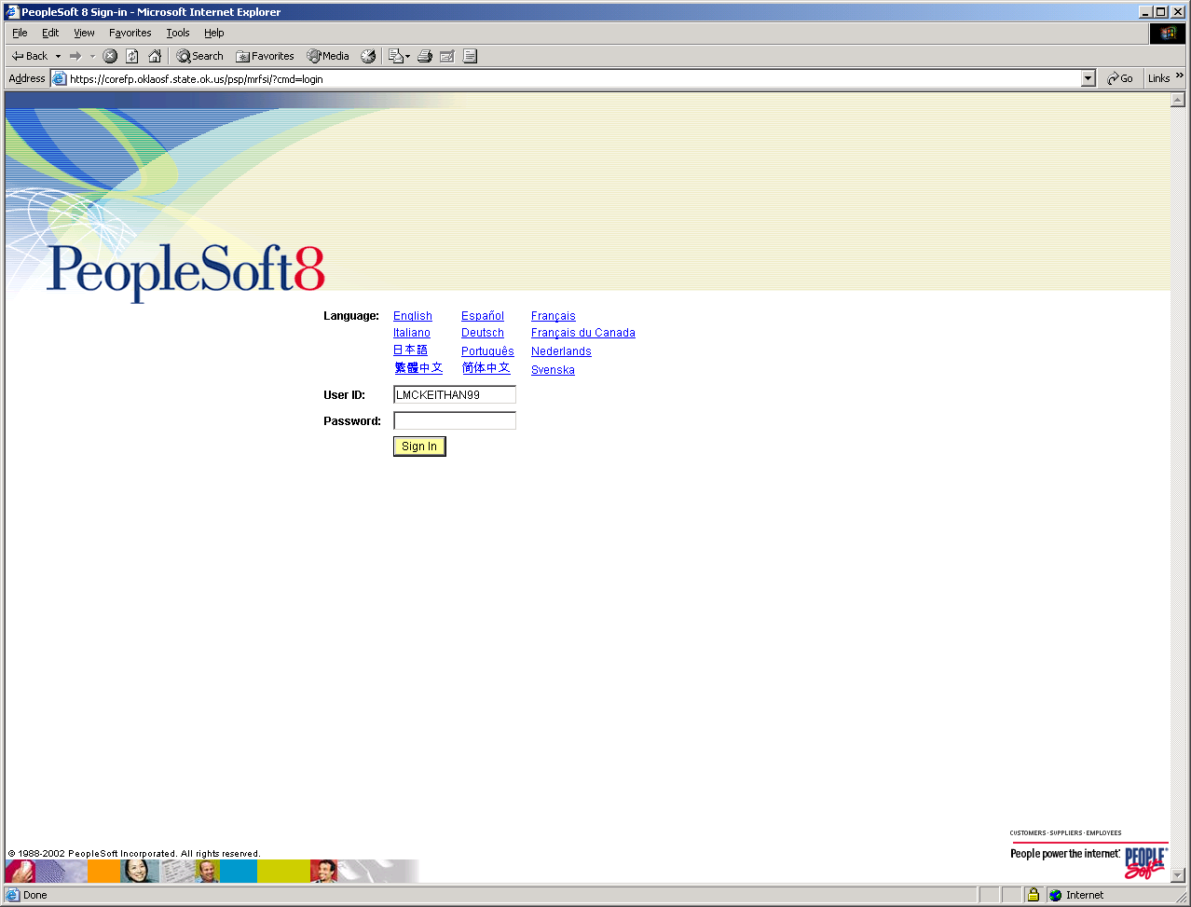

Submit Job

To submit the job, follow the path:

CORE Interfaces
Inbound
EDT Claims

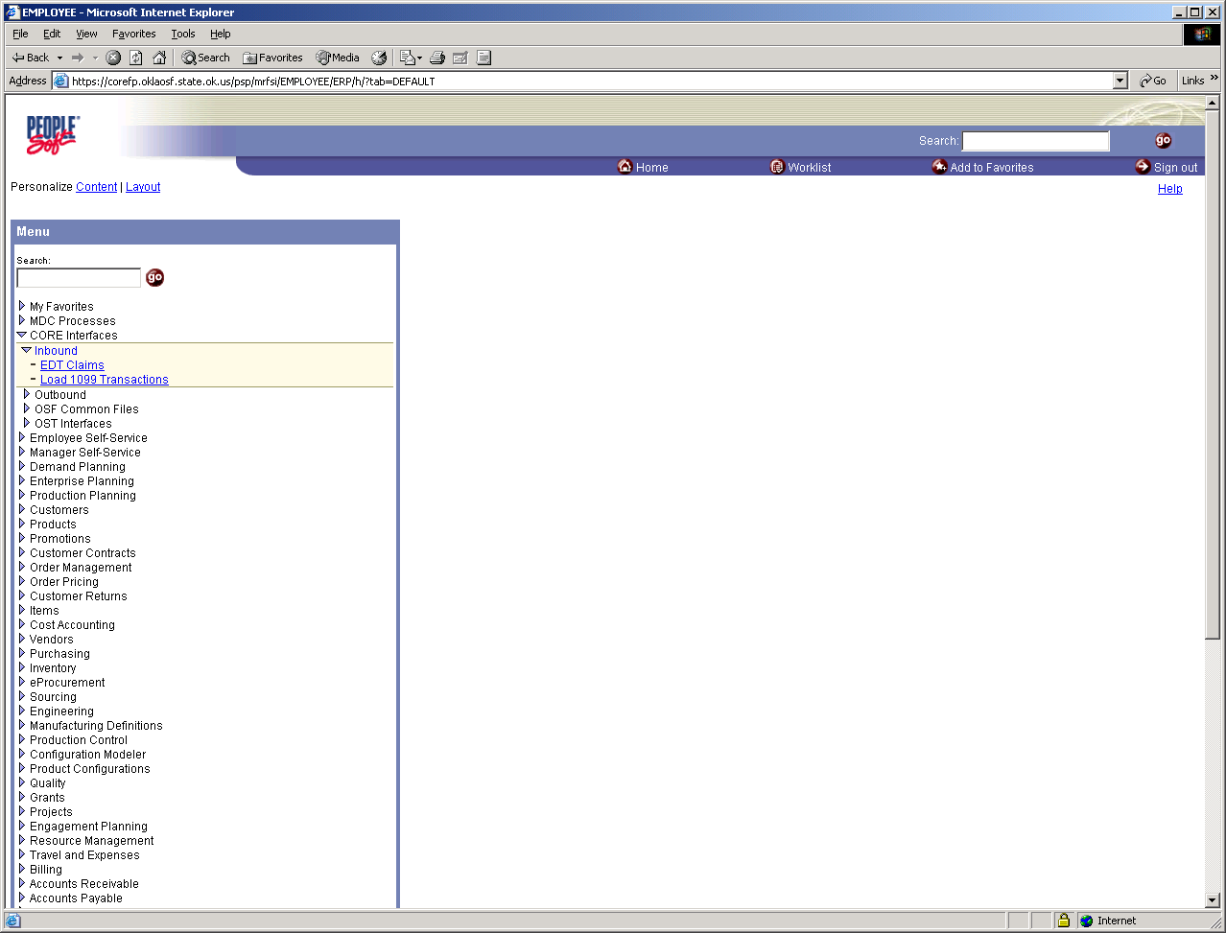

Select the EDT Claims option and the Run Control screen will appear.

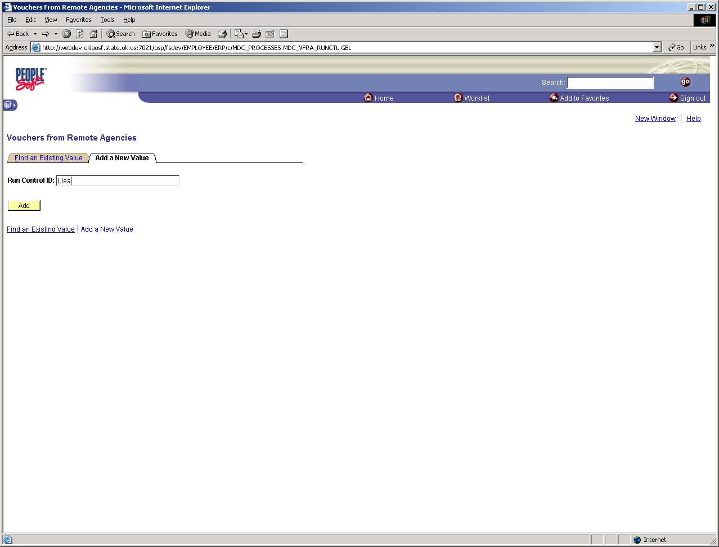

The first time, a run control will have to be added. The run control id can be any descriptive text that you choose. Type in a Run Control ID, for example, “EDT Claims” and then click the ‘Add’ button

On the next screen, enter your agency number and EDT number and click the ‘Run’ button.

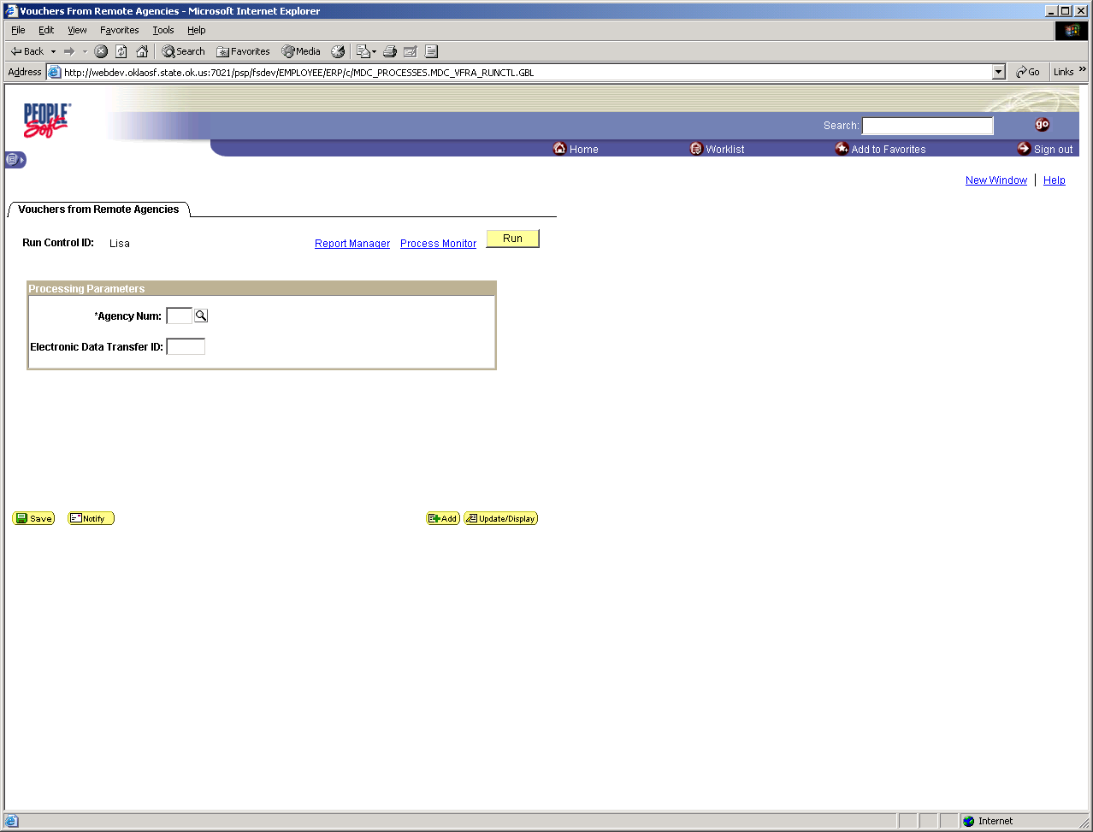

The Process Scheduler Request panel is displayed.
- Enter the server name - PSNT
- Check the edit or load checkbox
The last two options listed on the screen are ‘Vouchers From Remote Agencies’ and ‘Edit Vouchers from Remote’.

The Vouchers from Remote Agencies option is the edit/load option. It will edit your claims and then try to load them.

The Edit Vouchers from Remote option will only edit the claims.

Either option will return an edit report.

Check the check box next to the desired option.
- Press the OK button

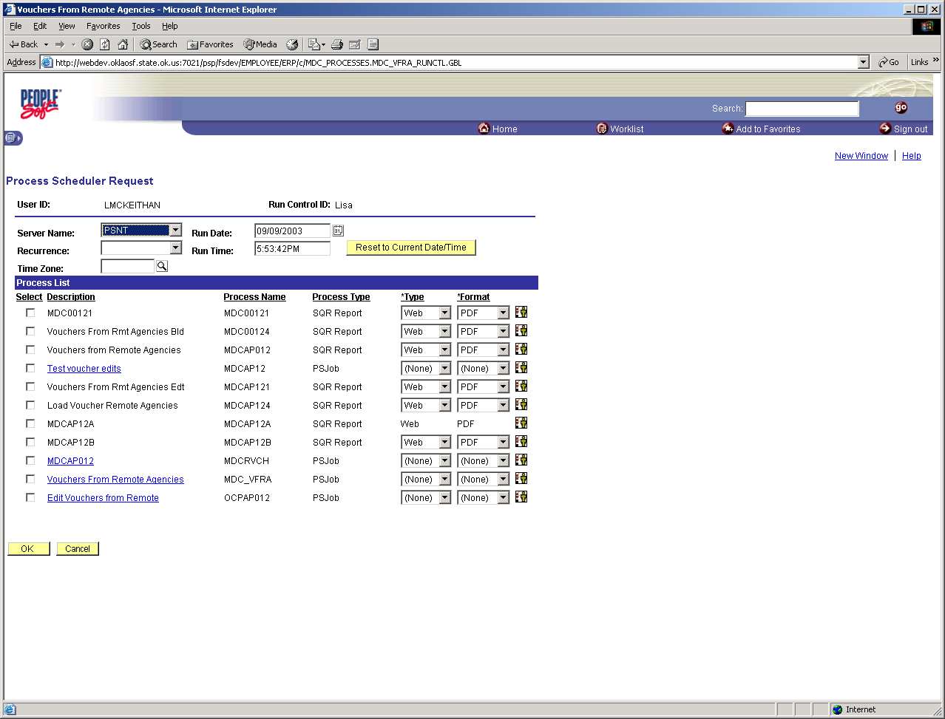

You will be returned to the previous panel. Click on the Process Monitor hyperlink and your job(s) will be displayed. This screen will show the status of your jobs. Press the Refresh button to update your job ‘Run Status’. In general, jobs have the following statuses:

Queued Waiting to run
Initiated Starting to run
Processing Running
Posted Finishing running
Success Completed successfully
Error Completed unsuccessfully

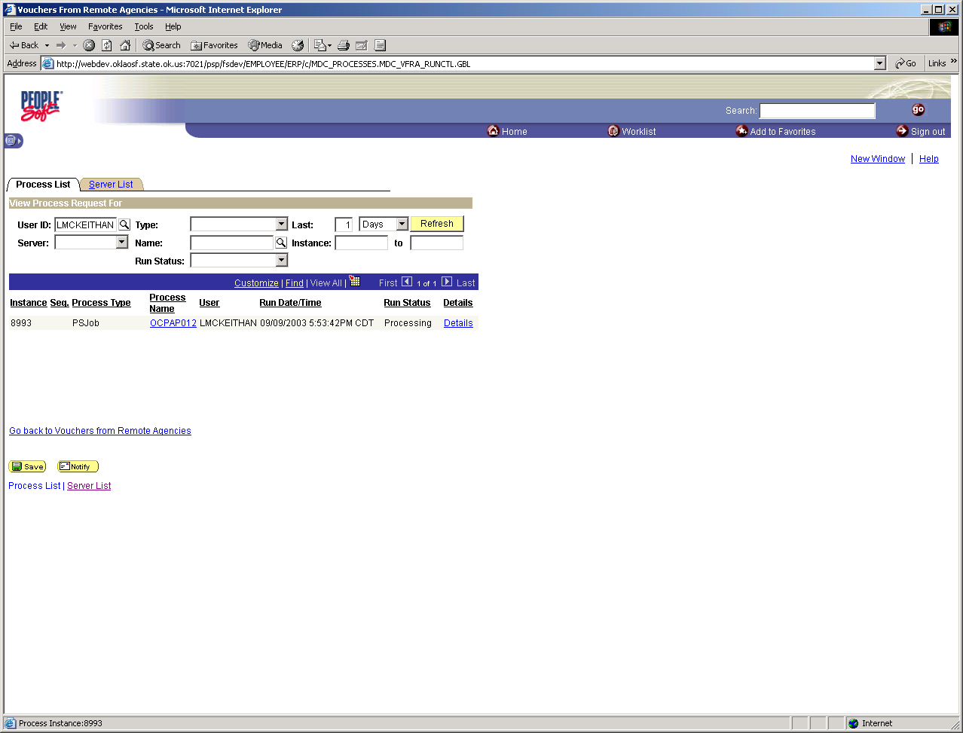

Once the job has completed, you may click on the ‘Details’ hyperlink to review/print the report.

If you need assistance, we will need to know the process instance number so we can find your job.

Submit Batch Slip to OSF

The OSF will process vouchers each afternoon. A batch slip must be filled out and faxed to the testing room at 405.521.2871. Once the batch slip has been received, the corresponding vouchers will be selected for payment.

The batch slip may be produced from PeopleSoft by following the path:

Accounts Payable > Reports > Vouchers > Voucher Register Batch Slip

Overview of Daily Processing

Currently, when claims are processed through OSF each night, OSF adjusts the cash and allotment balances and generates the warrants for payment.

In PeopleSoft, the budget checking process is separate from the payment posting process. The budget checking process will update the cash/allotment information. Once the payments are posted, the ‘actuals’ ledger will be updated. The process within PeopleSoft will be:

1) agency submits their claims (vouchers) into PeopleSoft
2) each night the budget checking process is run (all vouchers will be budget checked). This information will be in the AP funding alltrans file (see budget checking date). This will also tie back to the cash sheet.
3) agency submits their batch slip (and claims if required) to the OSF
4) the OSF selects claims for payment
5) payment posting is run (warrants are generated). This information will be in the AP funding and AP warrants alltrans file (see payment date).
6) journal generation is run (transactions are submitted from Accounts Payable to the General Ledger)
7) journals are posted (GL alltrans)

You may send your batch slip the same day that you load your vouchers or you may wait until the budget checking process is done at night to see if any vouchers reject before submitting your batch slip.

See the Accounts Payable Business Process Flows for more details.

Each day during voucher processing the following exception reports will be produced:

path Accounts Payable > Reports > Vouchers

Budget Checking Error (OCP_0224_AP )
This report will show all vouchers that have a budget exception and what the exception is.

Vouchers in Recycle Status (OCP_220_AP)
Shows vouchers that have been created but are in a recycle status and will not continue to process until fixed. (Addition error).

Vouchers not Posted (OCP_0221_AP)
Shows vouchers that should be posted but have not. Vouchers have a budget status of valid, match status of either no match or matched, document tolerance has been checked and the voucher has been approved.

Match Exceptions (APY1090)
Shows all P.O. vouchers that have a match exception and what the exception is. Also, there is a view screen called the Match Manager. You can retrieve all vouchers with a match exception and hyper-link to the exception.

Print Vouchers (OCP_0229_AP)
Vouchers may be printed for submission to the OSF. Vouchers may be printed by voucher date, warrant date, voucher numbers (range) or userid.

Voucher Register Batch Slip (OCP_0245_AP)
This report must be submitted to the OSF in order for vouchers to be selected for processing.

How to Handle Rejections

If a voucher has a budget checking error, there are two ways to correct the error:

- modify the voucher in PeopleSoft to reflect the correct information, or
- close/delete the voucher in PeopleSoft and resubmit electronically

See the Accounts Payable Business Process Flows for more details.

General Processing Tips

Do NOT submit claims twice. The current system is keyed by the agency claim number so we know when you have submitted claims twice. Since claims are being converted to vouchers, there will no longer be a check for duplicate claims. If you have one or more claims reject from a transmission, you will need to transmit those claims separately. If you do not follow this procedure, your claims will load a second time and will also budget check a second time during the nightly process.

Vendor ID - This field is defined as alphanumeric. If you are not sending the vendor id, submit spaces in the field instead of zeroes. If you put zeroes in the field, the payment will be made to the general revenue fund!

Help Desk

The PeopleSoft implementation will include new Help Desk software which will allow us to track calls and responses. Therefore, after go-live, you MUST contact the Help Desk with any questions. The Help Desk number will remain 405.521.2444.

However, during this testing phase, if you need help you may contact us directly:

Judi Mott 405.522.5403 judi.mott@osf.state.ok.us
Theresa Walters 405.522,3211 theresa.walters@core.state.ok.us
Susan Jones 405.521.3766 (receptionist)

Please be patient….we are learning too!

Follow-up

It is important that each agency thoroughly test their processes until they are assured that their vouchers are being loaded accurately.

We will be working closely with each agency to confirm that the testing process is progressing. Please send me contact information for the person you would like us to contact regarding the status of your testing.

Please submit their name, phone number and e-mail address to me at lisa.mckeithan@osf.state.ok.us

As always, if you have any questions or concerns, please contact me at the above e-mail address or at 405.521.3772.

