**Submitting Budget Request Information**

**(Program info, KPMs, etc.) and Strategic Plan:**

1. Go to **Submit Budget for Approval** on the task list.

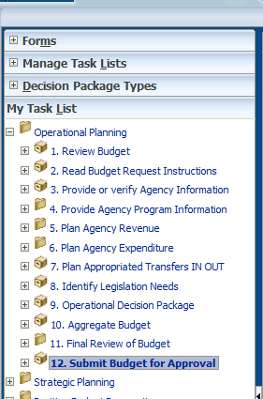

OR

Go to the **Action Button** on the task list in the main pane.

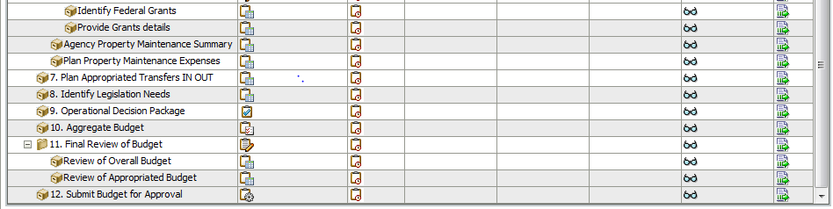

1. Go to the first division line. (When you change the division line, all relevant departments should change.)

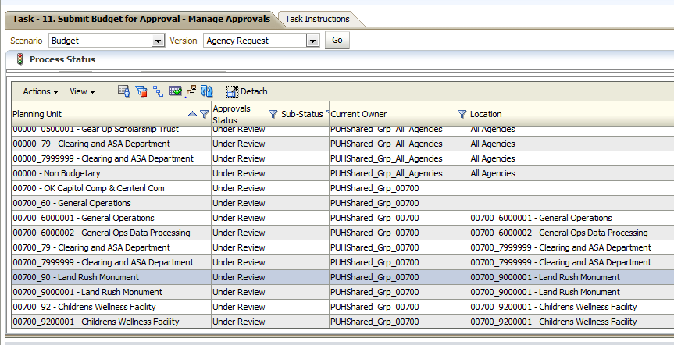

1. Go to the **Actions** button then **Change Status**.

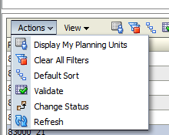

1. Change the status to **Promote** for the first box then **PUHShared_GRP_Your Agency Number** for the second box.

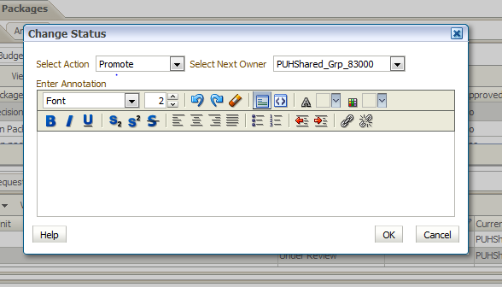

6. Push the **OK** button.



7. Click on the same division/department line. (There are two steps to approving each part.)



8. Click on the **Actions** button then **Change Status**.



9. Change the status to **Promote** for the first box then **PUHshared_GRP_All_Agencies (this submits to OMES)** for the second.

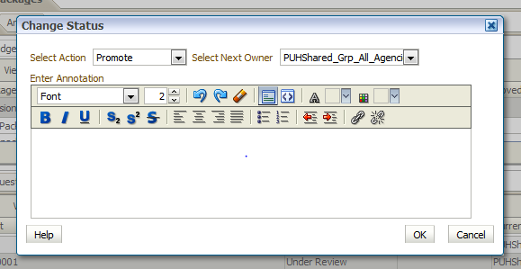

10. Push the **OK** button.



11. The **Current Owner Column** should say “PUHshared_GRP_All_Agencies.” The **Location Column** should say “All_Agencies.”

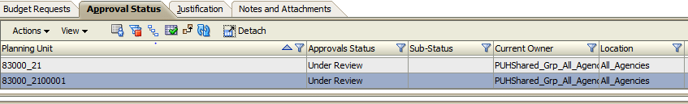

12. Repeat each step for each division.