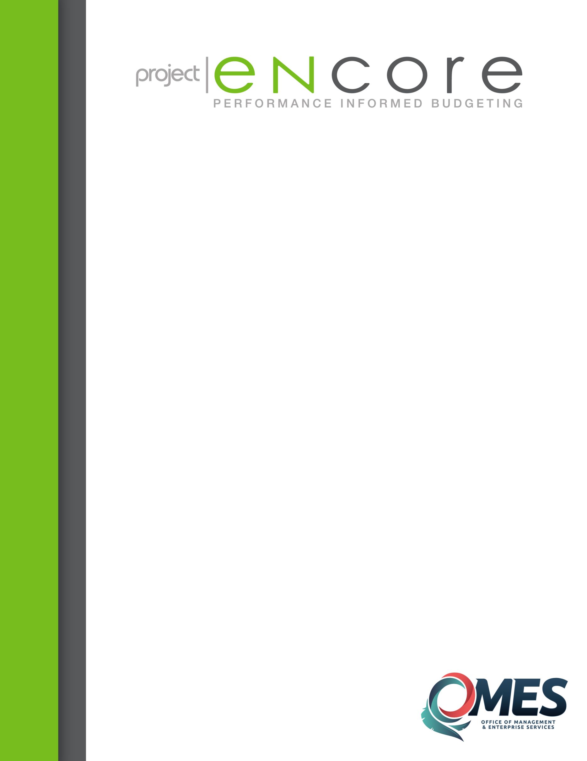

**END USER GUIDE:**

**Preparing a Budget Revision - Preparer**

Document History

Document Location

This document is posted on the following websites...

Revision History

|  |  |  |  |
| --- | --- | --- | --- |
| Revision Number | Revision Date | Summary of Changes | Changes marked |
| 0.0 | 07/16/2015 | Original Guide | n/a |
| 0.1 |  |  |  |

Maintenance

This document is maintained by: Office of Management & Enterprise Services – Budget Division – PSPB Administrators

Last Modified: 08/04/2015

Version 0.0

Budget Revisions (aka Budget Amendments) will be done through decision packages. Each new revision will be a new decision package.

Planners will have a new task list in their “My Task List” pane. It is called “Budget Revisions”.

In the instructions for entering budget revisions task, a Planner will be able to see a shorter description of the tasks in this guide. Task 2, Enter Budget Revision Decision Package, once clicked, will take the Planner to the Decision Package homepage.

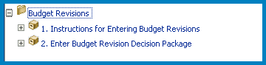

Once on the Decision Packages homepage:

Select the proper POV: Scenario = Budget

Version = Budget Amendment

Year = FY## (the first year will be FY16, then FY17, etc.)

Click Go.

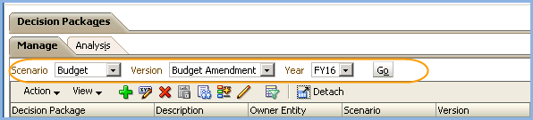

The Planner is now in the correct point-of-view and can begin adding their revisions.

NOTE: One revision per decision package, only.

Click the add icon, or select action>add new decision package.

**NOTE**: The naming conventions mandated in this guide must be followed for your revision to be entered into PeopleSoft appropriately. **Naming Conventions will be in bold-type.**

1. Enter the name of your revision. **Naming Convention: 5-Digit-Business-Unit_Revision_##**. For example: 09000_Revision_01
2. Leave Rank as 1, or you may change this to match the revision number.
3. Verify that scenario is “Budget” and Version is “Budget Amendment”.
4. For the owner entity, please select your 5-digit business unit, especially if you will be entering data in multiple departments.
5. Click the Justification tab.

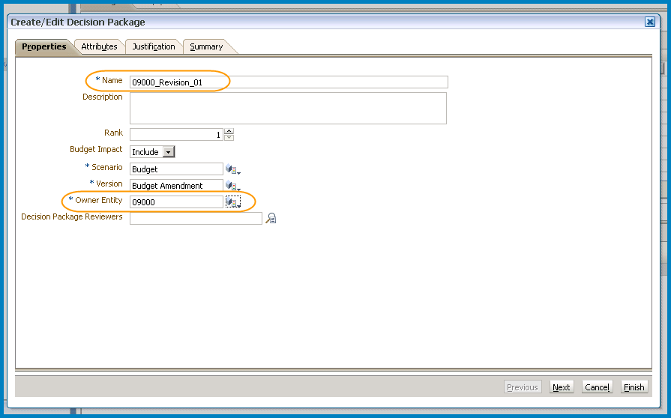

**Note:** Leave the Decision Package Reviewers box blank.

The Justification tab is mandatory. Enter your justification here.

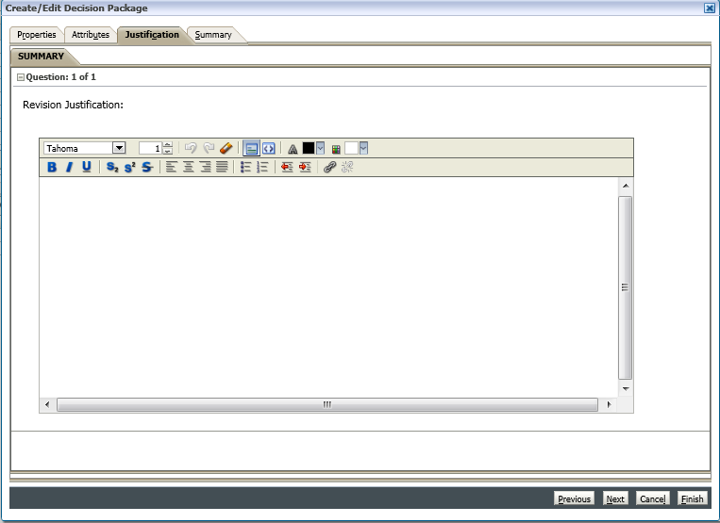

Click Finish.

Once the decision package has been processed, the Planner will automatically be brought back to the Decision Package homepage.

On the Decision Package homepage, you will now see the decision package you just created. Verify again that the Scenario is “Budget”, Version is “Budget Amendment” and the year is correct.

1. Click on your newly created decision package. This will highlight the row. Note here that the owner entity is your 5-digit business unit. This will allow you to enter data in multiple departments, yet see the total on this decision package row.
2. In the Budget Requests pane, click the + icon to add a new budget request. Note: You may use one budget request and, by changing the POV on the data collection form, enter data for multiple departments.

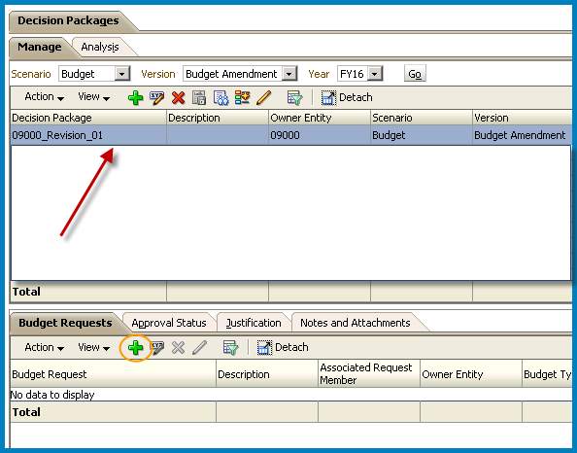

Shown below is the dialog box where you enter the information about your new budget request.

1. Enter the name of the budget request. **Note that if you do not follow the naming convention below, your revision cannot be posted.**

**NAMING CONVENTION:** The first six characters of your decision package name should be your business unit and an underscore. The last six characters of your request name need to be the revision number in the form, REV_01, REV_02, REV_03, etc., using all capital letters, the underscore character, and the two-digit format of the revision number (01 for revision 1, 02 for revision 2, etc.).

Example:

* 09000_REV_01

1. Enter an optional description.
2. Enter the owner entity. Be sure to use the 5-digit business unit so the total for this request will reflect all departments in which data was entered.
3. Click Finish.

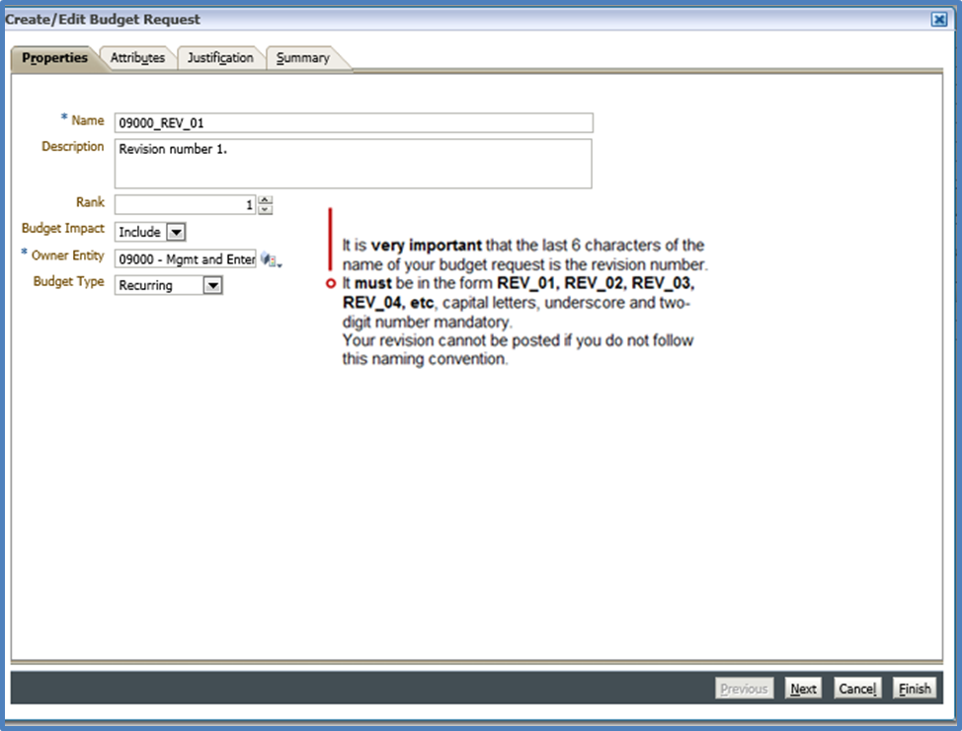

In the Budget Requests pane, click on the newly created Budget Request to highlight it.

Then select the pencil icon to edit the budget request data.

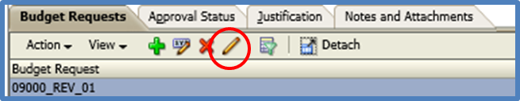

When the Budget Requests forms open, **verify** the Point-of-View at the top of the screen. This should be your decision package, budget request, budget scenario, budget amendment version, owner entity and year for your revision. If it is not, please click on the bread crumb, “Decision Packages” and go back to the decision package homepage to select the correct decision package and budget request.

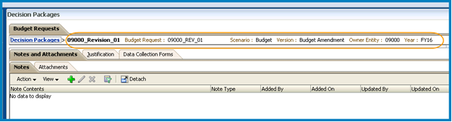

Click on the Data Collection Forms tab.

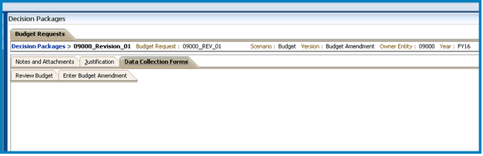

You may click on the Review Budget form, if you so choose.

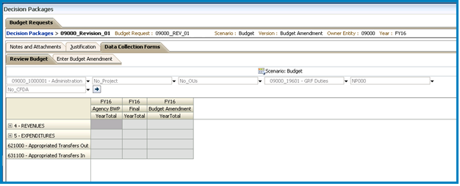

Click on the “Enter Budget Amendment” tab.

Verify the Point-of-View.

Enter data, as needed at the six-digit account code level by expanding the accounts to editable cells.

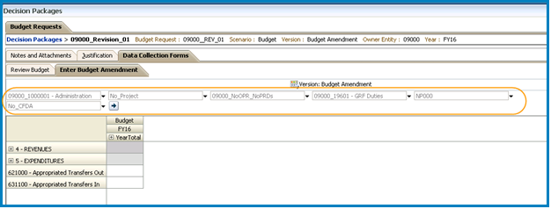

Save your data (File >> Save; or, the floppy disk icon). While the system is saving your data, you will see the following message on your screen. Please let the system work until it has completed the saving and aggregating of your data and shows the success information box. This could take a minute or two.

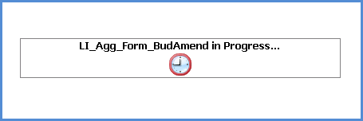 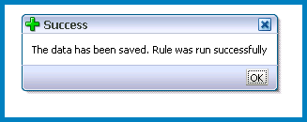

The following image reflects the saved changes to this budget request. Note the point-of-view and that the 631100 account was used. This is just an example of how the screen may appear.

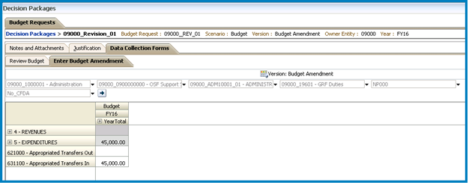

When you have completed entering your data, click the bread crumb, “Decision Packages” to return to the decision package homepage.

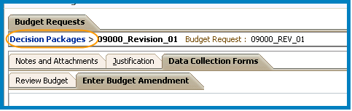

The amount column shows the total net expenditure change for the revision.

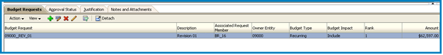

When you have completed your decision package entry, submit it to “All Agencies” and send your revision request documents to your budget analyst as instructed by your analyst.

**Steps to Submit Decision Packages / Budget Revisions:**

2. Click on the decision package you wish to submit.

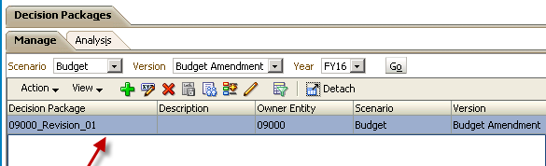

3. Click on the Approval Status tab on the bottom half of the screen.

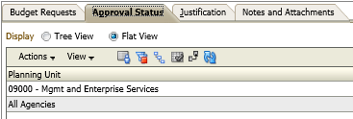

4. Click on the line with the agency number.

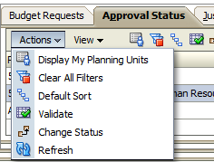5. Click on the Actions button then Change Status.

6. Change the action to Promote for the first box and leave the second as Automatic.

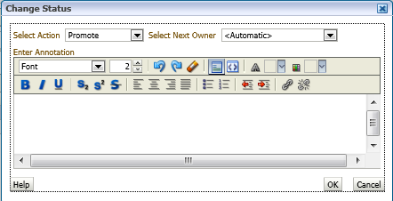

7. Push the OK button.

8. Click on the agency line again. There are two steps to approving each Division/Department.



9. Click on the Actions button then Change Status.

10. Change the action to Promote for the first box and leave the second as Automatic.



11. Push the OK button.

12. The Current Owner column should say “PUHshared_GRP_All_Agencies.” The Location Column should say “All_Agencies.”

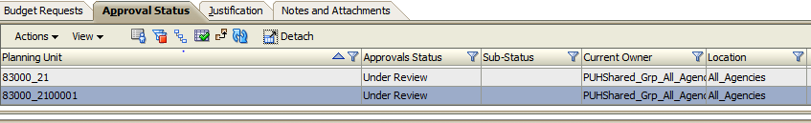

13. Notify your budget Analyst and send your letter to allot along with any other applicable information.