**CARL ALBERT STATE COLLEGE**



***POSITION: Vice President of Business Operations***

***LOCATION: Poteau, Oklahoma***

**About CASC**

Carl Albert State College (CASC), ranked as one of the top community colleges in the nation, invites applications for the position of Vice President of Business Operations. A member of the Executive Cabinet reporting to the President, the Vice President of Business Operations is the chief financial officer and is responsible for the overall financial leadership, strategic financial planning, and financial management of the College.

Founded in 1933, Carl Albert State College pursues the vision of providing an exemplary learning community by creating excellent educational opportunities that are responsive to the needs of the area and enables students to achieve their aspirations and develop into successful participants in an ever- changing world.

CASC is located in beautiful southeastern Oklahoma, just 30 miles west of Ft. Smith, Arkansas, and within easy driving distance of Tulsa, OK and Fayetteville, AR. Poteau is known as the Gateway to the beautiful Ouachita National Forest.

A Higher Learning Commission site visit took place in February of 2013. This review resulted in a renewed accreditation for ten years.  
*CASC’s mission is to provide affordable, accessible and exceptional education that fosters student success.*

**About our students**

CASC has an annual student population of approximately 4250. We provide three-fold goals for student education:

1. Preparation for transfer to a four-year University
2. Education-to-work degrees
3. Education for personal growth and benefit

In addition to academic opportunities, CASC provides a wide variety of student activities and organizations. On-site housing is available at the Poteau campus for approximately 300 students, which includes Athletic Housing, Scholars Center, and Residential Program Housing.

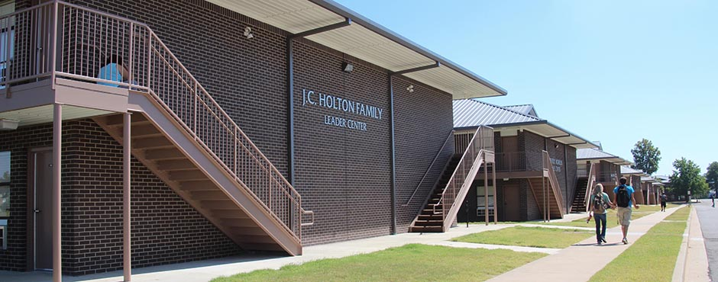**Position Profile**

**Responsibilities:** Oversee the business operations at the Poteau and Sallisaw campuses; provide oversight and supervision of the Business Office (including payroll) and Financial Aid. Perform financial functions including treasury, accounting, budgeting, financial operations, and reporting and strategic fiscal development. Provide financial accountability and ensure compliance with state, college, and external funding agency guidelines. Review and approve reconciliation of accounting records with college reports/financial statements and prepare recurring financial/budget reports for internal and external purposes. Serve as a liaison with vendors and contractors when needed. Develop and recommend fiscal policies and procedures to be considered for the financial integrity of the college. Give the final approval of all purchase orders, and sign off on all claims submitted for payment. Coordinate external and internal audits and respond to auditor requests and recommendations. Manage the bidding process with compliance to laws and regulations; and all aspects of the college’s insurances, including risk management. Assist with and maintain CASC business contracts. Provide oversight of the CASC Energy program. Additional supervisory roles as administered by the College President. Some travel required, including state and higher education meetings.

 **Qualifications:** Master’s degree required with a bachelor degree in Business, Accounting, or related field. A CPA and MBA preferred. Experience in the management of fiscal affairs required. Management and higher education experience required. Required competencies for this position are strong decision-making skills, accounting skills, excellent written/oral communication and interpersonal skills, attention to detail and organization capabilities, and possess the ability to develop and assess information and an understanding of excellent business practices. The Vice President should act on strong convictions of honesty and integrity and be committed to the mission of a two-year college.

*Deanna Reed Science & Math Center*

**Application Information:** CASC offers an excellent benefit package that includes paid sick and vacation leave; employer-paid health, dental, life and long-term disability insurance; and employer-paid state retirement.

The Search Committee will review applications upon receipt until the position is filled.

 A CASC employment application can be submitted online (<http://carlalbert.edu/discover-us/human-resources/>), with the following attachments:

1. Cover letter—expressing interest and specific qualifications

2. Resumeˊ

3. Copies of transcripts

4. Five letters of recommendation

Application may be made to: Carl Albert State College, Human Resources, 1507 S McKenna, Poteau OK, 74953 OR email: [employment@carlalbert.edu](mailto:employment@carlalbert.edu)

Carl Albert State College is an EO/AA employer.   
Posted: 3-3-17