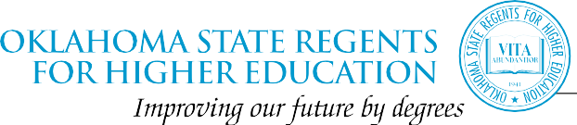



**SB550 - Out of State Authorization**

**KEY TALKING POINTS**

* Consumer protection for Oklahoma students. Permits the State Regents to develop rules and fees for operation within the state. National standard of care across the United States. Response to Corinthian College failure – bailout of approximately $58 billion.
* Assuring academic quality of private and out of state institutions. This does not include private college and universities who are OTEG approved. Please see list at the end of the document which are approved.
* Safeguards students against academic and financial loss if an institution suddenly closes.
* Regulate distance education from out-of-state institutions to comply with in-state standards.
* Multiple cases of institutions offering non-accredited degree in Oklahoma referred to Attorney General’s office. Non-responsive to inquiries from Regent’s staff. Programs are not accredited - students cannot transfer credits to any of our 2 or 4-years colleges and universities.
* Fees to operate in state are minimal. National standard is approximately $10,000.00 which is charged with application to operate within the state.
* Under current law, Oklahoma taxpayers are paying for the costs of authorization private, for profit, and out-of-state institutions.

*   Bacone College  
*   Community Care College  
*   Family of Faith Christian University  
*   Mid-America Christian University  
*   Oklahoma Baptist University  
*   Oklahoma Christian University  
*   Oklahoma City University  
*   Oklahoma Wesleyan University  
*   Oral Roberts University  
*   Randall University (formerly Hillsdale Free Will Baptist College)  
*   Southern Nazarene University  
*   Southwestern Christian University  
*   The University of Tulsa