June 26, 2026

OSRHE System Presidents

Dear Presidents:

Re: Approval of Tuition and Fees

At their meeting on June 25, 2026, the State Regents approved institutional requests for tuition and mandatory fees for resident and nonresident undergraduate, graduate, and professional programs as well as the guaranteed tuition rates for Fiscal Year 2027. Additionally, the State Regents approved requests for changes to academic services fees for Fiscal Year 2027.

Enclosed are copies of the approved tuition, mandatory fees and changes to academic service fees.

Should you have questions, please contact me at 405-225-9281 or nhathaway@osrhe.edu.

Sincerely,

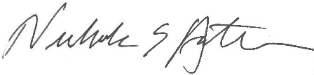
Nick Hathaway
Vice Chancellor for Budget and Finance

