Here are three draft communications (listed one per page) that need to go out this week.

Save the Date

**Subject: Save the Date - 2023 Oklahoma Higher Ed IT Summit, May 15-16**

The 2023 COIT Summit is the premier event in Oklahoma for higher education IT professionals and registration is free!

**Event: 2023 Oklahoma Higher Ed IT Summit**

**Dates: May 15th and 16th, 2023**

**Location: University of Central Oklahoma,**

**100 North University Drive, Edmond, OK 73034**

**Learn More at** <https://coitsummit.onenet.net>

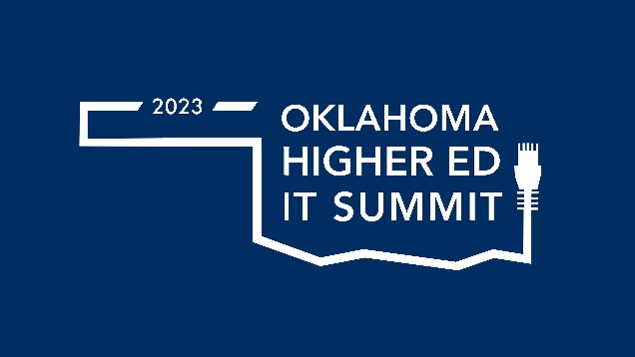

Call for Proposals

**Subject: Call for Proposals - 2023 Oklahoma Higher Ed IT Summit**

The 2023 COIT Summit is the premier event in Oklahoma for higher education IT professionals and registration is free! The agenda for this event is crafted for you and by you. There are exciting and innovative initiatives happening across the state and it is time to share your story! We are seeking IT professionals, faculty, or students to [submit a proposal](https://energyconferencenetwork.swoogo.com/itsummit/3107336) to present. **Deadline for proposals is April 10th, 2023.**

**Learn more at** <https://coitsummit.onenet.net>

**Track Descriptions:**

**Data All Over** – Share how your organization is using data to inform decision making, solutions that connect people and systems to trust data in useful formats, compelling reports and data visualization tools. Topics can include, but are not limited to, the people (organization, leadership, grassroots, literacy), processes (policy, governance, assessment, strategic planning, collaboration), and/or technologies (infrastructure, analytics, visualization, collaboration/sharing) aligned to your data strategy and best practices.

**Enterprise for the Modern Age** – Digital transformation depends on successful convergence of information systems and cloud computing infrastructure with a security posture that makes it all work across the breadth of a higher education institution (not just central IT). Modernizing infrastructures can increase agility and flexibility, bolster data protection, and encourage innovation. Topics in this track include cyber/infrastructure services and enterprise architecture/systems, as well as frameworks and strategies for securing the enterprise and business continuity.

**Putting People First** – This track focuses on the relevancy of information technology, how IT organizations socialize transformations and the critical role that IT plays in serving the needs of the entire institution. Topics include creating a modern workforce; diversity, equity, and inclusion (DEI) with OKWIT; accessibility; performance effectiveness; collaborative initiatives related to strategic institutional, vendor, research and external partnerships; process transformations; culture change; making IT more effective; measuring the journey to excellence; efficient IT service delivery and project management including agile, DevOps, and ITIL.

**Student Centered Institution** – The digital student experience affects learners across the life cycle with the institution, shaping how they are recruited, educated, retained, and engaged. How do institutional IT processes and practices enable and empower the core academic mission of teaching, learning, research, and scholarship? This track invites presentations from a range of topics including digital learning, learning technologies and space design, online and blended learning, digital credentials, research computing, accessibility and universal design, and mobile learning,

**Technology Buzz** – We will continue to see an accelerated rate of digitization and virtualization of education, business and society. What emerging technologies, innovative projects, pilots, and initiatives are moving your organization forward? Sessions in this track can include but are not limited to emerging technologies (artificial intelligence, chatbots, IoT and smart devices, virtual reality, augmented reality), innovative use of technologies, product roadmaps, and digital transformation efforts.

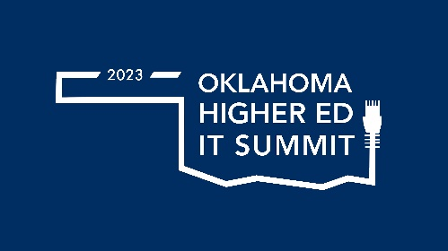

Vendor Information

**Subject: Join Us at the 2023 Oklahoma Higher Ed IT Summit**

The return of the in-person two-day COIT Summit is an annual gathering of IT leaders and professionals representing 25 Oklahoma Higher Education institutions with over $100M in combined annual technology expenditures, making it a perfect opportunity for new and existing technology partners and vendors to build and strengthen relationships within our vibrant community.

For sponsorship opportunities, please reach out to Jessica Angsomwine at Jessica.angsomwine@energyconferencenetwork.com

**2023 Oklahoma Higher Ed IT Summit**

**Dates: May 15th and 16th, 2023**

**Location: University of Central Oklahoma,**

**100 North University Drive, Edmond, OK 73034**

**Learn More:** [Oklahoma Higher Ed IT Summit](https://energyconferencenetwork.swoogo.com/ITSummit)