**Introducing…**

**Gayle Jones**

**Education Consultant**

**And Presenter**

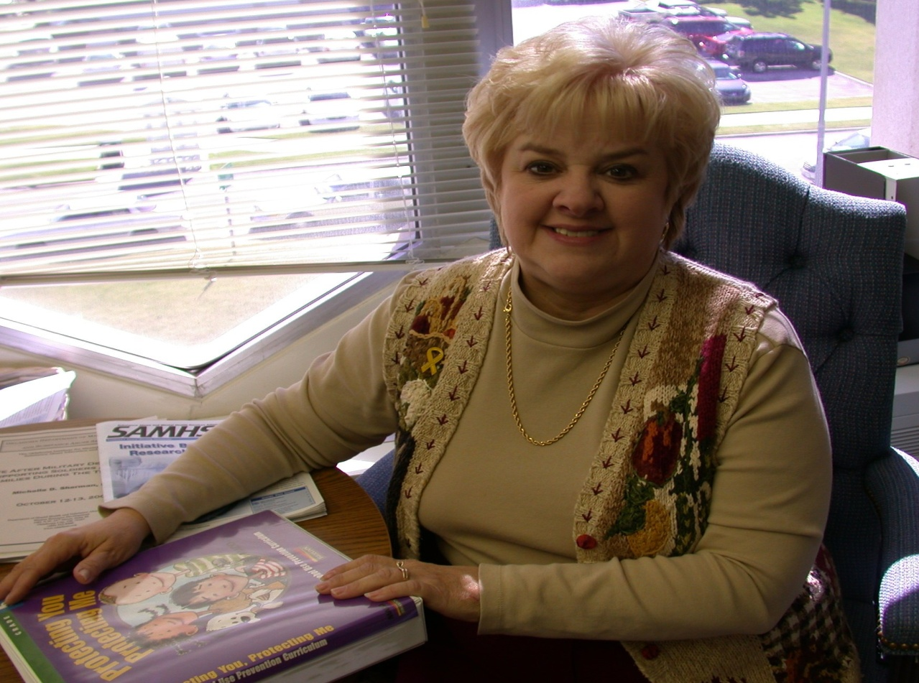

*Gayle Jones has been training staff and parents in Oklahoma schools for over fifteen years. Her years of training include the issues of violence prevention, school safety, social and emotional development and the importance of life skills. She is the former Director of Safe and Drug-Free Schools and Communities Act program (Title IV) at the Oklahoma State Department of Education. Gayle has provided technical assistance and training to school districts, nationally and locally. She welcomes the opportunity to share her information and enthusiasm with teachers, counselors, parents, law enforcement and community partners.*

*Are you seeking training for bullying prevention, stress/anger management or*

*conflict resolution for your staff and students?*

*Do you need a speaker for a parent education program or conference presenter?*

*Is it time to review essential elements for your school crisis plan,*

*reexamine your school safety strategies, and update your bullying prevention*

*and intervention policy and methods?*

Gayle offers a variety of strategies, resources, and training for staff development for educators, counselors, administrators, and support staff to ensure a safe school climate for learning. Her presentations for educators and parents include essential life skills young people need for mental, physical, and emotional well being. Workshops and presentations include:

*Peacemaker or Troublemaker?  Bullying and Cyberbullying Prevention Strategies*

*Combustible Personalities: Extinguishing the Flames of Anger*

*Keeping the Peace:  Resolving Conflicts*

*Oklahoma Laws and Policy Requirements for School Safety and Violence Prevention*

*Resilience:  A Toolkit to Bounce Back from Set Backs*

*The Parental Backpack:  Resources to Help You Raise a Savvy Child*

*When the Pressure is Tough, the Tough Make Wise Decisions*

*A Safe Place to Be Me: The Ingredients of a Safe School*

*Suicide Prevention: Identifying Early Warning Signs and What To Do*

**For more information, contact Gayle Jones at (405) 720-8480; (405) 210-9614**

**or email at** [Trainer4change@sbcglobal.net](mailto:Trainer4change@sbcglobal.net)