
Contents
Patch and Upgrade Guide
Best Practices for Self-Hosted Clients
October 12, 2010

© 2010 by Desire2Learn Incorporated. All rights reserved
About this Document
Site Unavailability
Backups
Application Server
File Server
Database Server
Scheduled Tasks

About this Document
This document provides an overview of best practices for self-hosted clients for Desire2Learn patches and upgrades. It is designed for a Desire2Learn client who self-hosts and is targeted at the System Administrator level. This document assumes a base level of Windows and SQL knowledge.
This document is valid starting with 9.1 upgrades, but can and should be applied to any previous patch/upgrade which does not have a workbook associated with it.

Site Unavailability
During a patch or upgrade it is important that your Desire2Learn website(s) be made unavailable to users.
Unless otherwise instructed, the D2L Deployment Consultant will post a maintenance message for the duration of the patch/upgrade. This will be enabled at the beginning of the upgrade window, and removed when the upgrade is signed off as complete by the D2L Deployment Consultant (often before the scheduled window is complete). This maintenance page utilizes server level IP restriction, and is applied to all Application Servers. When a user navigates to any of the applicable websites, the message will appear as follows:
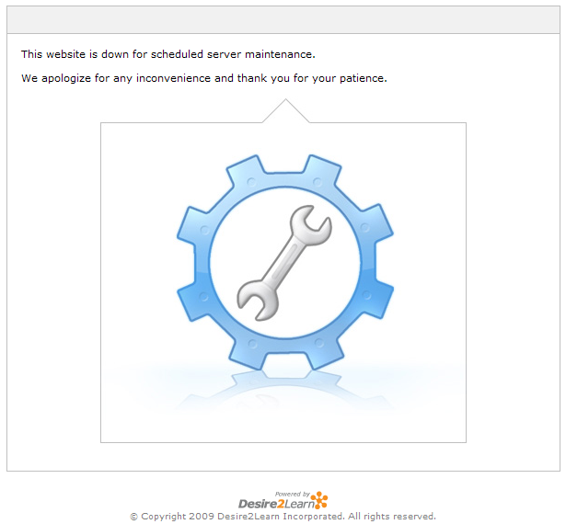
If you would prefer to use a different method of site unavailability, please inform your D2L Account Manager or D2L Project Manager of the details, and they will request that the D2L Deployment Consultant not use the standard maintenance message.
Notwithstanding the above, if the upgrade window begins and no site unavailability has been implemented, the D2L Deployment Consultant will apply the above maintenance message anyway, as it is very important access restriction be in place for the duration of the upgrade.

Backups
Self-hosted clients are responsible for performing backups of their environment before all patches and upgrades. Recent and comprehensive backups are critical to the recoverability of an environment should anything catastrophic occur during a patch or upgrade. Below are instructions for performing backups in such a way that, if necessary, the upgrade could be effectively rolled back.

Application Server
Instance directory copy – On any one Application Server, take a compressed copy of the <driveletter>:Desire2learn\Instance\<instancedirectory> folder.
IIS export – On any one Application Server, open IIS. Navigate to the “Web Sites” node and right click, All Tasks->Save Configuration to a File. Name the file, save it, and store it with the instance directory copy.

File Server
File server data is not changed during patches and upgrades. Any exceptions will be noted in this document.
Exceptions:
- During 9.1 upgrades, LOR objects that have been previously deleted are removed permanently from the file server. If concerned, a backup should be taken of \\<fileserver>\<fileshare>\web\LOR\.

Database Server
All Desire2Learn databases should undergo a backup before the upgrade begins. If there is concern about ensuring the latest user data is retained, it is highly recommended that an access restriction method be enabled before the backups are taken.
There are several different databases that may exist depending on the tools present. All should be backed up to ensure complete recoverability:
- LMS (usually named for the Instance). This is the main database.
- Reporting (usually <InstanceName>_Reporting). This database can be rebuilt, and so does not require a backup (though a backup would speed up a rollback).
- Logging (usually <InstanceName>_Logging). Exists as of 9.0.0.
- LOR (usually <InstanceName>_LOR). Exists if LOR is present.
- SIS (usually <InstanceName>_SIS or <InstanceName>_Tank). Exists if there is a Holding Tank Integration present.

Scheduled Tasks
Self-hosted clients are responsible for disabling any scheduled tasks that could conflict with the patch or upgrade process. All scheduled tasks which are related to Desire2Learn processes (for which there could be a scheduled run during the upgrade window) should be disabled. After the upgrade is complete they can be re-enabled.
Scheduled tasks will generally exist on whichever server is acting as the Utility server (which is often the first Application Server, should there be no dedicated Utility server).
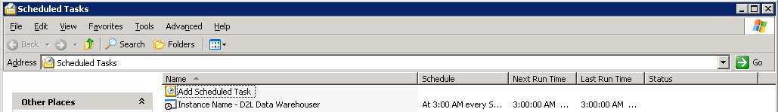
The reporting warehouser task will always exist. In addition, each of the bulk tools (BCC, BCE, BLU) can have its own scheduled task, as well as batch integration, and any custom projects.
Since most of these tasks are set to run overnight, it is unlikely they will conflict with normal day-time upgrade windows, but this should always be checked.

