

Eastern Oklahoma State College
Degree Web Audit - Students User Guide

Created by: Chris Ames
EOSC Systems Development
Overview

DegreeWorks Web Audit is a tool for students to use to help monitor your progress towards completion of a degree at Eastern Oklahoma State College. EOSC’s catalog of degree requirements are compared against your EOSC classes to give a snapshot of all your completed classes, grades and GPA’s and all classes needed to complete your degree. DegreeWorks is accessed through the internet from any computer using a web browser (Microsoft Internet Explorer recommended). Open your web browser and click on the DegreeWorks icon on the main EOSC web page (www.eosc.edu).

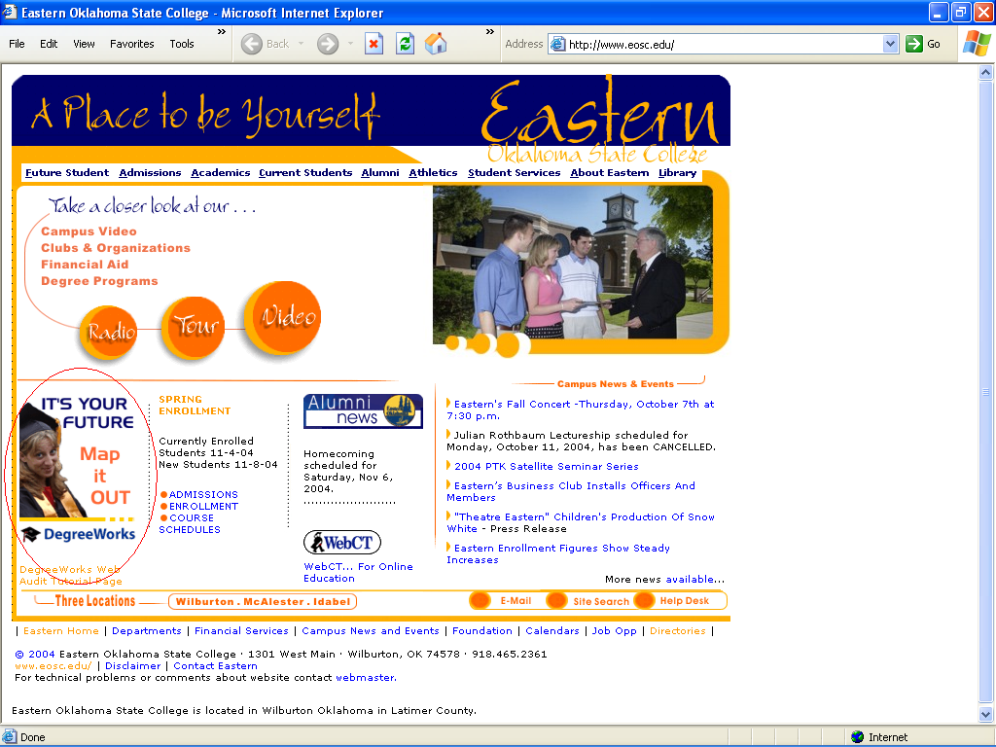

This will bring up another web page with instructions on using DegreeWorks. Click on the "LOGIN NOW" line at the top of the page to login into DegreeWorks. This will bring up this login screen.

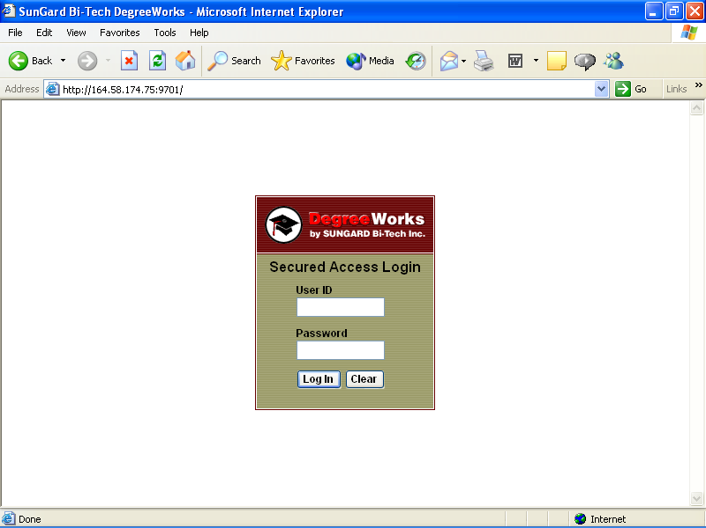

Type in your User ID and Password and click on “Log In” button. Your User ID is your first initial, middle initial and last name all combined. If you do not have a middle initial in our main database system then you should enter a blank space for your middle initial. Your password is your 4 digit PIN number that has been emailed to your EOSC email address.

Opening Page

Once you have logged in DegreeWorks will open up the following new web page.

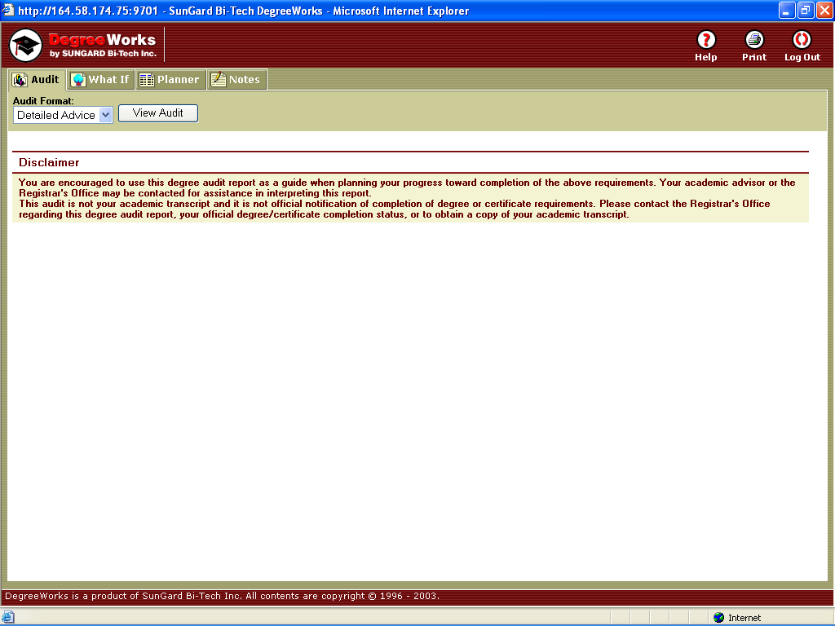

Click on the "View Audit" button to see your Degree Audit.
Audit

Click the “View Audit” button to see your audit.

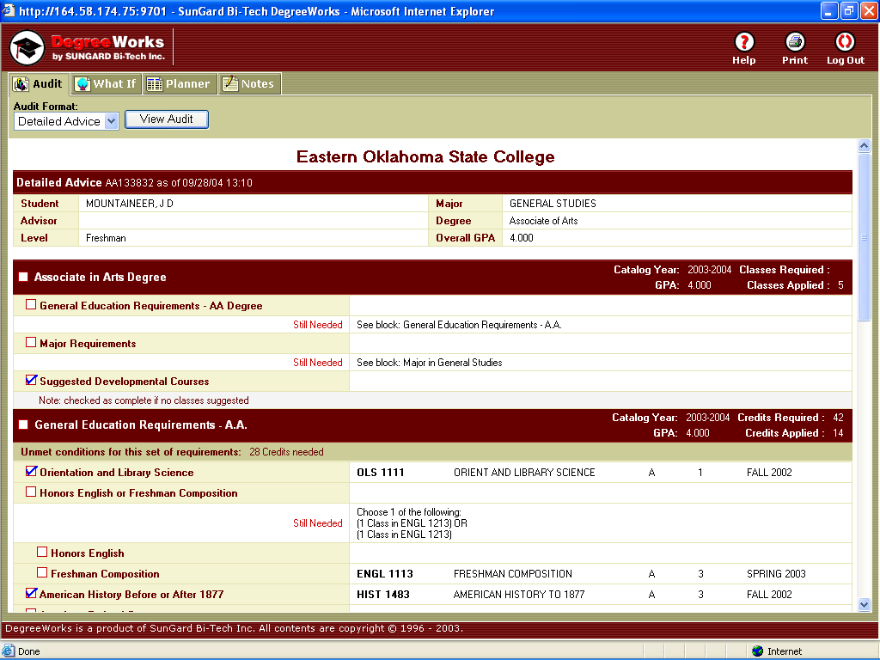

The audit presents a summary paragraph of your total credits, your GPA (overall and within your major) followed by a check sheet of the requirements for your degree. After the degree checklist there is a listing of all Elective courses. This list includes all classes that you have completed that do not fall into a specific requirement for your major or G.E. requirements. Note: This list will also include all Advisor Approved Electives (if applicable to your major). Please consult your Advisor as to which classes listed in your Electives sections can be used to fulfill any Advisor Approved Electives requirements. At the bottom of the audit is a list of your current in-progress classes. To print a copy of your audit click on the “Print” button in the upper right hand corner.
You can choose from one of four sections: “Audit”, “What If”, “Planner” or “Notes” by clicking on that tab.

What If
The “What If” tab allows you to generate a degree audit based upon what if you changed your major or degree path. This can be used to explore different degree paths at Eastern. Select a new major from the drop down boxes and click on the “Process Audit” button to generate new audit. By default, new audits include in-progress and pre-registered classes. If you would like to exclude either of these two groups in an audit then uncheck their checkbox by clicking on their green check mark before clicking on the Process Audit button.

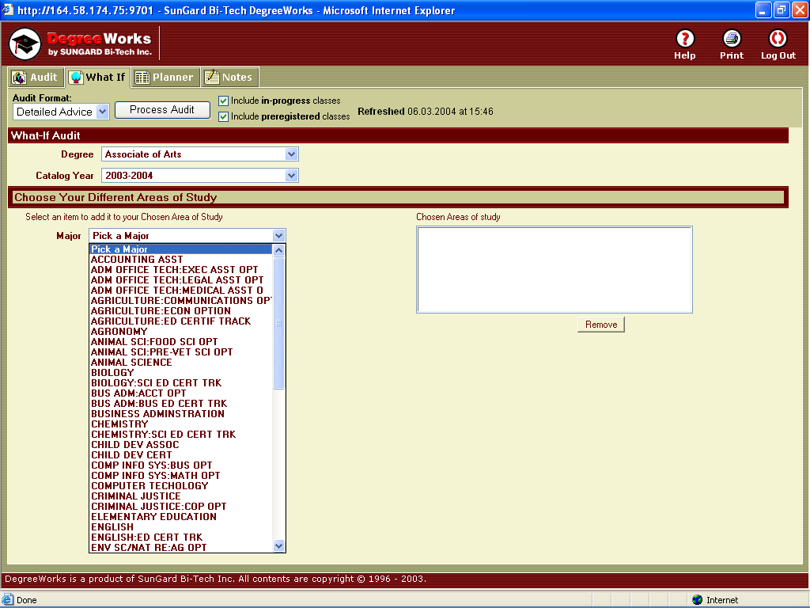
Planner

The Planner tab provides a place for your Advisor and you to plan out your future semester schedules. All work saved in the degree planner is stored along with your degree audits.

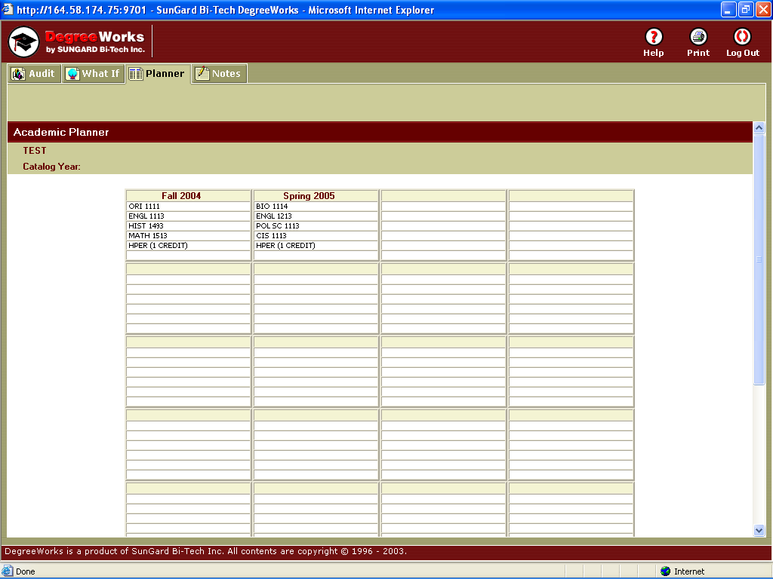

Logging Out

Once you have finished using Web Audit you should log out by clicking the “Log Out” icon in the upper right hand corner of the page and then close your web browser.

If you have any questions and/or comments about this system please contact Chris Ames at extension 747.

