6 pm

BATTLE OF THE BANDS

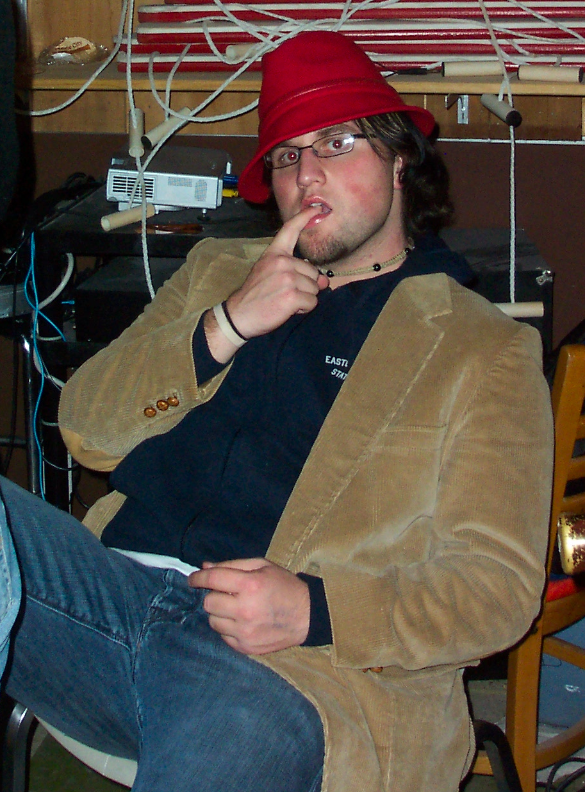
Featuring:

Kyle Williams

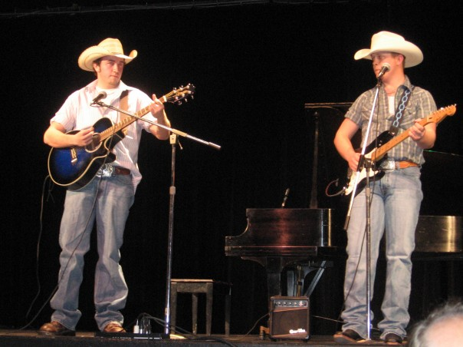
Eastern Idols:
Justin Eubanks &
Jason Stringfellow

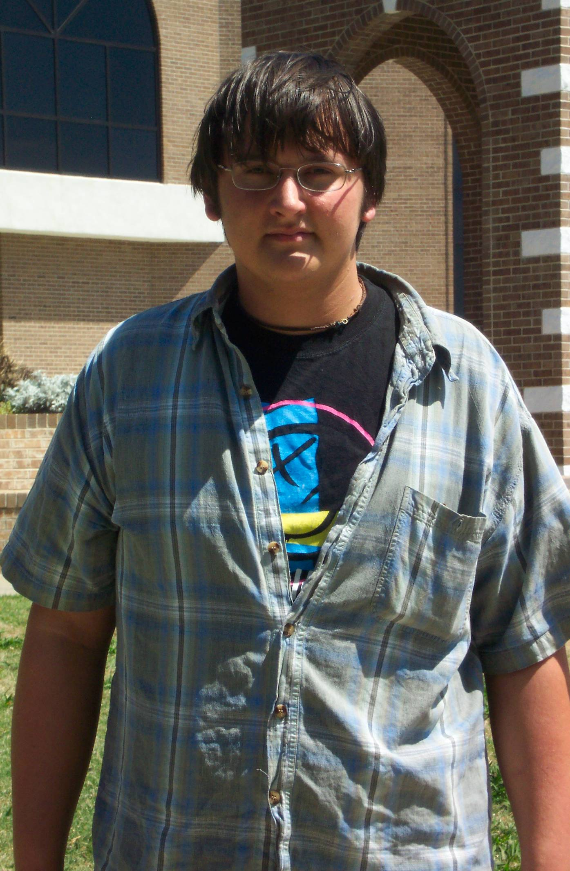

James Guess

cash door prizes

L I B R A R Y L A W N

