Steven Akins’ Scotland & England Tour
Tour Center ID: Akins-2432
May 13-21, 2009 from Dallas
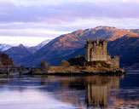
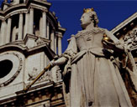
PRICE BREAKDOWN FOR STUDENTS:
Tour Fee $1824
Lifetime Membership Fee $95
Airport Fees and Surcharges $439
STUDENT TOTAL FEE $2358

Added Adult fees (age 23 & up) $335
Optionals
Windsor Castle excursion $75
Stonehenge & Bath excursion $110

Tour Itinerary:

Day 1 Start Tour
Day 2 Hello Highlands
Travel to Highlands via Loch Lomond

Day 3 Glencoe and Loch Ness
Glencoe and Loch Ness excursion

Loch Ness Monster Exhibition visit, Culloden Moor

Day 4 Highlands--Edinburgh
Travel to Edinburgh via the Trossachs

Stirling Castle visit

Day 5 Edinburgh Landmarks
Edinburgh guided sightseeing tour

Royal Mile, Old Town, Sir Walter Scott Monument

Edinburgh Castle

Edinburgh city walk

Charlotte Square, Alexander Graham Bell’s home, Robert Louis Stevenson’s home, Robert Burns Monument

Optional Scottish folklore show $95

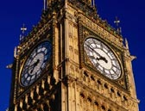
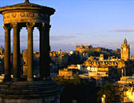

Day 6 Edinburgh--London
Fly to London

London city walk

Thames River, Trafalgar Square, National Gallery Visit, Piccadilly Circus, Covent Garden, Leicester Square, Soho

Fish & chips dinner

Day 7 London Landmarks
London guided sightseeing tour

Buckingham Palace, Big Ben, Houses of Parliament, Westminster Abbey, Tower Bridge, Hyde Park, St. Paul’s Cathedral

Optional Windsor Castle guided excursion $75

Day 8 Stonehenge & Bath
Optional Stonehenge & Bath excursion $110

Dinner at Hard Rock Café

Day 9 End Tour

Register Online:
www.myexplorica.com

