
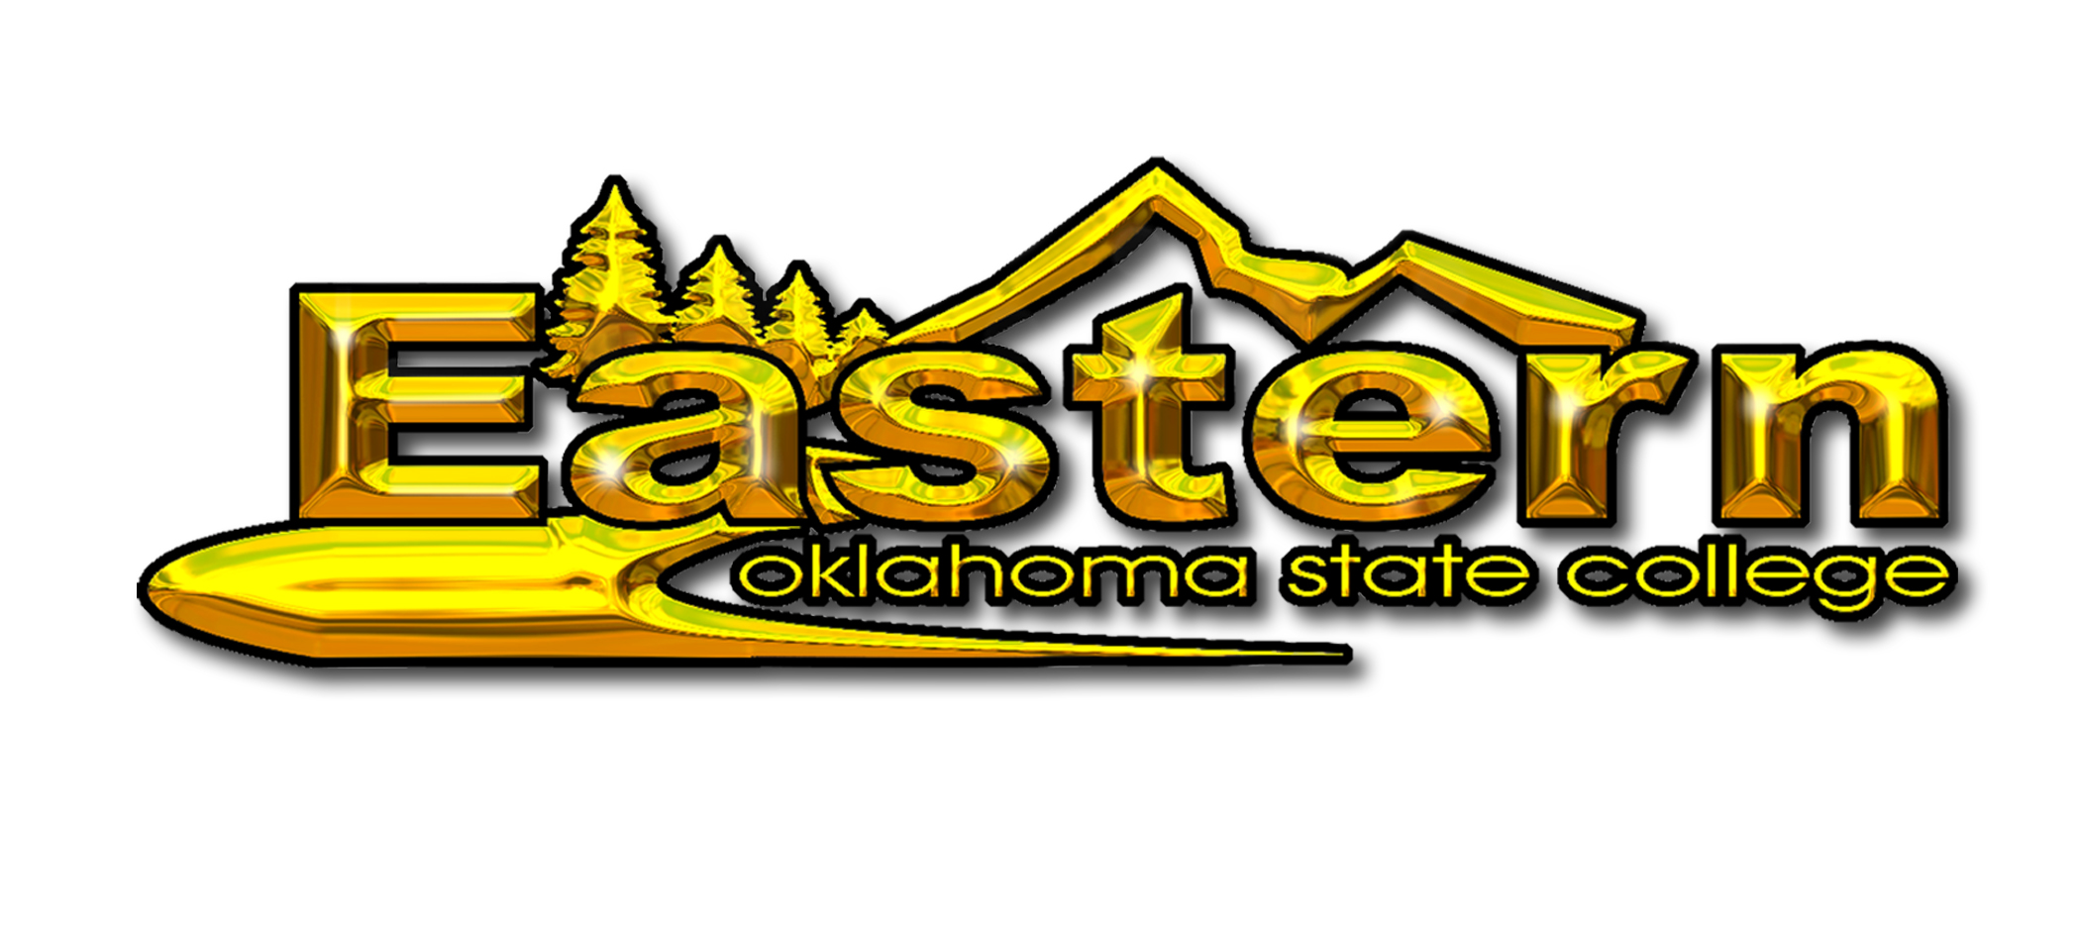
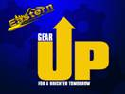

Dear Community Leader,

Eastern Oklahoma State College, GEAR UP for a Brighter Tomorrow, Kiamichi Technology Center, The City of McAlester, MEDS, McAlester Regional Health Center and the Choctaw Nation are preparing for the 2nd Annual Career & College Tour at the Southeast EXPO Center on October 30, 2008. The inaugural event was one of the largest student-centered events in our area, bringing together over 85 exhibitors, more than one hundred volunteers, 26 school districts, and almost 1,000 8th grade students!

The Career & College Tour is taking a hands-on approach to exposing our youth, during a critical stage in their development, to the opportunities awaiting them if they stay in school, make good grades, stay out of trouble, and say no to drugs and alcohol. The impact of this event on student success and future workforce development will be great. With the 2nd Annual Career & College Tour, we expect to educate over 1,000 8th grade students from 33 area schools on the opportunities for education, employment and careers in our area. The very popular “College Road Trip” program is returning, as is the Career and College EXPO. Our objective is to get these 8th graders thinking about how their choices today impact the rest of their lives.

The Career & College Tour partners are working for the future of our youth and for the economic development of our area. We hope you share our dream of preparing our youth for the future and keeping them in our area. One step in doing this is to help us educate these students on the career opportunities available here in our communities. Please join us as a volunteer “tour guide” by completing the attached Volunteer Commitment Form.

Sincerely,

Nicole George Cook
Education Coordinator
GEAR UP for a Brighter Tomorrow
Eastern Oklahoma State College
office 918.302.3640
fax 918.426.1606
ncook@eosc.edu

