Eastern Oklahoma State College
Student Registration
www.eosc.edu

- Click on the WebAdvisor icon on Eastern’s main web page at http://www.eosc.edu.
- Click on login. Put in your User Id and password. If you don’t know what your User Id/Password are, please review this link: http://www.eosc.edu/academic/webadvisor_faq.html
- Click on Express Registration. (for initial enrollment do not use Register and Drop Sections)

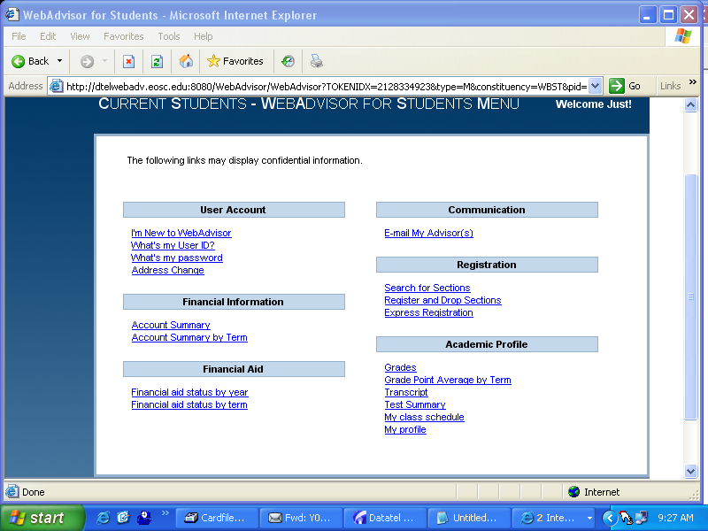

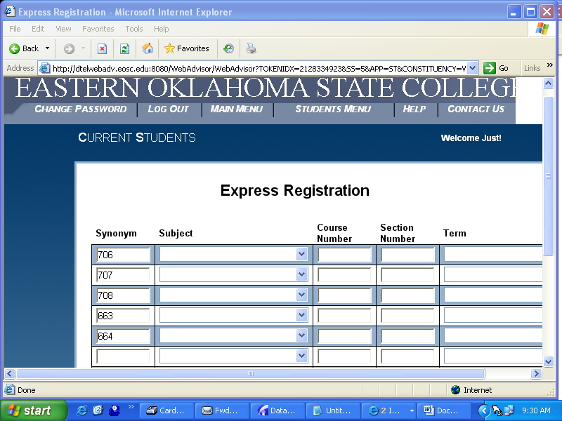

- On the Express Registration Screen, input the class Synonym number for each class you wish to enroll in. This is the number in parenthesis on the Search for Sections screen.
- If you use the Synonym number for the class no other fields are required on this screen.
- Click Submit

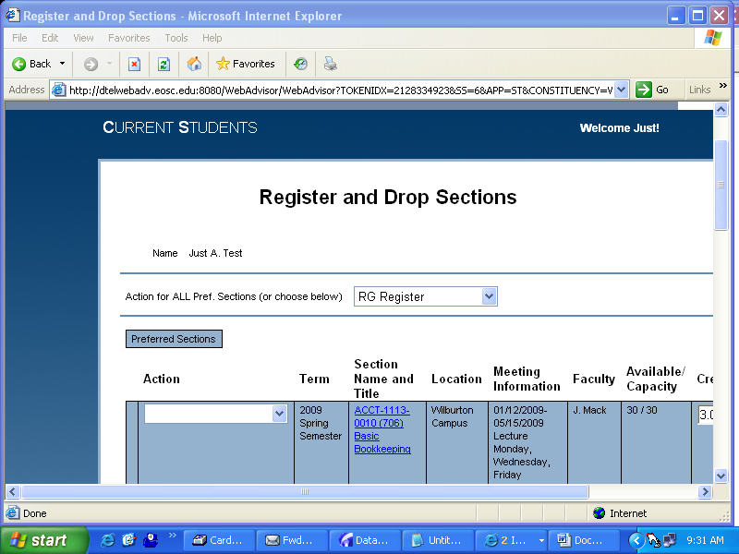

- On the Register and Drop Sections screen, Select RG Register for all classes. Or, select Register from the Action drop down box located by each class for each class you wish to enroll in.
- Click Submit.

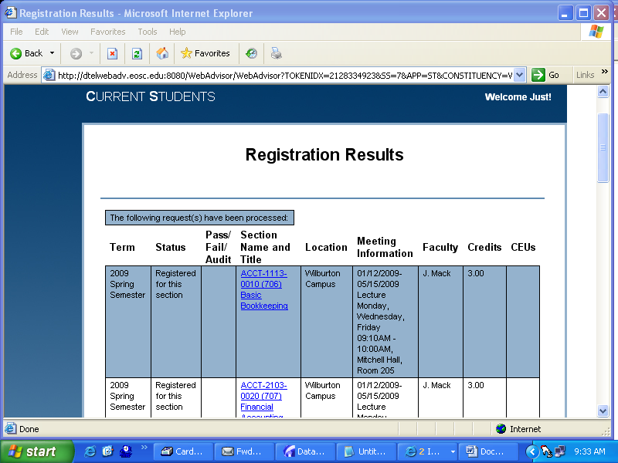

- Please review the Registration Results screen for accuracy. If there are errors in your enrollment, please review and take appropriate actions. Example: Class is closed, then you would have to set the Action for that class to “Remove from list” and find another course. Then set the action for the other classes to Register.

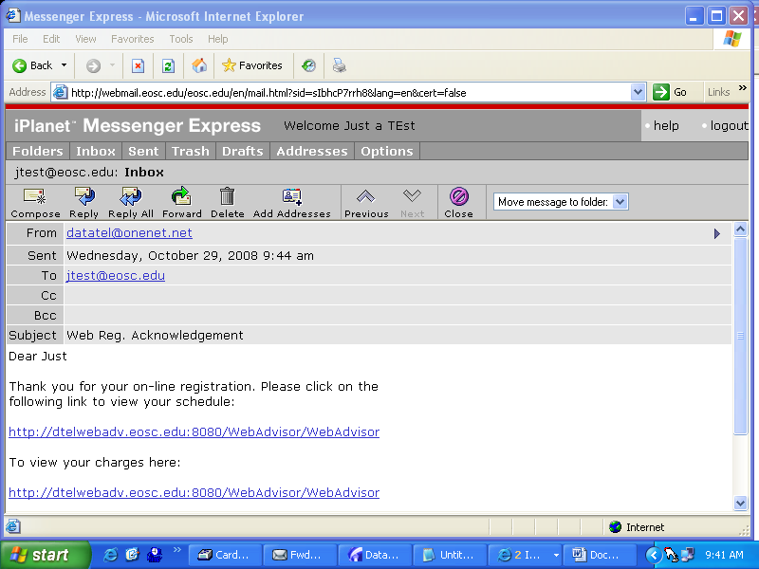

Upon successful registration an e-mail will be sent to your Eastern e-mail account indicating the results of your registration.

Thank you for enrolling at Eastern!

Attention Students

If you have any holds on your enrollment, please contact the appropriate office.

Business Office holds: 918.465.1708 or 918.465.1776
Registrar holds: 918.465.1828
Financial Aid holds: 918.465.1771
Student Services holds: 918.465.1818

For technical problems with WebAdvisor, please call: 918.465.1750 or 918.465.1749

If you can not enroll because of the following issues, please contact the Registrar’s office at 918.465.1828.

- Suspended
- Wrong Student Type
- No Residency Code
- No SSN on file
- No Student Type (Billing Type)
- No Valid Student Program
- Pre- requisite issues

