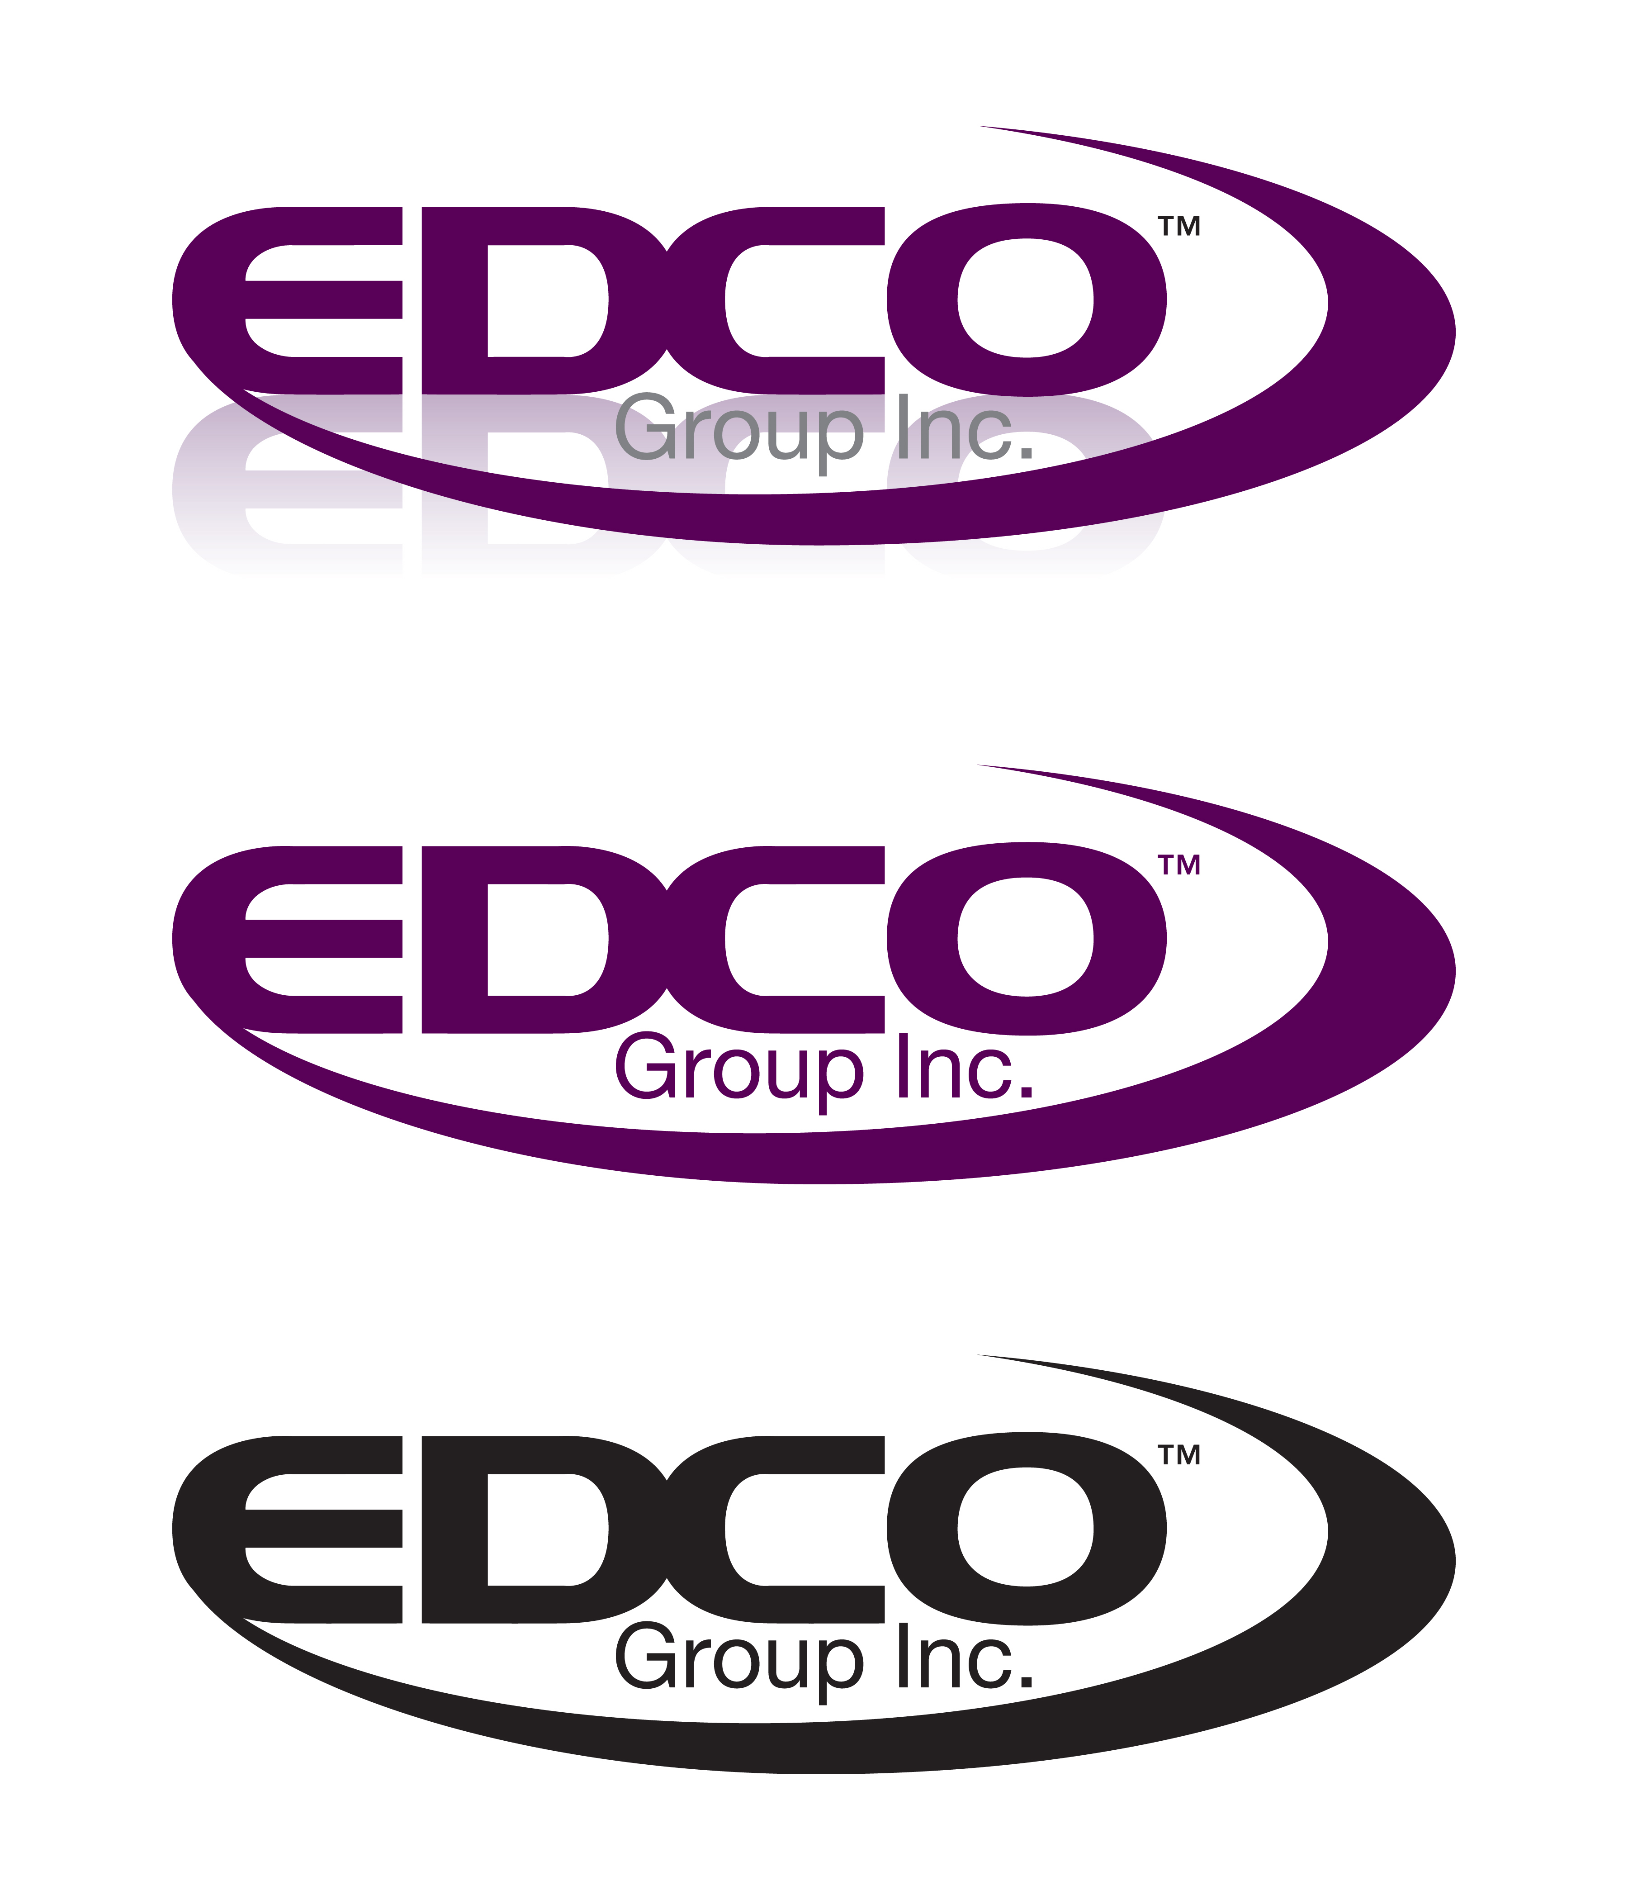

Job Posting:

Edco Group Inc is currently seeking part time help for the following :

Industry:Computer Software, Healthcare-Health Services

Manages Others:No

Job Type:Admin-Clerical, Entry Level,General Labor

Experience: Not Specified

Post Date:9/3/2010

Description: EDCO Group,Inc. is currently seeking Document Specialist to fill evening and weekend shifts. This position is responsible for preparing and scanning medical records in a production setting.

Requirements: A clerical or production background is preferable, but not required.This position requires ability to work in a team environment,work quickly and efficiently, and absorb new ideas.This position also requires high self-motivation and goal orientation.

Job Location: McAlester Hospital
McAlester OK

Contact Information:Tammy Joy
Edco Group Inc.
Springfield Mo
417-447-3395
tjoy@edcogroupinc.com

