Halloween Week Activities

**ALL WEEK: HUMAN VS. ZOMBIES**

Tuesday, Oct. 28th

Haunted Walk (sponsored by Honors)

In the woods behind Miller

@ 7:30pm

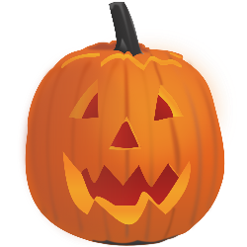Wednesday, Oct. 29th   
Pumpkin Carving/Decorating Contest (BYOPumpkin)  
@ 6:30pm in Amphitheatre   
**WIN PRIZES**!

Thursday, Oct. 30th

4:30pm – 6:30pm Halloween Carnival & Trunk or Treat

7:00pm – Halloween Dance in Ballroom

Friday, Oct. 31st

