First Basketball home game November 2

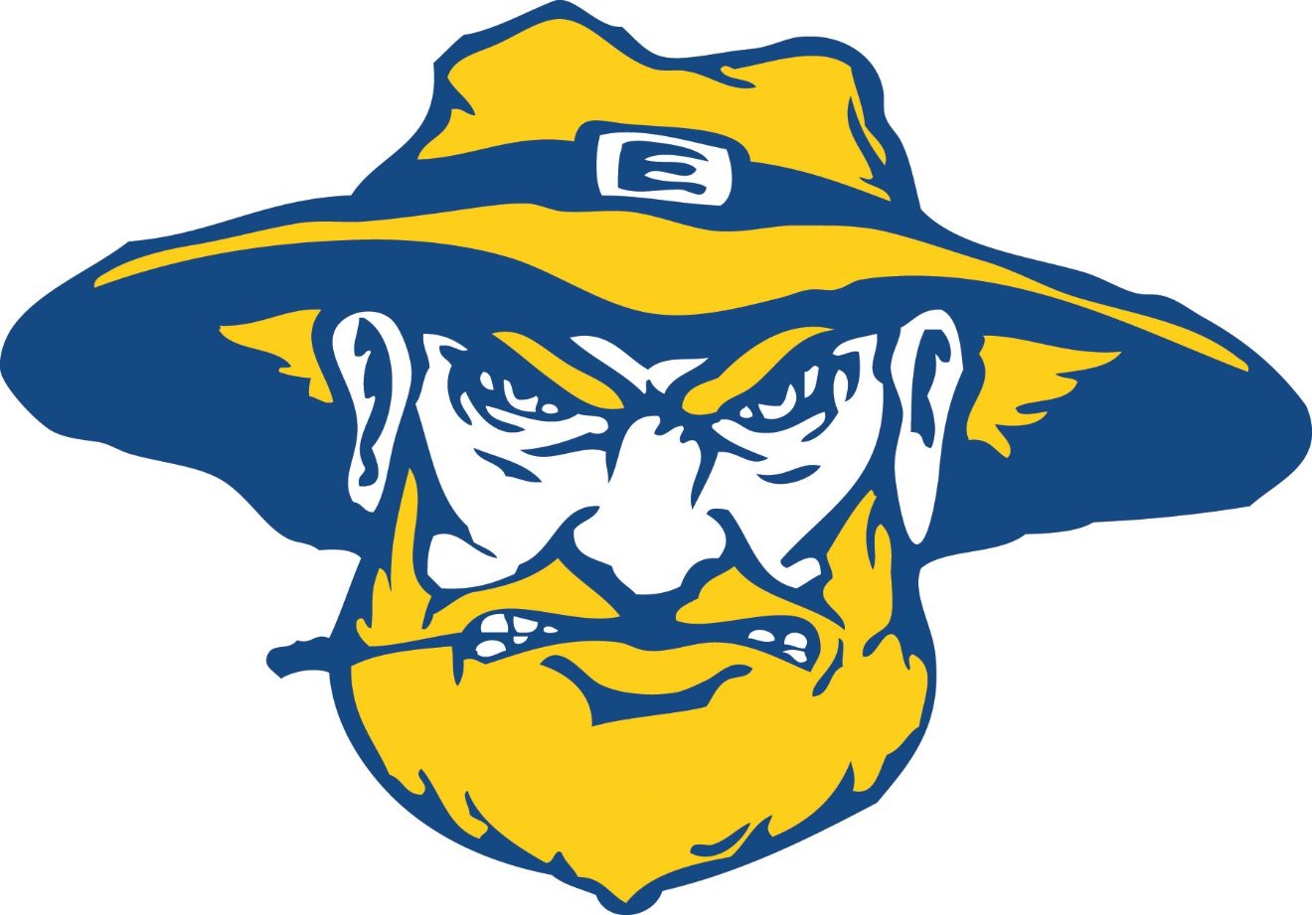

Women @ 6pm

Men @ 8pm

Free pizza for first 50 people

Prizes and Candy