|  |  |  |
| --- | --- | --- |
| **TIME** | **NAME** | **PHONE** |
| **9 AM** | TAKEN |  |
| **10 AM** | TAKEN |  |
| **11 AM** |  |  |
| **12 PM** |  |  |
| **1 PM** |  |  |
| **2 PM** |  |  |
| **3 PM** |  |  |

**Need help filing FAFSA? Sign up for an appointment time and an EOC Advisor will help.**

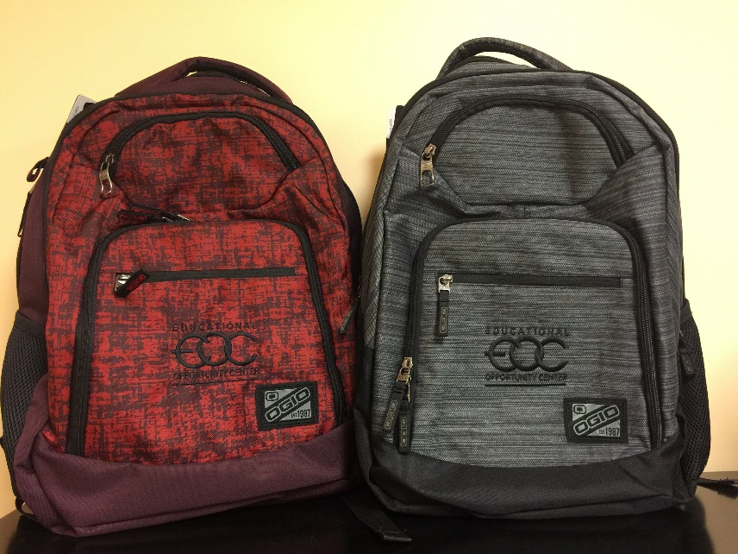

**VISIT LAURA SMITH IN EOSC ENROLLMENT CENTER TO FILE YOUR FAFSA**

**AND RECEIVE FREE BACKPACK!!**