* Click “**Textbooks**”
* Select “**Order Textbooks**”
* Verify the correct **Term** is selected
  + *Summer I & II may be listed together*

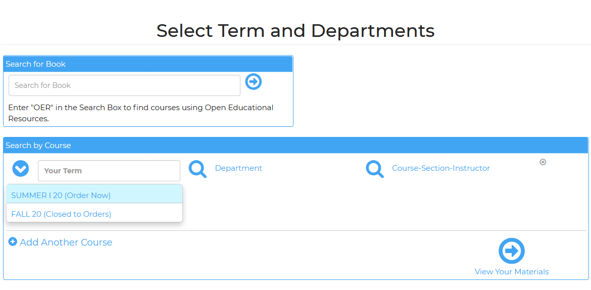

* Select **Dept** as it appears on your schedule (ie: ENGL, BIOL, ECON)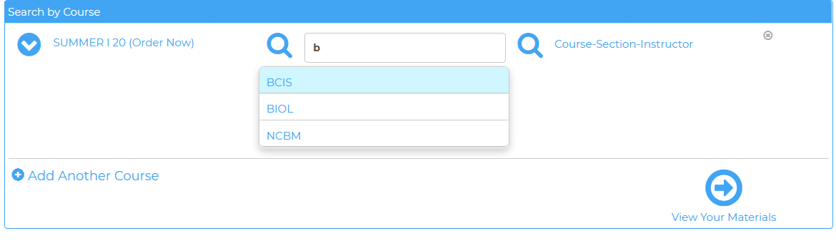
* Select the correct section from the drop down menu under “**course - section - instructor**” as it appears on your schedule.
  + *Sections may be grouped together*
  + *ie: BIOL 2301.0024 is listed as “2301 - 14/24/34” or Section 104 may be listed as “101 thru 107”*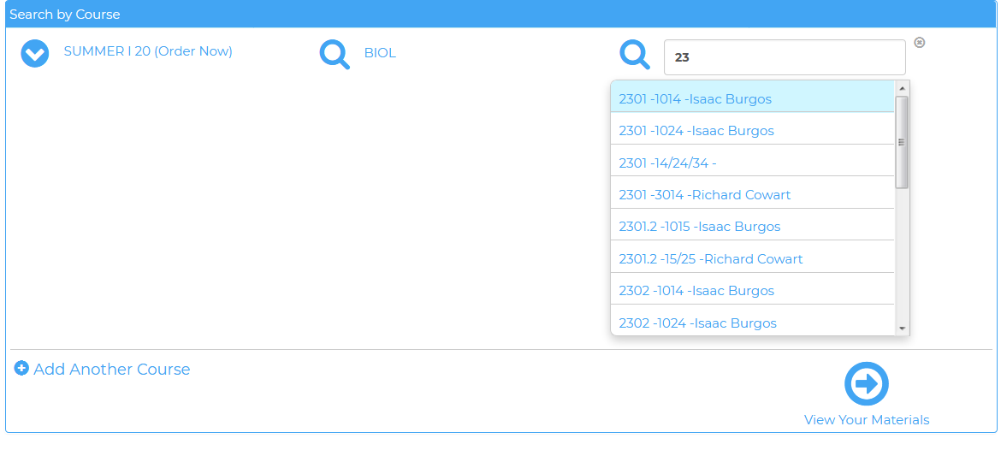

***Continue this process until all courses have been added.***

* Scroll to bottom of page and click “**View Your Materials**”
* Select item(s) and click “**Add to Cart**” - See Book Notes for any additional information.
  + *Options will be labeled Required, Optional Format, Recommended, etc.*
  + *Rentals will* ***require*** *a Credit Card at checkout, even if paying with Financial Aid*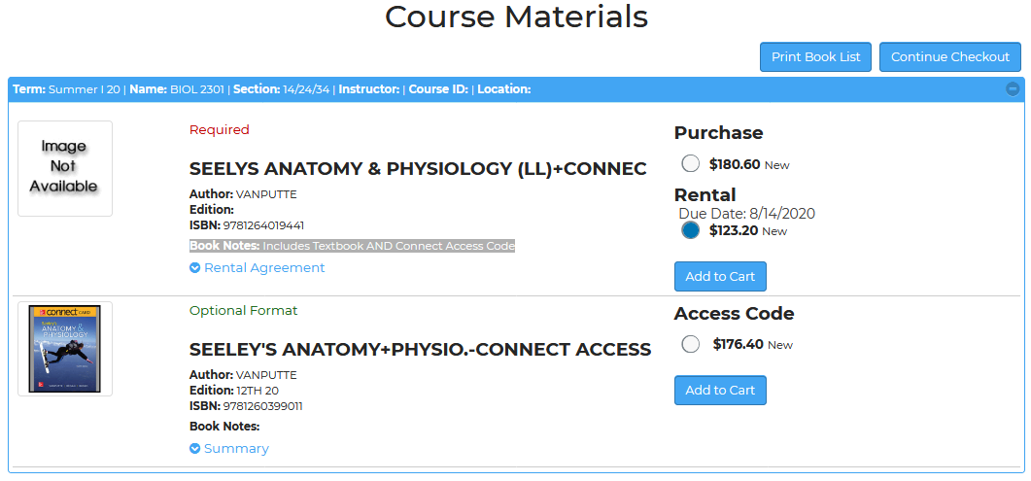
* Once items for each course have been added to cart click “**Continue Checkout**”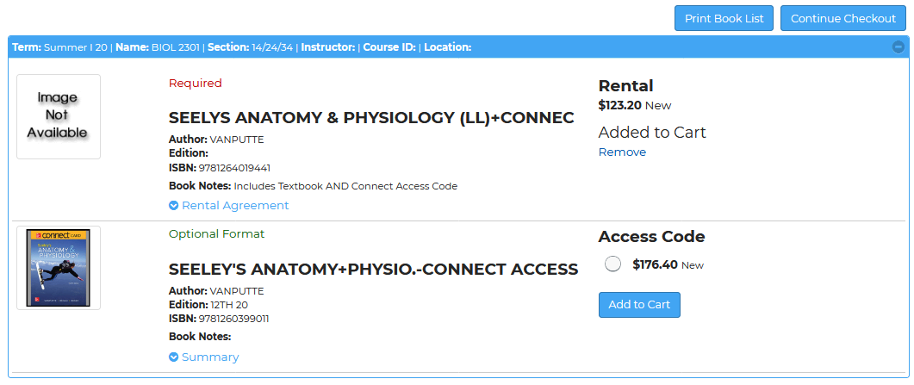
* Review Cart and click “**Continue Checkout**”

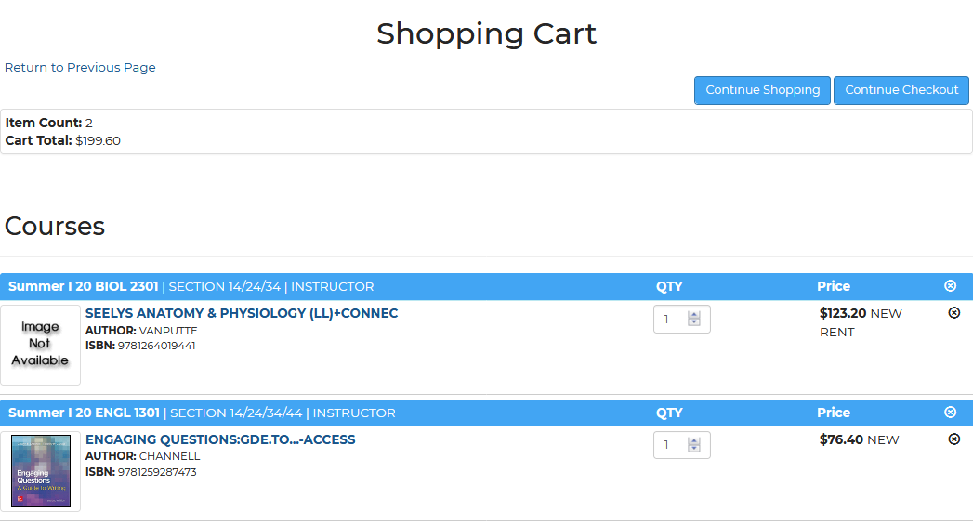

* Answer each prompt pop-up & click **Continue**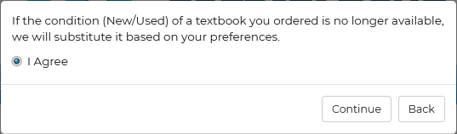

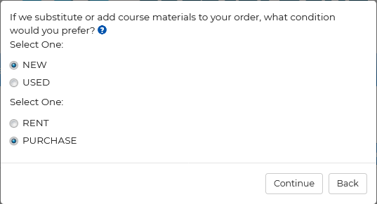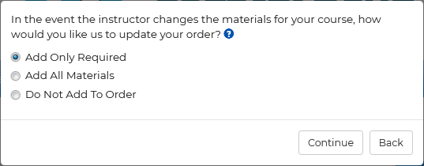

* Verify & Click “**Payment Options**” 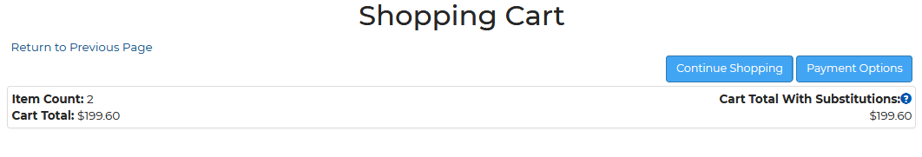
* You will be prompted to **login** or check out as a guest.
  + *If using Financial Aid, you will need to sign in or create an account****\*FA not allowed on guest orders.***
  + *If using a credit card, you may sign in or check out as a guest.*
  + *Guests will still need to enter a valid e-mail address.*

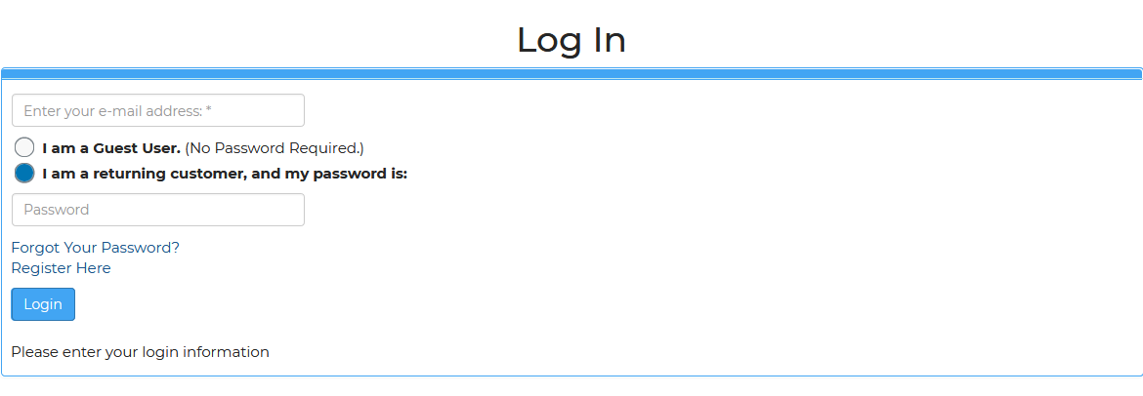

* Select **Pick-Up Order** or **Ship Order**

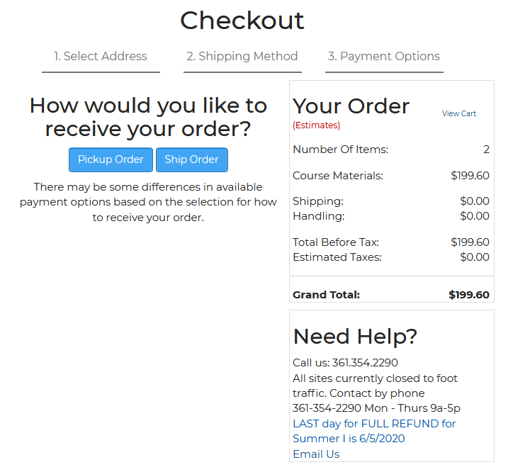

* Verify **Billing** and **Shipping** Address & Click **Continue**
  + *If using a Credit Card, the billing address* ***MUST*** *match the billing address on your card.*

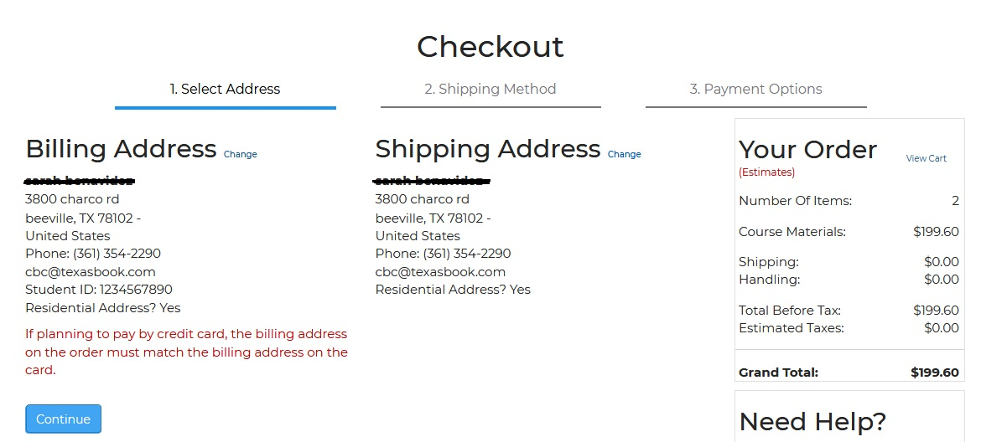

* Verify Shipping Method & click **Continue**
* Enter **Promo Code** (if any) & choose **Payment Option** from the drop down menu
  + *If using Financial Aid, enter acct # as instructed for your campus bookstore*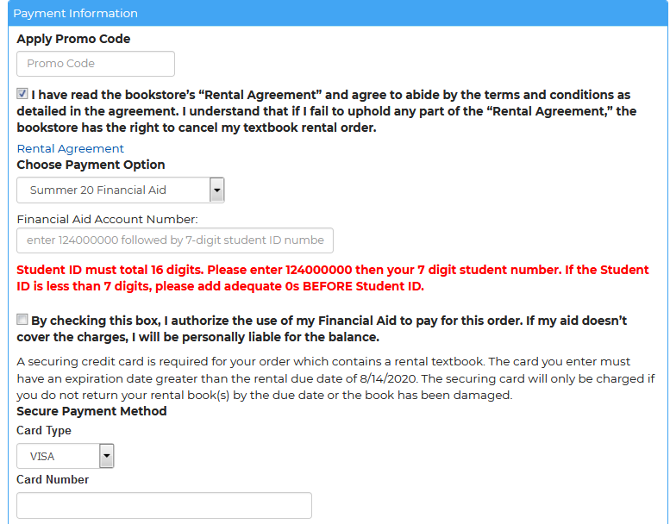
* Fill out **Payment Info** 
  + **If Rentals selected:**
    - *click* ***Rental Agreement*** *to read your bookstores rental terms. Then check the box agreeing to the Rental Agreement.*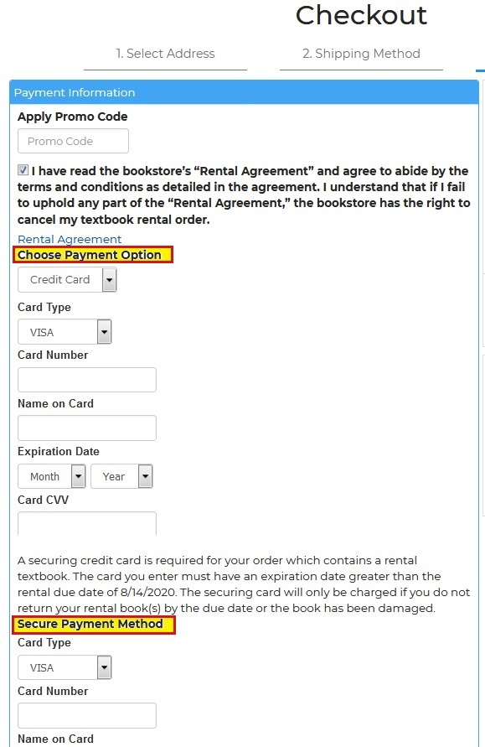
    - *it will also require* ***Securing Credit Card*** *Info*
* Any special instructions or notes can be added on **Payment Information** screen in the   
  “**Order Comments**” box.
* Click **Submit Payment**

**Your order will then be submitted & you will receive an “Order Confirmation” e-mail.**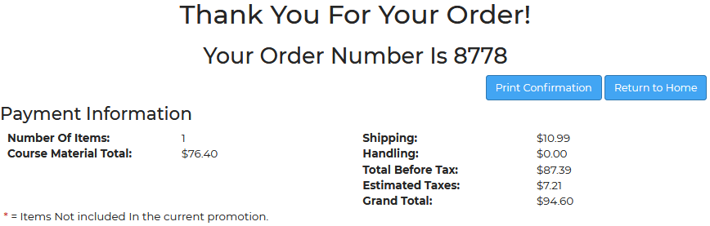

**If using Financial Aid, your order has to go through a process before**

**it can be ran through the register and added to your account.**