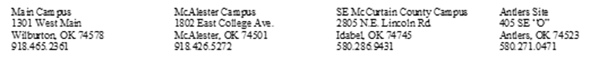

**2022-2023 William P. Willis Scholarship________**

**Deadline: June 30th, 2022 at 5:00PM**

$2000.00 scholarship for low-income, full-time students ($1000.00 fall / $1000.00 spring). To be eligible, students must meet the following requirements: have an effective income of $32,000 or less per year, be an Oklahoma resident, be a full-time undergraduate student, and be making satisfactory academic progress. You must also complete a 2022-23 FAFSA so income can be verified.

Final Four of Social Security Number: ­­­­­_______________ Student ID #: ________________

Last Name: ______________________ First Name: _____________________ MI: _______

Address: ____________________________________________________________________

City: _________________________ State: _________________ Zip: __________________

Telephone: *_*______________________________ DOB: _____________________________

College GPA: ______________________ Major: ___________________________________

Have you received any degree (A.A., B.A., etc.) from a college or university: Yes____ No____

On campus clubs, activities, and/or community service involvement: ______________________________________________________________________________________________________________________________________________________________________________________________________________________________________________________________________________

Briefly explain how this scholarship would benefit you: __________________________________________________________________________________________________________________________________________________________________________________________________________________________________________________________________________________________________________________________________________________________________________________________________________________________________________________________________

Signature: _______________________________________ Date: _______________________