FACULTY DEVELOPMENT
TOPIC: Healthy Eating for Academic Success

Presentation Date | Time Available
Wednesday, September 17, 2014 | 11:00 a.m. – 12:00 p.m. Gandy Hall 108

Ahondju Umadjela Holmes, MS, RD/LD
Faculty – Public Health Program
School of Nursing and Health Professions
Room 229, extension 2910
aumadjela@langston.edu

TOPIC: Healthy Eating for Academic Success

Synopsis

Research shows that a relationship exists between overall well-being and academic success. Although well-being is a general term that indicates a state of being healthy, happy, or successful (Merriam-Webster Online, 2014), there are some steps that need to be taken in order to be healthy, happy, or successful. One of the most important steps is healthy nutrition. Healthy nutrition contributes to a person’s well-being because you are what you eat. This presentation will provide practical healthy eating tips for academic success.

Reference:
Merriam-Webster Online, 2014. Wellbeing. Retrieved from http://www.merriam-webster.com/dictionary/well-being

Suggested Items for participants:

- Nutrition and Wellness - Good Health Value Basket available at
Positive Promotion, phone 18006352666, Fax 1800-635-2329
Website: http://www.positivepromotions.com/good-health-value-basket/p/nt-874/
The basket contains an assortment of the following nutrition topics (there are 50 items per topic): Fast Food Nutrition Guides; Easy Brown Bag Lunches Pocket Pals; 101 Healthy Snacks Bookmarks; Eating Smart for Busy People Slide guides; and 100 Eat for Good Health Pencils
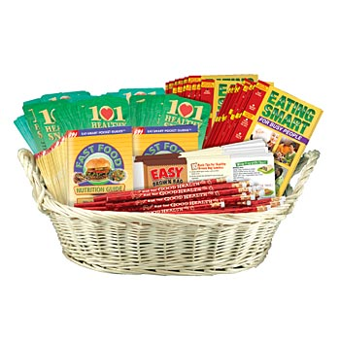
OR
- Breakfast Basic Handouts (Tablets of 50) – Available at
Learning Zone Express, phone 888-455-7003 (toll free) or 507-455-9076’ Fax 507-455-3380
Website: http://www.learningzonexpress.com/p-627-breakfast-basics-handouts-tablet-of-50.aspx
OR
- Sugar ShockersTM handouts (50 sheets) Available at
Learning Zone Express, phone 888-455-7003 (toll free) or 507-455-9076’ Fax 507-455-3380
Website: http://www.learningzonexpress.com/p-1618-sugar-shockers-handouts-tablet-of-50.aspx s

