**PROGRAM DIRECTOR**

**&**

**VOLUNTEER TRAINING**

**The Massey Building**

**200 W. Main | Durant, OK 74701**

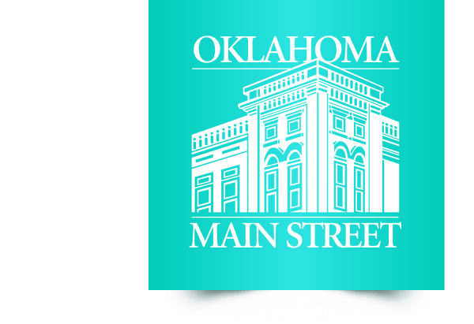  
  
AGENDA  
November 7-9, 2017

***Tuesday, November 7, 2017***

1:30 p.m. Welcome and State of the State Program

*Buffy Hughes, Oklahoma Main Street Director*

1:45 “Diagnosing Your District: A Toolkit for Keeping Your Businesses Fit"

*Amy Meadows*

2:45 Break

3:00 Administering the Survey/Q and A

*Amy Meadows*

4:00 Roundtable Discussion

5 – 8 p.m. Durant Main Street Event: Live Local Night: “Build Your Own Downtown Night Out!”

***Wednesday, November 8, 2017***

9:30 a.m. "Made You Look: Eye-catching, Sales-driving Visual Merchandising Strategies"

*Amy Meadows*

10:30 Secret Shopper / Social Media Survey / Lunch

1:30 p.m. Operation Refresh Overview

2:30 Retail Boot Camp: Operation Refresh

4:30 Adjourn / Discovery Time

5:30 Reception - TBA

*continued on back …*

***Thursday, November 9, 2017***

8:30 How to Survive in an Amazon / Online World

*Barbara Wold*

10:00 Break

10:15 Amazon/Online World (cont’d)

11:30 Awards

*Jeremy Zeller & Kelli Yadon*

12:00 p.m. Adjourn