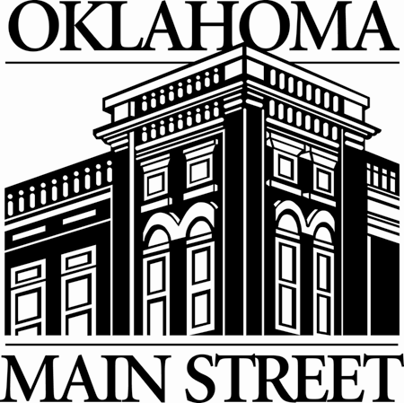
Oklahoma Main Street Center
2018 Calendar
January
- New Year’s Holiday – Main Street Office Closed
5 Applications Due for New Towns
11 Advisory Board Meeting
15 Martin Luther King, Jr. Day – Main Street Office Closed
26 Award Nominations Due – 5:00 p.m. in house Commerce Oklahoma City
February
9 New Town Judging Commerce Oklahoma City
19 President’s Day – Main Street Office Closed
20-23 Awards Judging Commerce Oklahoma City
March
1 Top 3 Awards Announced Commerce Oklahoma City
26-28 National Main Street Conference Kansas City, MO

April
12 Advisory Board Meeting Commerce Oklahoma City
27 New Town Announced
May
8 Main Street Awards Banquet Oklahoma City
28 Memorial Day – Main Street Office Closed
June
6-8 30th Annual Statewide Preservation Conference Tulsa
19-20 New Town/New Director Training Oklahoma City
July

4 Independence Day – Main Street Office Closed
9-13 New Town Committee and Work Plan Training
12 Advisory Board Meeting Commerce Oklahoma City
20 Annual Agreements, Work Plans & Surveys Due Commerce Oklahoma City
August
7-9 Program Director/Volunteer Training Guymon, OK
10 New Town Work Plans Due
September
3 Labor Day – Main Street Office Closed
11-13 Application Workshop for Prospective Communities OML Conference Oklahoma City
October
11 Advisory Board Meeting Commerce Oklahoma City
November
6-8 Program Director/Volunteer Training Muskogee, OK
12 Veteran’s Day – Main Street Office Closed
13-16 National Preservation Conference San Francisco, CA
16 Letters of Intent from Prospective Communities Commerce Oklahoma City
22 -23 Thanksgiving – Main Street Office Closed
December
6-7 Staff Retreat TBA Oklahoma City
24-25 Christmas – Main Street Office Closed Happy Holidays!

Bold items indicate mandatory activities for program directors and/or community representatives.

