## A picture containing text, clipart AI-generated content may be incorrect.NEW Oklahoma Commerce Portal Registration Instructions

1. Clicking on portal registration link you received in your email (Check Spam) will open the following in your web browser. Email will come from **SVC_D365-ODOC@agency.ok.gov**
2. Leave the “**I have an existing account**” unchecked- Click **Register**

1. Click **User Signup/Login**

1. Graphical user interface, text, application

   AI-generated content may be incorrect.Select “Sign up now”
2. Enter Email Address and select **Send Validation**
3. Retrieve and enter the Validation Code from the email you provided. Once you select Verify Code, complete the remainder of the form with password information and First/Last Name and select **Create**. This will take you to the Profile page to complete the registration process

1. Select your Name at the top right corner and select **Profile**.

1. Complete the **User** **Profile** page (Select Main Street) and select **Submit**.

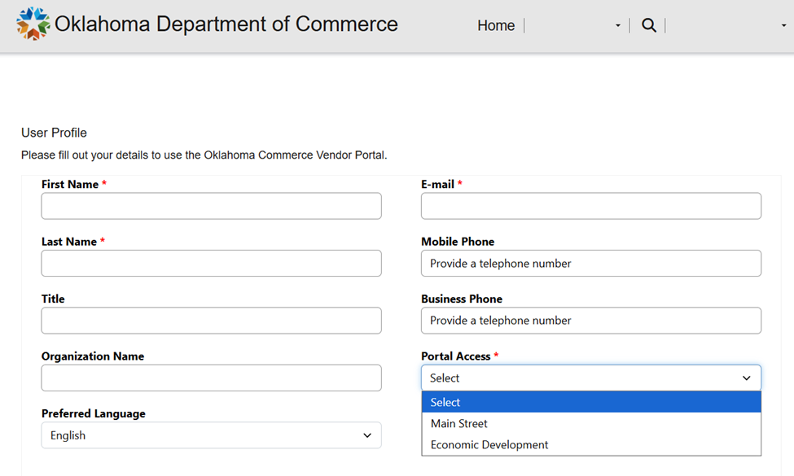

1. **A message will display that your request has been submitted and being reviewed. You will receive an email once approved allowing access to the portal.**

If your request is denied, you will receive an email with an explanation and/or further instructions.