Reinvestment Reporting Guideline
New Portal Homepage. Select (NEW Monthly Reinvestment)
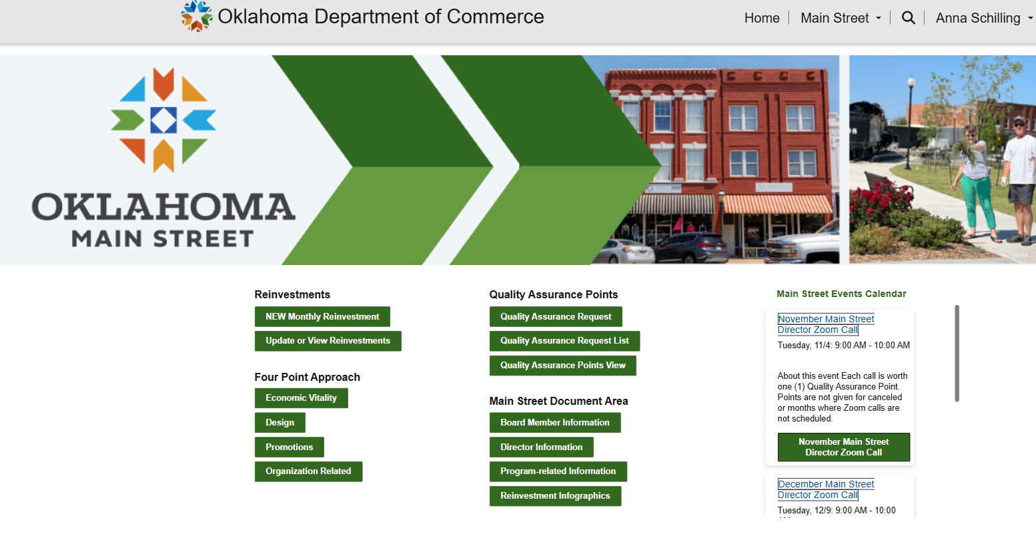

Once you are in the report
- NOW – your community’s name will automatically populate
- Enter year and select month
- If you answer “YES” to any of the reinvestment questions, you will need to hover over the text box for the definition to show up.

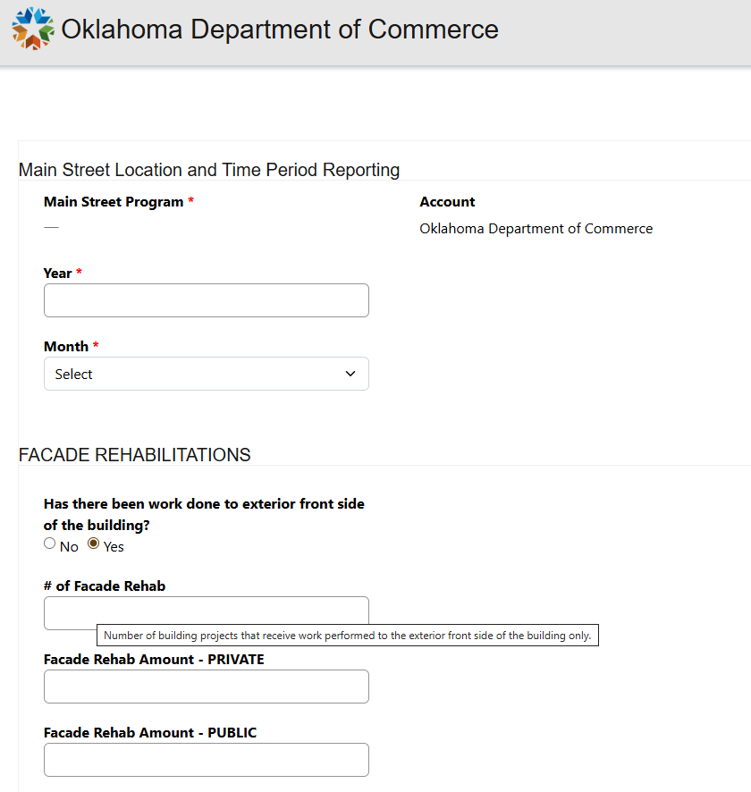

Update or View Reinvestments
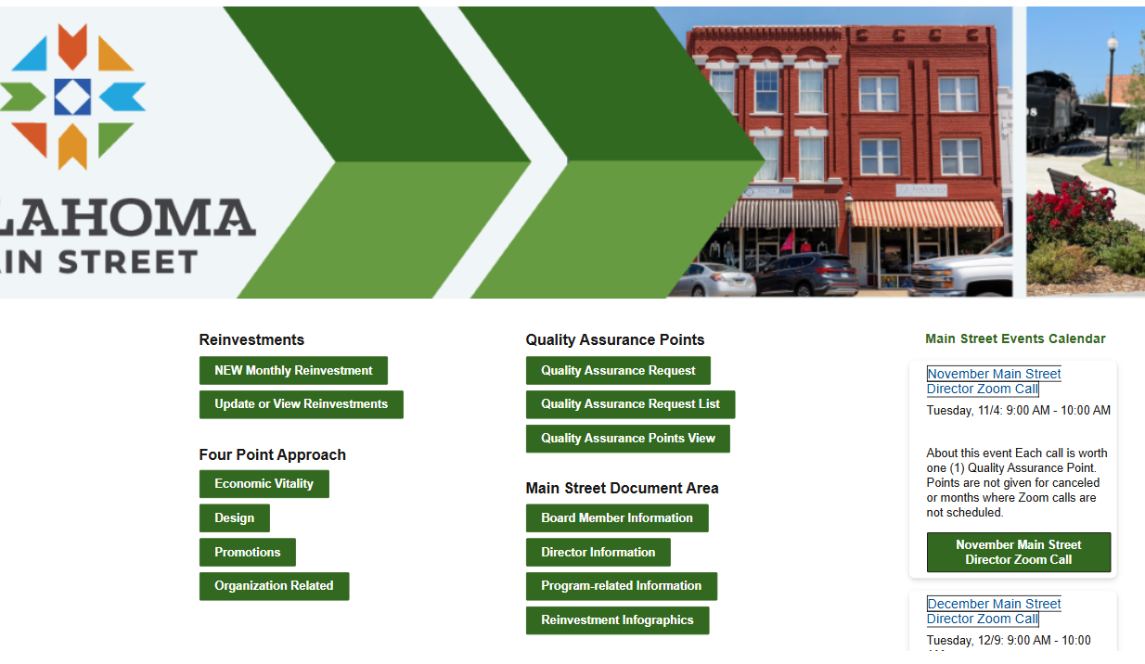

The look will be different, but your reinvestment reporting will be listed here you will need to select the one you are editing.
