OKLAHOMA STATE REGENTS FOR HIGHER EDUCATION
Council on Instruction Meeting Minutes
By OACRAO Representative
Thursday, April 9, 2026 – 1:00 pm

The following meeting minutes (in blue) were taken by the OACRAO representative. While care was taken to accurately capture the discussion, the notes may contain errors, omissions, or interpretations that do not fully reflect the agenda speaker’s remarks or intent. Any inaccuracies are the responsibility of the note-taker and should not be attributed to or construed as positions of OACRAO, OSRHE, or the COI.

AGENDA

- Welcome and Introductions
- Roll call

- Vote to Approve Minutes of March 2026 meeting
- Approved

- Legislative Update
Mr. Joel Dean
- Full budget found on Senate website
- 1.5% increase, primarily for OK Promise
  - Some cuts, some expansions but by and large a flat budget
- Fighting the accreditation bills banning DEI
  - With the Senate Rules Committee
- Working on Homeschool ACT exemption bill
  - Negotiating a lowering of threshold but not eliminating entirely
- SB1477
  - Age cap on concurrent enrollment
- SB1546
  - Renaming Inspire to Teach Act to NextEd
- Career Readiness and Assessment bill is still in House Committee:
- Loads of state questions still active: TSET Reset, Ad Valorem, Medicaid expansion rollback, Proof of ID for voting, and more

- Budget Update
Mr. Nick Hathaway
- Nearly flat appropriation
- Now moving through tuition part of budget, probably take place in June
  - FY27 budget planning will most likely have a 2% cut
  - With weakening of income tax collection, may face steeper cuts by FY28

- Tier Meeting Updates
- 2 year tier discussions:
  - Shared partnerships—how do we share resources (library, career service, nursing services programs, shared partnerships, etc.)
  - Workforce Pell, challenges, infrastructure
  - Sofia Learning Credit—around the table still primarily a faculty discretion decisions
  - HB 1632 (Workforce and Economic Development)
    - Requires the Regents for Higher Education to allow institutions to grant college credit based on assessment-based credentials and scores earned on career-readiness assessments
    - Passed off the Senate Floor 46-0 on 3/11. Passed 9-0 on 4/7
  - Sub 120s
  - International Student Services and attendance policies

- 4 year tier discussions:
  - Administrative
  - Attendance polices…how they are made, how they dovetail into reports
  - Sophia Learning, again faculty playing a large role in determining transfer
  - New program approval and modality and how that works
  - Fraudulent Application
  - Sub 120s

- Credit for Prior Learning Discussion
Dr. Stephanie Beauchamp
- Discussion on Sophia Learning
  - Length of time students have to complete Sophia Learning
  - Issues like taking 3 days to complete Comp I with Sophia, yet unable to complete comp II at a college/university
    - Is there truly the rigor in such amount of time
  - Currently policy lists several methods to evaluate credit for prior learning, but does not restrict certain methods
    - Q: Can we find out if a transcripted course is from Sophia
    - A: No. Once on the transcript, it is that school’s transcripted credit given/earned

- Academic Innovation Update
Dr. Anna Dunn
- AI Symposium, June 8-10, Hard Rock Hotel, Tulsa
  - Theme: “The Ground Has Moved: Building Oks AI-Ready Future”
  - Contact Roxie James (NWOSU), rjjames@nwosu.edu
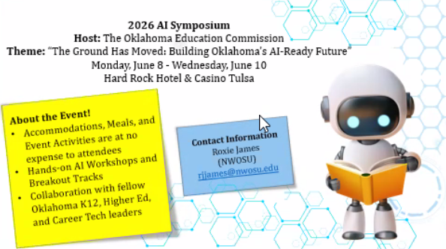
  - Some sponsorships available

  - Working on a grant proposal for online Nursing online learning
  - Upskill OK, audit completed.
    - Next step is to embed Lightcast data on relating OK jobs to the data in Upskill
Employer tab will be able to look a data on learners in general

- Reach Higher Update
Dr. Anna Dunn and Ms. Tisha Bradford
- Synopsis of Reach Higher Program
  - For people returning to education
  - Over 4000 scholarships since FY23
- 2 current programs
  - Flex finish—original set of requirements under pilot program, limited set of programs
  - Direct Complete
    - Proposing a unified reach higher single program, just “Reach Higher”
      - Not to start over, but a single unified experience.
      - A shared identity for Oklahoma adult completion programs
      - One program, with multiple pathways and workforce alignment
      - Easier for students to explore degree pathways and access to financial helps
      - Institutional authority would remain the same
  - Please complete survey with thoughts before April 17
    - https://www.surveymonkey.com/r/7JPYTB8

- Report on Procedures Handbook Committee
Dr. Jeffrey Gibson, Chair

- Vote to Approve Revisions to:
- 3.5 Intensive English Program Approval and R
  - Current have 4 current IEPs
- 3.6 Cooperative Agreements Between Higher Education Institutions and Other Entities
- 3.8 Approval of Changes in Academic Structure and Nomenclature

- 3.5 INTENSIVE ENGLISH PROGRAM APPROVAL AND REVIEW
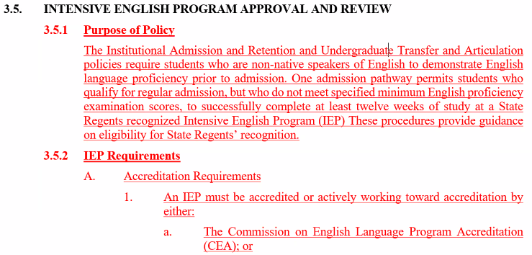

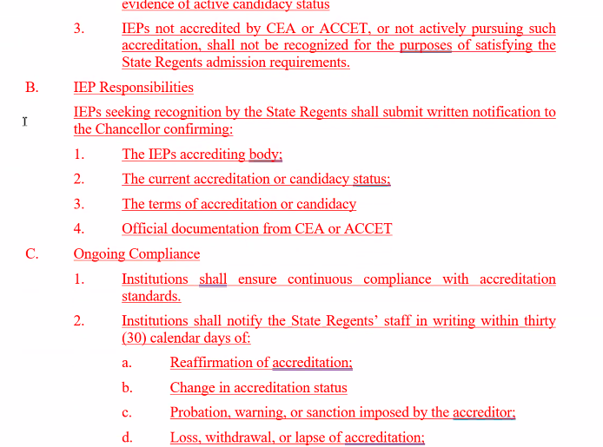

  - 3.5 Approved

- 3.6 COOPERATIVE AGREEMENTS BETWEEN HIGHE EDUCATION INSTITUTIONS AND OTHER ENTITIES
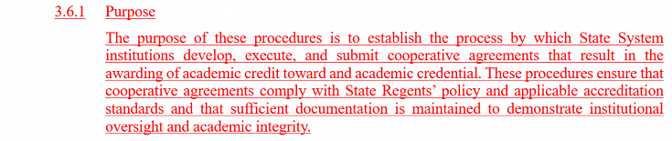

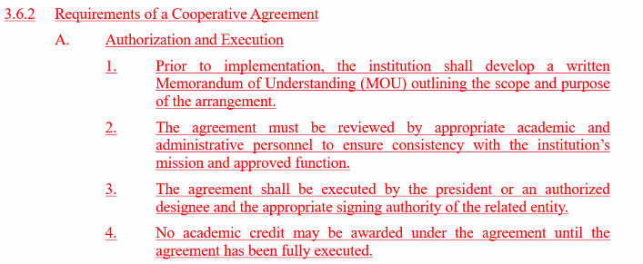

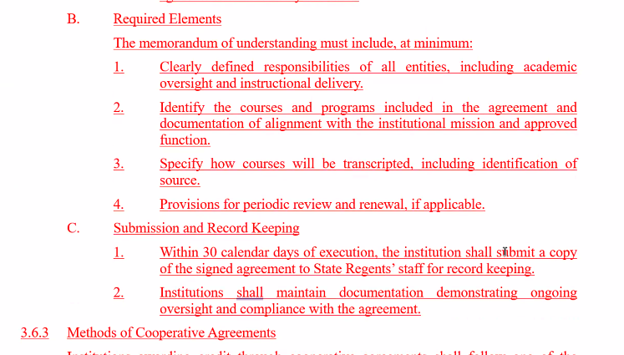

  - Specifically C.1: Reference to keep MOUs updated on institutional websites vs having to submit every MOU, especially for those schools with multiple MOUs
    - Perhaps update to read within 20 calendar days of execution the institution shall…
  - 3.6 Vote Tabled

- 3.8 Approval of Changes in Academic Structure and Nomenclature
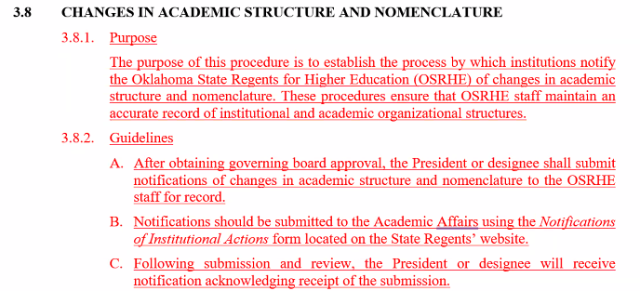

- Approved

- Approval of High School Course
Ms. Angel Icenhour
- 3rd math course based on survey of College Mathematics from Union Public HS
  - 79% of course did exceed content and rigor of Algebra I
  - Approved

- Proposed Fall 2026 COI Meeting Dates
Ms. Elizabeth Baird

- September 2026 – Zoom
  - COI, Thursday, September 10, 1pm
- October 2026 – In-Person
  - COI, Thursday, October 8, 1pm – Most Fall Breaks are Oct 15-16
- November 2026 – Zoom
  - Thursday, November 12, 1pm
- December 2026 – Zoom
  - COI, Thursday, December 10, 1pm

- Posting of COI Chair Elect for 2026-2027
Dr. Chris Francisco
- Elected Dr. Jeffrey Gibson as Chair

- New Program Proposals and Workforce Data Updates
Dr. Stephanie Beuachamp
- Should have received meeting request for next Friday with a training from Lightcast
- Regents hoping to have a New Program form ready soon
- When you submit a new program proposal, also submit the data you found on Lightcast
- No movement regarding a review of General Education policies
- 3.7 close, still not available for review

- Reduced Credit Bachelors Update
Dr. Stephanie Beauchamp
- Required to submit a feasibility report
  - Went to presidents and COI
  - Dr. Carlton Brown will present national trends and issues next Wednesday’s retreat
  - 3.4, 3.15 have been approved by COI, and posted to regents’ page
  - Some institutions are already trying to develop but have been aske dnot to submit yet
  - Not sure if there will be a limit or not

- State Regents’ Update
Dr. Stephanie Beauchamp
- Low productivity programs still being monitored

- Campus Share-Out
- Seminole State College Annual FFA interscholastic contest with over 1800 students today
- Dr. Gibson (ECU): successfully completed 4-year HLC review, 1st doctoral candidate for graduation this May!

- New Business
- No new business

- Adjournment

Upcoming Dates
- April 24, 2026 – Reach Higher Coordinator Training – OKC
- April 25, 2026 – Reach Higher Reception - OKC
- June 3-4, 2026 – SARA State Meeting - OKC
- June 6, 2026 – Grants Conference – OKC
- June 8-10, 2026 – AI Symposium – Tulsa
Upcoming Dates

- April 15, 2026 – State Regents’ Meeting – OKC
- April 16, 2026 – State Regents’ Meeting – OKC
- May 29, 2026 – State Regents’ Meeting – OKC
- June 24, 2026 – State Regents’ Meeting – OKC
- June 25, 2026 – State Regents’ Meeting – OKC
- September 2, 2026 – State Regents’ Meeting – OKC
- September 3, 2026 – State Regents’ Meeting – OKC
- October 21, 2026 – State Regents’ Meeting – OKC
- October 22, 2026 – State Regents’ Meeting – OKC
- December 2, 2026 – State Regents’ Meeting – OKC
- December 3, 2026 – State Regents’ Meeting – OKC

