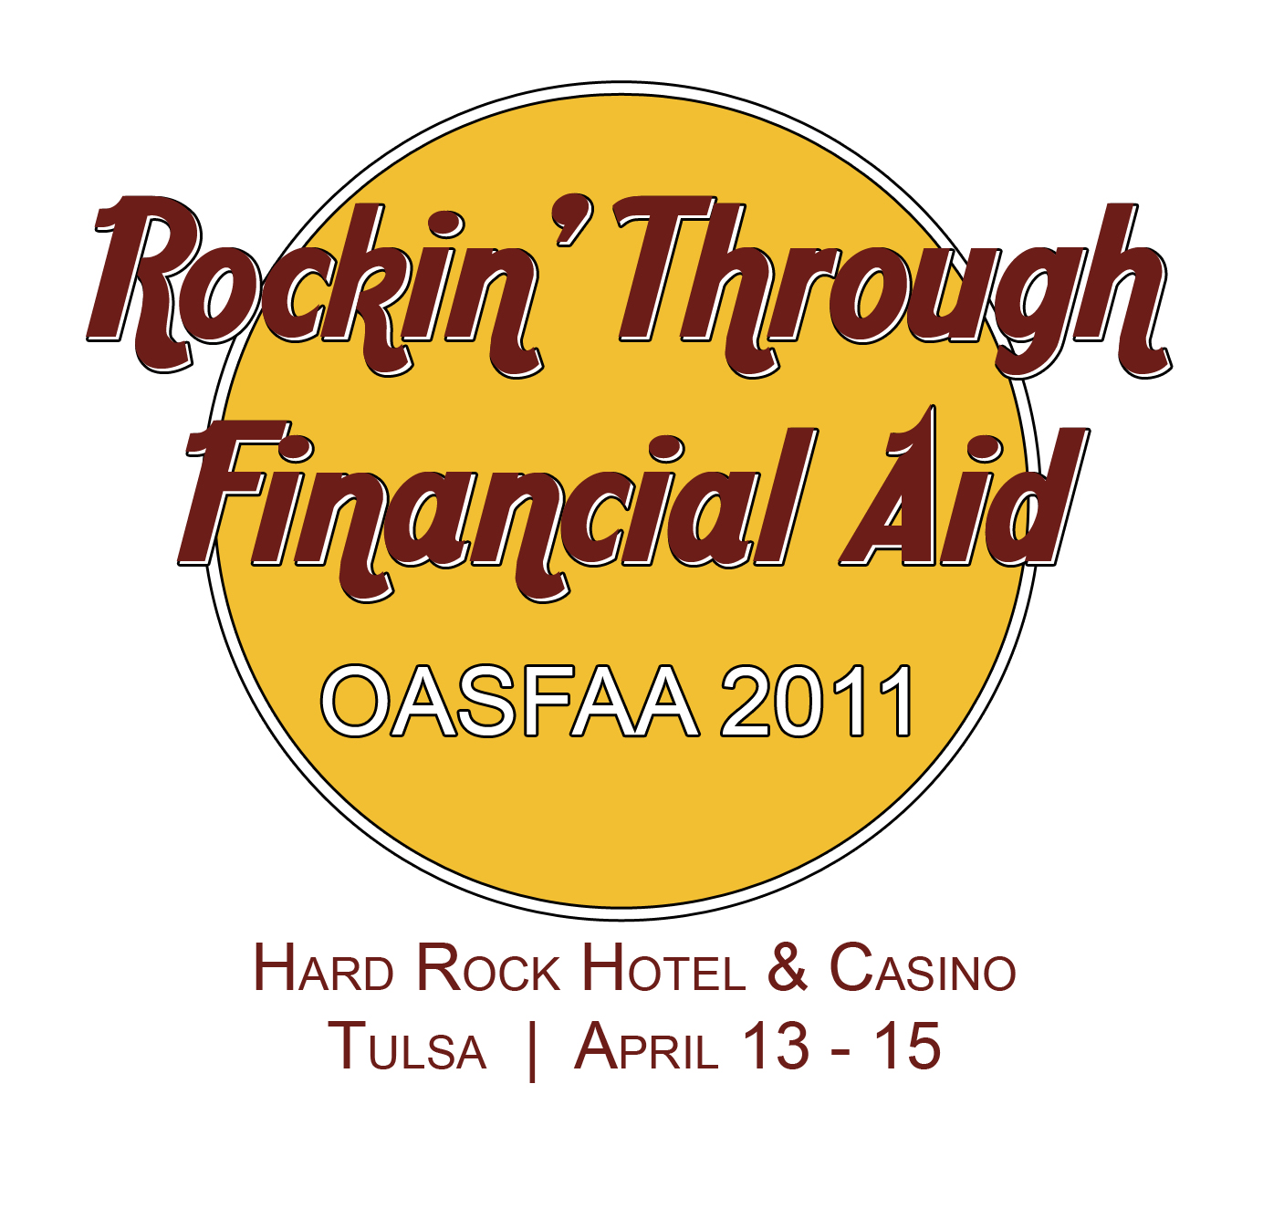

Wednesday, April 13th

11:00-1:00 Registration desk open

1:00-2:00
 Federal Update

2:00-3:15 Registration desk open

2:00-2:15 Break

2:15-3:15
Nuts and Bolts Verification
Presenter: Kevin Campbell, Training Officer, United States Department of Education
Cooperative Alliances - Partnerships Between Institutions and Technology Centers
Presenters: Dr. Debra Stuart, Vice Chancellor for Educational Partnerships, Oklahoma State Regents for Higher Education and
Irala Magee, Director of Scholarship and Grant Administration, Oklahoma State Regents for Higher Education
Benefits of Combining the Financial Aid Office & Bursar’s Office
Presenter: Clint LaRue, Director of Student Financial Services, Oklahoma Christian University
Private Loan Presentation Panel
Facilitator: Mike Mutziger, Great Lakes Educational Loan Services

3:15-3:30 Break

3:30-4:30
Nuts and Bolts Verification, continued
Presenter: Kevin Campbell, Training Officer, United States Department of Education
Customer Service
Presenter: David Barron, Executive Director for Enrollment Management, Rogers State University
Direct Loan Tools & Reconciliation
Presenter: Becky Garrett, Assistant Director for Technical Services, University of Central Oklahoma
Net Price Calculators
Presenter: Deborah Bradford, USA Funds

4:45-5:30
Sector meeting—4 year schools
Sector meeting—2 year schools
Sector meeting—State public career technology centers
Sector meetings—Proprietary schools

Dinner on your own

Thursday, April 14th

8:00-11:45 Registration desk open

8:00-9:15 Breakfast

9:30-10:30
General Session—2 Pell Awards in 1 Year, part 1
Presenters: Kevin Campbell, Training Officer, United States Department of Education

10:30-10:45 Break

10:45-11:45
General Session- 2 Pell Awards in 1 Year, part 2
Presenter: Kevin Campbell, Training Officer, United States Department of Education

12:00-1:45 Lunch

2:00-3:00
General Session-Satisfactory Academic Progress
Presenter: Kevin Campbell, Training Officer, United States Department of Education

3:00-3:30 Break

3:30-4:30
Nuts and Bolts-Dependency Override and Professional Judgment
Presenter: Jonna Raney, Director of Student Financial Services, Oklahoma Baptist University
Unaccompanied Homeless Youth
Presenter: Cara Cusick
Veteran’s Affairs Update
Presenter: Danny Stewart, Director, Oklahoma State Accrediting Agency
Program Integrity Rules
Presenter: Mary Heid, Director for Policy, Compliance, and Training, Oklahoma Guaranteed Student Loan Program

5:00-6:00 President’s Reception
Conclusion of Citizen’s Caring for Children drive “It’s In the Bag”

Friday, April 15th

8:00-9:00 Breakfast

9:00-9:30
OASFAA Business Meeting

9:30-9:45
SWASFAA update

9:45-10:00 Break

10:00-11:00
OTAG and Oklahoma’s Promise Updates
Presenters: LaTreece Langston, Scholarship Programs Coordinator, Oklahoma State Regents for Higher Education
Irala Magee, Director of Scholarship and Grant Administration, Oklahoma State Regents for Higher Education
Bryce Fair, Associate Vice Chancellor for Scholarships and Grants, Oklahoma State Regents for Higher Education

Conference adjourns

