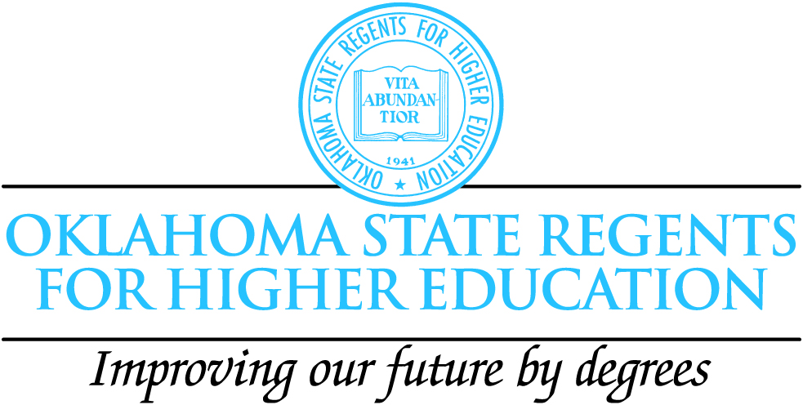

Hello Oklahoma School Counselors!

We are down to the last few opportunities to participate in the College Access Counselor Retreat program as the grant ends this year.

The retreats have been a great learning experience for the Student Preparation Team, as we nurture a growing statewide Professional Learning Community of counselors from elementary, middle, and high schools ( public and private), from CareerTech Centers, AHEC, and other agencies who work with Oklahoma kids.

Our group has come from literally every corner of the state. Friendships and networks are being forged and extended as we share ideas and resources at retreats and come together for a Summer Institute.

There are just a few retreats remaining. The flyer is included here. If you would like to sign-up, look over the flyer, choose your date/site, and send an e-mail to Cari Lousch. clousch@osrhe.edu. Also feel free to call or e-mail if you have questions.

Cari Lousch

Field Coordinator for Student Preparation

Oklahoma State Regents for Higher Education

(918) 813-3199

The College Access Counselor Retreats!


Act 2: 2009-2010 School Year

Who: New Counselors and Counselors

Serving students in poverty

What: The Counselor Retreat is just that….valuable time for counselors to get together to share issues and ideas, and to discuss new and relevant information about EPAS, State-Testing, College Preparation and Access, Career Guidance, working with teachers and administrators, and helping students!

Bring your EPAS materials and anything else you’d like to discuss or need help with. Bring your own ideas about how to improve school counseling in Oklahoma for your kids and schools statewide! Be ready to make friends and participate in an ongoing, growing Professional Learning Community of Oklahoma School Counselors!
(*No Registration Fee and Meals and lodging provided!)

Where/When: (Revised Dates/Sites)
*Registration Deadline is 2 weeks prior to your selected date!

The Tatanka Ranch (Stroud) Mar. 28-29, June 30-July 1
Robber’s Cave Lodge (Wilburton) Mar. 7-8
Kerr Mansion Conference Center (Poteau) Apr. 25-26

Hosts: Cari Lousch, Matt Higdon , Cindy Brown

Oklahoma State Regents for Higher Education

EPAS/Student Preparation Team

Interested? Choose a location/date. (If you are flexible, also list a 2nd & 3rd choice.) Send your name, school, position and a brief note describing how you fit in to the “Who” above to:

Cari Lousch clousch@osrhe.edu (918) 813-3199

The College Access Counselor Retreats

Agenda

Sunday 1:00-3:00pm Check-in, Pick-up materials, cabin/room assignment
Networking Reception
5:00pm Dinner
6:00-10:00pm Sharing/Goals & Dreams Activity
Discussion Groups
8:00pm Refreshments
Defining the Counselor Role
(What does it look like? Who decides?
What are the needs at your school?)
Planning for Monday Activities

Monday 8:30am Breakfast/Networking
9:00am Using EPAS Results/Data

EXPLORE-PLAN-ACT

Interpretation
Working with students & parents
Working with Teachers & Administrators

State-Testing
Facilitating Curriculum Alignment
(Using what you know to make a better school!)
Developing a Guidance Plan
11:30am Lunch (check-out)
12:45pm Oklahoma’s Promise
Scholarships & Admissions
Preparing your Students for College & Work
OKCollegestart.org
2:00pm Taking your Goals/Plans back to your school
Being part of a PLC
Wrap-up Activities

4:00pm Dismiss

