**OSRHE Contract**

**Ordering ACT Explore or ACT Plan Test Materials with ACT’s College and Career Readiness Information System (CCRIS)**

1. The first and most important rule of thumb when placing your EXPLORE or PLAN test material order (for public schools affiliated with a school district), is that your order **MUST** **be placed by your district** in order to be funded by the Oklahoma State Regents for Higher Education. [Only private schools or schools not associated with a district may order as a school. You should see and select the correct Program as in Step 6 below.]
2. To place your district order, type or paste the following into your browser:

**readiness.act.org**

You will then see the following screen where you may enter your e-mail and password to begin the ordering process. Links are provided on the right if you have forgotten your password or need to sign up for an ACT account (a personalized account is needed to place an order for your district). Click the “Sign In” button as the enter key will not work on this screen. **If you placed an order last year as part of the OSRHE contract, you already have an account. Please do not set up a new account unless you are new to your position or did not place the order for 2012-2013 testing. If you have forgotten your password, click “I forgot my password” or call ACT for assistance at 877-789-2925.**

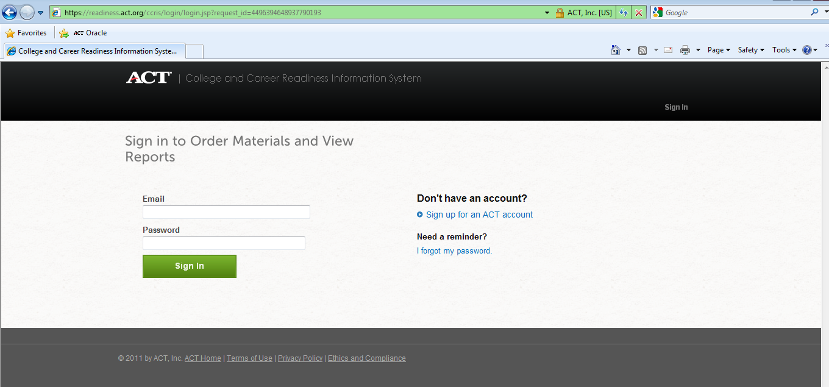

1. Once you have entered your e-mail and password or have set up an account, you will advance to the following page where you should see YOUR district’s name in the upper right hand corner.

(See 2012-2013 **sample** below. Your 2103-2014 screen will look slightly different.)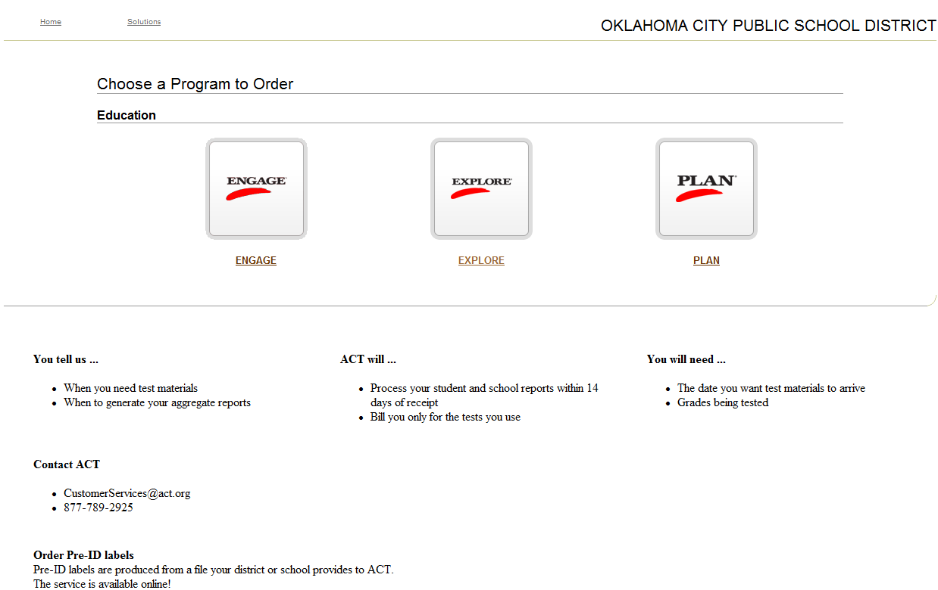

1. Select ACT Explore (or ACT Plan) and you will see YOUR district name in the upper right-hand corner. (See 2012-2013 sample below. Your 2013-2014 screen will look slightly different.)

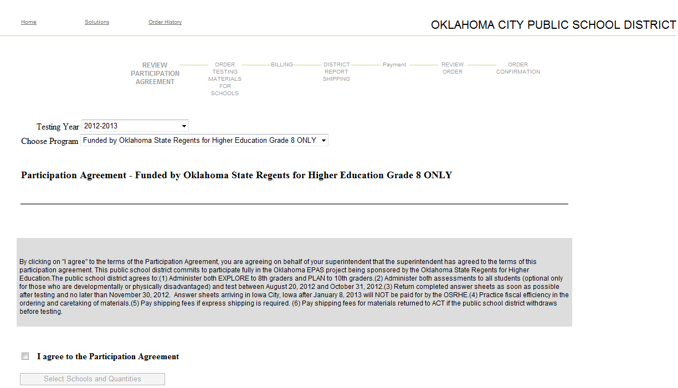

1. Enter Testing Year: **2013-2014**
2. Choose Program:

**ACT EXPLORE Funded by OK State Regents for Higher Ed. Grade 8 ONLY**

**or** **ACT PLAN Funded by OK State Regents for Higher Ed. Grade 10 ONLY**

**If you do not see either of these “program” choices, it means that you have not logged in as an eligible district. Do not continue with your order as it will not be funded by OSRHE.**  Log out of the system and log back in as your district instead of your school or contact ACT at 877-789-2925 to verify that your district is on the OK eligibility list if you do not see it.

1. Read the Participation Agreement in the shaded box and check the box below to agree to the Participation Agreement.
2. Click “Select Schools and Quantities” and continue with your order by clicking on the name of the school for which you need to order. If you have more than one school in your district, you will need to place an order for each school.
3. Order enough test packages to cover your anticipated Grade 8 ACT Explore or Grade 10 ACT Plan fall enrollment as well as any accommodated and/or supplemental test materials that you anticipate needing. ACT will ship an overage of the following items based on your enrollment: test booklet, answer folder, *Instructions for Completing Your Answer Folder*, and *Why Take ACT Explore [or ACT Plan]*.

Package Quantity Overage

1-10 1

11-50 3

51-20 5

201-500 10

501-1000 15

1001+ 20

1. If you wish to test students other than grades 8 and 10, you **must** place a separate order. Go to <http://www.act.org/products/k-12-act-explore/> to order ACT Explore for other than grade 8 or to <http://www.act.org/products/k-12-act-plan/> to order ACT Plan for other than grade 10. OSRHE will not pay for non 10th grade students taking ACT Plan or non 8th grade students taking ACT Explore. Please call ACT Customer Support at 1-877-789-2925 if you have any questions about ordering for contract or off-grade students.
2. If you do not see a school for which you need to order, please contact ACT at 877-789-2925. The school may need to be added to the OK eligibility list. ACT’s Service Center will be able to initiate that process for you.
3. **Select the “Standard” delivery option to avoid delivery charges**. Test materials will begin shipping in early August. **Please do not select expedited shipping.**
4. Select the test materials delivery date if a date later than the default delivery date of 8/12/2013 is desired.
5. SHIPPING OF TEST MATERIALS PRIOR TO TESTING--Select shipping address and contact from drop-down box OR add correct address and contact.
6. SHIPPING ADDRESS FOR SCHOOL REPORTS--Choose address from drop-down box OR add correct address as indicated. **Note: Reports must ship to a valid school or district address. Do NOT select the Oklahoma State Regents for Higher Education to receive your reports.**
7. After placing each school order, click “Next” in the lower right hand corner to return to the list of schools.
8. After you have ordered for all of your schools, hit the “Enter Billing Information” button at the bottom of your screen.
9. You should see:

For EXPLORE: “Billing Information – ACT Explore Funded by Oklahoma State Regents for Higher Ed. Grade 8 ONLY”.

For PLAN: “Billing Information – ACT Plan Funded by Oklahoma State Regents for Higher Ed. Grade 10 ONLY”.

If you do not see these words followed by the address of OSRHE and Dr. Cynthia N Brown as the contact, call ACT’s Service Center at 877-789-2925.

1. Enter your District Reporting address and contact and note the date indicated for processing of your district reports.
2. Check out.
3. The Payment Page will show a Total Amount due of $0.00 unless you have requested expedited shipping to be charged to your district.
4. Review your order to make sure everything is accurate then agree to the terms and conditions.
5. Finally, hit the “Place Order” button. **Your order will not be complete until you have done so.**
6. Thank you for your order!