**OSRHE Contract**

**Ordering ACT Explore Test Materials with ACT’s College and Career Readiness Information System (CCRIS)**

1. The first and most important rule of thumb when placing your ACT Explore test material order (for public schools affiliated with a school district), is that your order **MUST** **be placed by your district** in order to be funded by the Oklahoma State Regents for Higher Education. [Only private schools may order as a school. You should see and select the correct Program as in Step 6 below.]
2. To place your district order, type or paste the following into your browser:

**readiness.act.org**

You will then see the following screen where you may enter your e-mail and password to begin the ordering process. Links are provided on the right if you have forgotten your password or need to sign up for an ACT account (a personalized account is needed to place an order for your district). Click the “Sign In” button as the enter key will not work on this screen. **If you placed an order last year as part of the OSRHE contract, you already have an account. Please do not set up a new account unless you are new to your position or did not place the order for 2014-2015 testing. If you have forgotten your password, click “I forgot my password” or call ACT for assistance at 877-789-2925.**

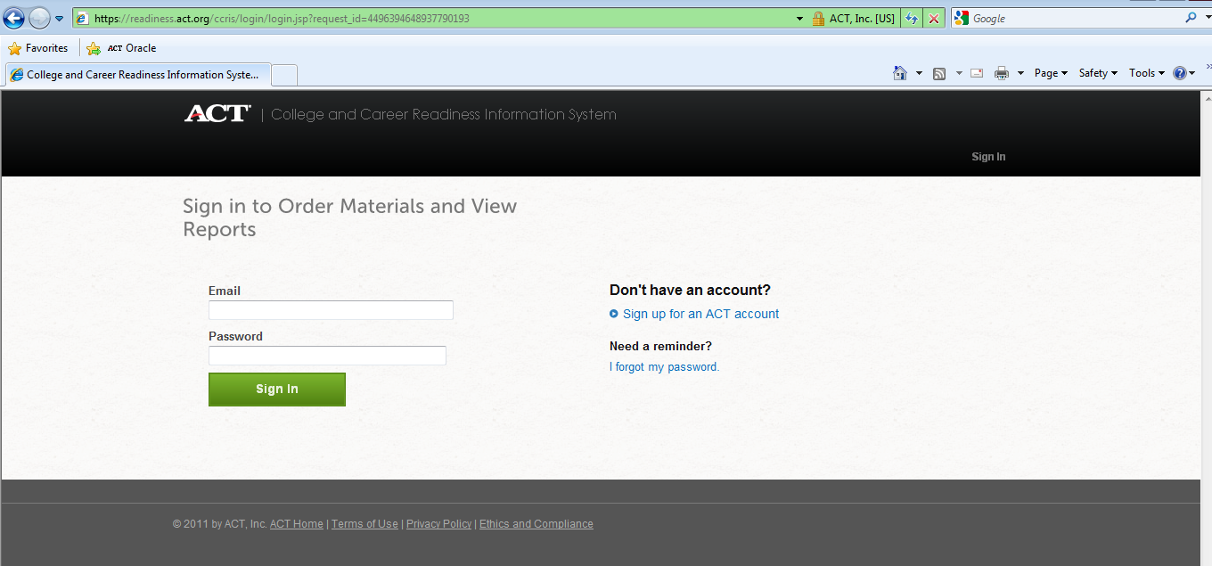

1. Once you have entered your e-mail and password or have set up an account, you will advance to the following page where you should see YOUR district’s name in the upper right hand corner.

(See 2012-2013 **sample** below. Your 2015-2016 screen will look slightly different and will only show the products you are eligible to order.)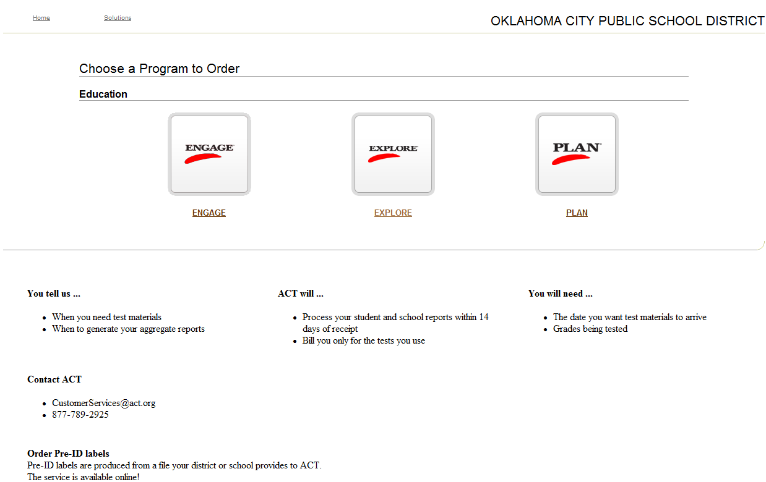

1. Select ACT Explore and you will see YOUR district name in the upper right-hand corner. (See 2012-2013 sample below. Your 2015-2016 screen will look slightly different.)

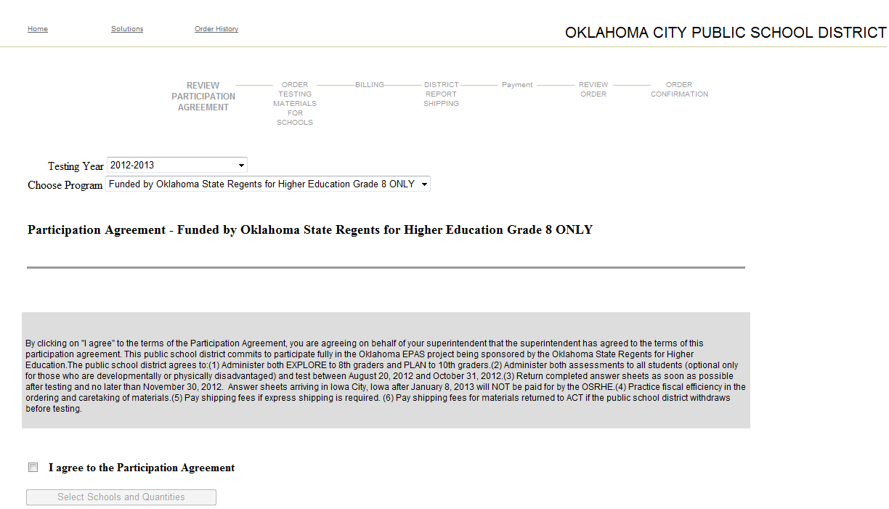

The Participation Agreement for testing in 2015-16 will read as follows:

|  |  |
| --- | --- |
| OSRHE 2015-2016 District Participation Agreement:  By clicking on "I agree" to the terms of the Participation Agreement, you are agreeing on behalf of your superintendent that the superintendent has agreed to the terms of this participation agreement.   This public school district commits to participate fully in the Oklahoma EPAS project being sponsored by the Oklahoma State Regents for Higher Education.  The public school district agrees to: (1 ) Administer the assessment to all students (optional only for those who are developmentally or physically disadvantaged) and test between August 18, 2015 and October 30, 2015. (2) Return completed answer sheets as soon as possible after testing, last day to test is October 30, so that they arrive at ACT no later than November 30, 2015.   (3) Practice fiscal efficiency in the ordering and caretaking of materials. (4) Pay shipping fees if express shipping is required.  (5) Pay shipping fees for materials returned to ACT if the public school district withdraws before testing. |  |

1. Enter Testing Year: **2015-2016**
2. Choose Program:

**ACT EXPLORE Funded by OK State Regents for Higher Ed. Grade 8 ONLY**

**If you do not see ACT Explore as a “program” choice, it means that you have not logged in as an eligible district. Do not continue with your order as it will not be funded by OSRHE.**  Log out of the system and log back in as your district instead of your school or contact ACT at 877-789-2925 to verify that your district is on the OK eligibility list if you do not see it.

1. Read the Participation Agreement in the shaded box and check the box below to agree to the Participation Agreement.
2. Click “Select Schools and Quantities” and continue with your order by clicking on the name of the school for which you need to order. If you have more than one school in your district, you will need to place an order for each school.
3. Order enough test packages to cover your anticipated Grade 8 ACT Explore fall enrollment as well as any accommodated and/or supplemental test materials that you anticipate needing. ACT will ship an overage of the following items based on your enrollment: test booklet, answer folder, and *Instructions for Completing Your Answer Folder*.

Package Quantity Overage

1-10 1

11-50 3

51-20 5

201-500 10

501-1000 15

1001+ 20

1. If you do not see a school for which you need to order, please contact ACT at 877-789-2925. The school may need to be added to the OK eligibility list. ACT’s Service Center will be able to initiate that process for you.
2. **Select the “Standard” delivery option to avoid delivery charges**. Test materials will begin shipping in early August. **Please do not select expedited shipping.**
3. Select the test materials delivery date if a date later than the default delivery date of 8/10/2015 is desired.
4. SHIPPING OF TEST MATERIALS PRIOR TO TESTING--Select shipping address and contact from drop-down box OR add correct address and contact.
5. SHIPPING ADDRESS FOR SCHOOL REPORTS--Choose address from drop-down box OR add correct address as indicated. **Note: Reports must ship to a valid school or district address. ACT does not ship to P.O. Boxes. ACT uses FedEx deliver. Do NOT select the Oklahoma State Regents for Higher Education to receive your reports.**
6. After placing each school order, click “Next” in the lower right hand corner to return to the list of schools.
7. After you have ordered for all of your schools, hit the “Enter Billing Information” button at the bottom of your screen.
8. You should see:

“Billing Information – ACT Explore Funded by Oklahoma State Regents for Higher Ed. Grade 8 ONLY”.

**If you do not see these words followed by the address of OSRHE and Dr. Cynthia N Brown as the contact, call ACT’s Service Center at 877-789-2925.**

1. Enter your District Reporting address and contact information and note the date indicated for processing of your district reports.
2. Check out.
3. **The Payment Page must show a Total Amount due of $0.00.**
4. Review your order to make sure everything is accurate then agree to the terms and conditions.
5. Finally, hit the “Place Order” button shown on the right side of the graphic above.

**Your order will not be complete until you hit the "Place Order" button.**

1. If you wish to test students other than grade 8, you **must** place a separate order. Go to <http://www.act.org/products/k-12-act-explore/> to order ACT Explore for other than grade 8. OSRHE will not pay for non 8th grade students taking ACT Explore. Please call ACT Customer Support at 1-877-789-2925 if you have any questions about ordering for contract or off-grade students.
2. Thank you for your order!