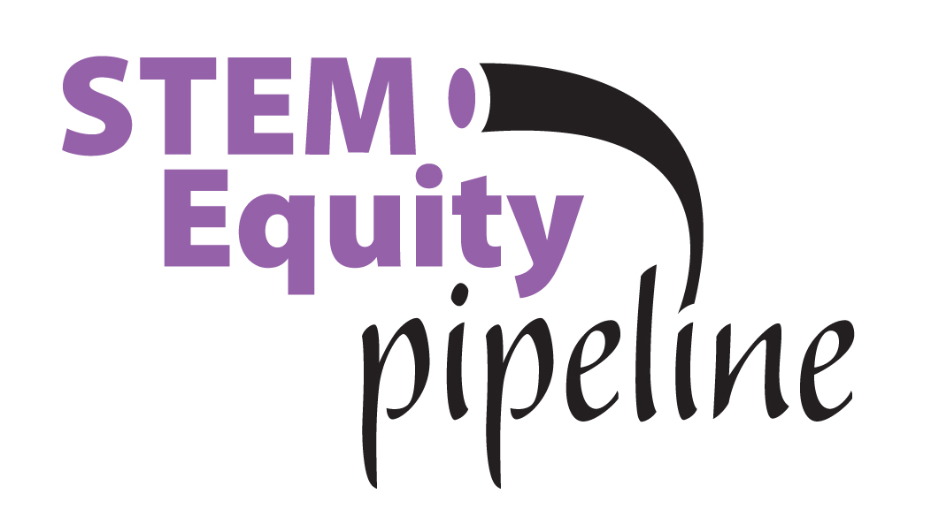
State Application Package

Directions
- Please go to www.stemequitypipeline.org to review the goals of the STEM Equity Pipeline project and the roles of the State Team. Please keep this information in mind while answering the questions on this application.
- Please complete each of the questions included in this form.
- Please provide attachments to help reviewers understand the status of STEM education in your state.
- An electronic version of the application must be submitted to Mimi Lufkin, STEM Equity Pipeline Project Director, mimilufkin@napequity.org by July 18, 2008.

If you have questions, contact Mimi Lufkin at (610) 593-8038 or mimilufkin@napequity.org

State:

Individual submitting this application (This individual will be contacted if there are any questions regarding the application submission)

Name:

Title:

Telephone:

Fax:

E-mail:

Lead State Agency Contact (If there is more than one lead state agency please include the following information for each lead state agency contact. Also include a letter of support from each lead state agency)

Name:

Title:

Telephone:

Fax:

E-mail:

Affiliation: Check all that apply.

Secondary Postsecondary Other

CURRENT STEM CAPACITY AND COMMITTMENT

The STEM Equity Pipeline project provides technical assistance and consulting services to state teams to increase the capacity of staff developers to integrate gender equity into STEM professional development in the state. To be successful lead state agencies and members of the state team must have the capacity and commitment to accomplish these goals.

- What are the existing STEM initiatives in the state? How will the project build upon or coordinate with these initiatives?

- What potential additional financial resources (cash and in kind) are available in the state to leverage the activities of this project?

- Initially, who will participate on your State Team (please include letters of support) See http://stemequitypipeline.org/StateTeams/Default.aspx for more information on State Team roles and responsibilities.

 |  | Name | Title | Organization
 | 1.
 | 2.
 | 3.
 | 4.
 | 5.
 | 6.
 | 7.
 | 8.
 | 9.
 | 10.
If there are more than 10 individuals identified at this point please attach their information on a separate sheet.

EXTENSION SERVICES

The STEM Equity Pipeline, as a NSF extension services grant, will provide access to experts in research and practice in gender equity in STEM through a train the trainer process. The project is intended to build knowledge of gender equity strategies in STEM among trainers providing professional development to middle school, high school and community college faculty. In addition, training will address how the five step program improvement process can be used to implement effective strategies for increasing the participation and completion of women and girls in STEM related career cluster programs of study.

- Who in your state will receive STEM Equity Pipeline training?

- How will those who receive STEM Equity Pipeline training deliver technical assistance or professional development to middle school, high school and community college faculty of math, science and STEM related career and technical education programs?

EVALUATION

One of the goals of the STEM Equity Pipeline project is to connect this work to existing accountability systems in the state. In particular, the project will be asking participating states to submit district/college level data from the Perkins Act Consolidated Annual Report as part of the projects outcome evaluation. In addition, state teams will be asked to participate in process evaluations regarding the projects services.

- What additional data sources could the state potentially use to assess long-term project outcomes?

INTENT TO PARTICIPATE

By signing below, your state has indicated its intent to participate in the STEM Equity Pipeline project if selected. Participation includes:
- Providing project evaluators with Perkins accountability data reported on the state’s Consolidated Annual Report to the Office of Vocational and Adult Education, disaggregated by individual school district and college. This data will be used to conduct performance gap analysis of women and girls in STEM related cluster programs of study within the state. Evaluators will work with the State Leadership Team to identify available state data sources.
- Conducting an inventory and assessment of professional development needs for teachers of STEM related career cluster programs of study, particularly as they relate to building the capacity of teachers to increase the participation and completion of women and girls in STEM related career cluster programs of study.
- Hosting the Facilitator for quarterly onsite visits with the State Leadership Team to monitor annual work plan implementation and conduct the 5 Step Improvement Process Training.
- Hosting an annual gathering of the State Team
- Participating in project sponsored webcasts, webinars and the annual State Team Leadership Training
- Participating on the Virtual Learning Community by sharing strategies, resources, models and research that supports the projects goals
- Incorporating the professional development received into the professional development provided to teachers of STEM related career cluster programs of study in at least one professional development mechanism in the state. Cooperate with the project evaluator to assess the impact of the projects activities on the participation of women and girls in STEM related career cluster programs of study and on teacher professional development efforts in the state

SIGNATURES

State Director of Career and Technical Education

Name Signature

State Contact(s)

Name Signature

Name Signature

CRITERIA FOR STATE SELECTION

The single most important factor to be used to identify participating states will be evidence of commitment to increasing the participation of women and girls in STEM related career cluster programs of study. In addition, the review committee will be looking for states that meet the following criteria:

- Capacity and commitment to integrating the resources of the STEM Equity Pipeline project into existing professional development mechanisms in the state that reach middle school, high school and community college faculty of math, science and STEM related career and technical education programs

- Depth and breadth of collaboration already in existence and the potential for the resources of the STEM Equity Pipeline project to add to that collaboration

- Evidence that secondary and community college state education agencies are an integral part of the state team and are supportive of the professional development efforts

- Adequate data collection and management systems in place to implement the program improvement process model, including access to Perkins Consolidated Annual Report data and other potential outcome data sources.

SELECTION PROCESS GUIDELINES

After screening on the basis of established participation criteria, the National Alliance for Partnerships in Equity Education Foundation will select two states that

- provide geographic, size and demographic diversity;

- have strong evidence of commitment from diverse state team members and letters of support; and

- designate a state contact(s) to serve as project liason and coordinate in-state activities who is in a position to implement the state team’s activities

The two states selected to participate will be notified by August 15, 2008.

SUBMISSION

An electronic version of the application must be submitted to Mimi Lufkin, STEM Equity Pipeline Project Director, mimilufkin@napequity.org by July 18, 2008.

Any support materials unavailable in electronic format can be sent to:
National Alliance for Partnerships in Equity Education Foundation
P.O. Box 369 (mailing address)
3157 Limestone Road (shipping address)
Cochranville, PA 19330

