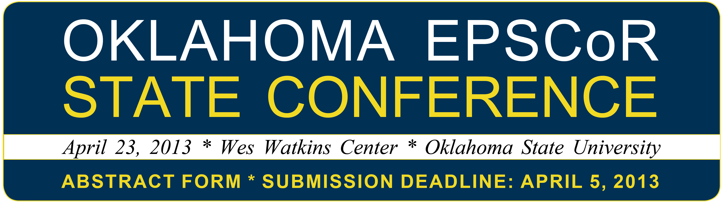
This abstract submission form is to be used by participants in the traditional scientific poster session, as well as students participating in the 2013 Student Hybrid Poster Competition.

It is not necessary to participate in the hybrid poster/oral presentation competition to present a poster during the scientific poster session. Only EPSCoR student researchers may participate in the competition portion of the event, but anyone may participate in the scientific poster session.

Poster Session Abstract Form
Note: Click “enable macros” in your window (usually appears top/left area of ruler bar) to access form fields.

YES I WISH TO PARTICIPATE IN THE STUDENT HYBRID ORAL/POSTER COMPETITION
NO I DO NOT WISH TO PARTICIPATE IN THE STUDENT HYBRID ORAL/POSTER COMPETITION

NAME OF PRESENTER AND THEIR UNIVERSITY AFFILIATION:

PRESENTER’S EMAIL ADDRESS:

TITLE OF POSTER:

IF YOU ARE A STUDENT, PLEASE INDICATE YOUR FACULTY MENTOR’S NAME AND EMAIL ADDRESS: <Faculty Name Faculty Email>

PLEASE INDICATE THE RESEARCH FOCUS AREA OF THE POSTER THAT YOU WILL BE PRESENTING:
Feedstock Development (Biofuels)
Chemical Conversion (Biofuels)
Microbial Conversion (Biofuels)
Other*

* IMPORTANT: Students participating in the hybrid poster/oral competition must be presenting research in one of the three research focus areas noted above. Additionally, students in the competition must be collaborating with an EPSCoR researcher. Individuals not participating in the competition may present posters that address other research areas.
Oklahoma EPSCoR 2013 Annual State Conference
Poster Session and Abstract Guidelines

Abstract Preparation Guidelines

- Microsoft Word files only (.doc or .docx)
- Abstracts will not be edited for content. Authors should double-check for typographical or grammatical errors prior to submitting.
- 300 words maximum
- 1” margins (top/right/left/bottom)
- Arial 12 pt font
- Set line spacing at 1.5 for all text
- Align left and justify all text
- Title in bold/all caps
- List all authors’ names and affiliations under title (double space between title and authors); underline name of primary poster presenter
- Save the file name as LastName_FirstName.doc (i.e. If your name is John Smith, the file name will be “Smith_John.doc”)

Poster Information

- 40” wide X 36” tall (larger posters not accepted)
- Presenters should bring their own attachment materials (tacks, etc.)

Submission Instructions

- Deadline for submitting abstract, abstract form and online registration is April 5, 2013.
- Complete the abstract submission form (page 1 of this document). Be sure to indicate your research category and your intent to participate/not participate in the student hybrid oral/poster competition.
- Carefully review the abstract guidelines, which are outlined above.
- Submit your completed abstract submission form, along with your abstract, to
gmiller@okepscor.org. Both documents must be in MS Word format and per instructions above.
- Register for the conference online prior to the April 5 deadline at:
http://www.okepscor.org/calendar/oklahoma-epscor-annual-state-conference-0
Important: You must register for the conference online IN ADDITION TO submitting your abstract
and abstract form via email.

Student Hybrid/Oral Presentation Competition Instructions and Guidelines
Students who wish to participate in the student hybrid/oral presentation competition may access the complete guidelines at www.okepscor.org. General steps for registering to participate in the competition are:

- Complete and submit the abstract submission form (page 1 of this document) and abstract (per guidelines above) to gmiller@okepscor.org. Submission deadline is April 5, 2013.
- Upon receipt of the abstract form and abstract document, students who have indicated a desire to participate in the competition will be provided a PowerPoint presentation template to follow.
- Register for the conference online at www.okepscor.org by April 5, 2013.
- Submit presentation slides per the provided template to gmiller@okepscor.org by April 10, 2013.

Questions: Contact Gina Miller, EPSCoR outreach coordinator * gmiller@okepscor.org * 405.744.9964

