Award Name:  Oklahoma Alliance for Manufacturing Excellence 2015  
Award Dates:  July 1, 2015 - December 31, 2015  
Award Amount:  $21,000  
Project Director:  Mr. Curtis Evans 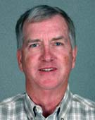  
   
Purpose of Award:  A Manufacturing Extension Agent working out of the NSU-BA campus, will assist local manufacturers in various ways to make their businesses more successful.

**Award Name:**  AI STOMP-American Indian Students STOP Smoking by Mobile Phone  
**Award Dates:** July 1, 2015 - February 29, 2016  
**Award Amount:**  $21,950  
**Project Director**:  Dr. Diana Mashburn 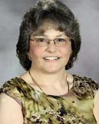  
   
**Purpose of Award:** This award will provide recruitment and project support for AI STOMP.  It is one of three in an National Institutes of Health P20 Center grant.  It will be a collaborative project between Washington State University, the University of Washington, and Northeastern State University.  The goal is to implement an intervention to increased tobacco abstinence in American Indian college students using text messaging.

**Award Name**: Student Support Services 2015-2016   Year 1/5  
**Award Dates**:  09/01/2015 - 08/31/2016  
**Award Amount:**  $288,683  
**Funding Agency**:  U.S. Department of Education

**CFDA#:**  84.042A  
**Project Director:**  Lena Deere 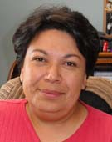

**Purpose of Award(s):**  To provide student services to those who meet the federal eligibility criteria and demonstrate academic need in order to successfully complete a program of study at NSU. To provide a comprehensive system of support services such as counseling, tutoring and academic enrichment activities.

**Total Award:  1,443,415.00**