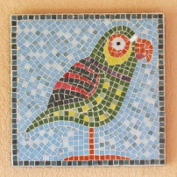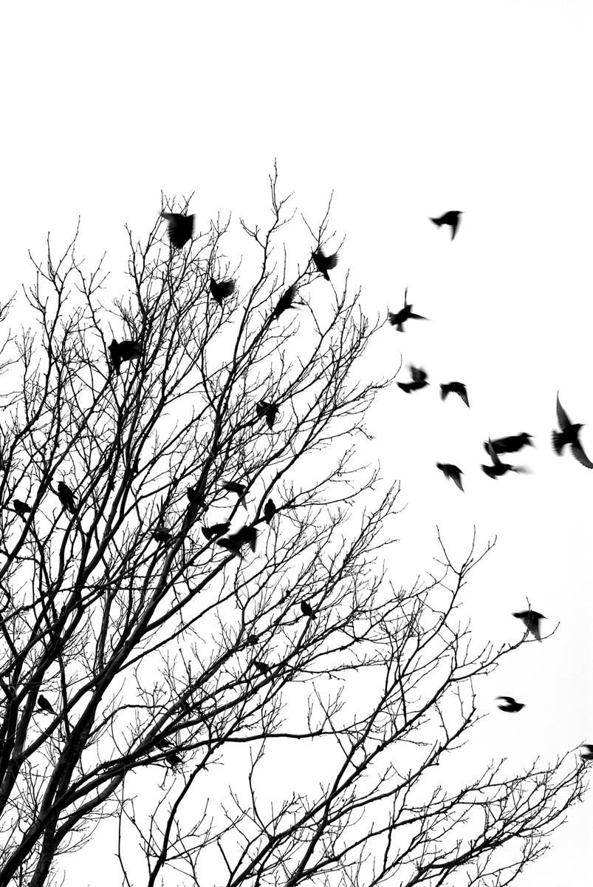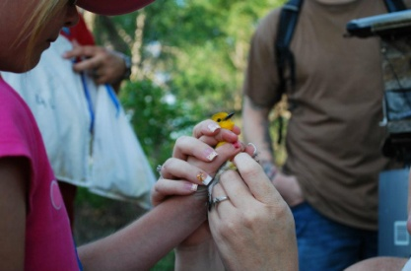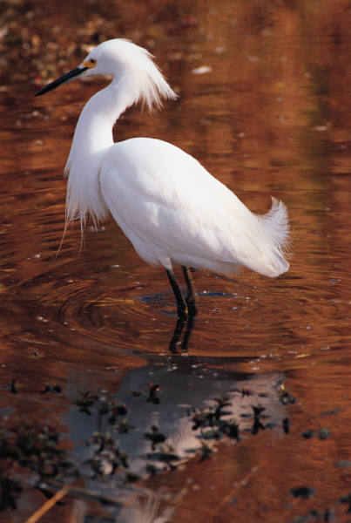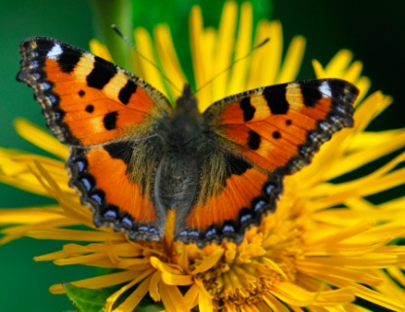

Join the

Summer Fun

at MSC!

PLUS MORE. . .

* Kids to College at Southern Oklahoma Technology Center
* An Orienteering project
* Career Moment at Miranda Lambert’s downtown business
* AND $100 Stipends for Participants!

Contact Karen Cantrell, Summer Academy Dir. 580-371-2371 X137 or kcantrell@mscok.edu.

Mosaic Math Art

**Murray State College**

**Summer College STEM Academy**

**June 9-12, 2014**

**8th and 9th Grade Residential Camp**

**MSC-Tishomingo Campus**

***Stay in our dorms - Experience college life!***

***Cost of Camp – Free!***

Fish & Turtles

at the Fish Hatchery

Birds. . .

Butterflies. . .

Botany. . .

Biodiversity

at the Wildlife Refuge!