NC-SARA
Draft Emails & Landing Pages - 2020 Data Reporting

List of documents (11):
- Landing Page – OOSLP
- Landing Page - Enroll
- Invite Email to Report (for both)
- Confirmation Email – OOSLP
- Confirmation Email - Enroll
- First/Second Reminder Email – OOSLP
- First/Second Reminder Email – Enroll
- 4 Days Left Reminder Email – OOSLP
- 4 Days Left Reminder Email – Enroll
- Last Day Reminder Email – OOSLP
- Last Day Reminder Email – Enroll

Landing Page- OOSLP

NC-SARA 2020 Annual
Out-of-State Learning Placements (OOSLP) Reporting
[Institution Name]

NC-SARA Annual Out-of-State Learning Placements Reporting
SARA institutions are required to report each year certain learning placements in every state, territory, and district other than their own. Learning placements (clinical rotations, student teaching, internships, etc.) are a critical component of many instructional programs. Out-of-state learning placements include on-the-ground, out-of-state learning placements, both for on-campus/face-to-face courses as well as those associated with distance education courses. The learning placements are referred to as out-of-state learning placements (OOSLP).

Data Reporting Window is May 15 – June 30 2020

While every effort has been made to provide clear instructions through the NC-SARA Data Reporting Handbook, the variety of institutional practices in determining student location and tabulating placement data make some institutional reporting decisions difficult to answer. Please use your best judgment and adopt and document an approach that ensures your institution’s reporting is consistent from year-to-year and captures the requested information.

Instructions
Use the reporting form on the next screen to report OOSLP for your institution. Select the first CIP code from the drop-down menu, along with the state/district/territory where learning placements were reported. Use the Add another CIP Code tab to expand the data reporting screen to accommodate each of the CIP codes and states/district/territories you need to report OOSLP for. You can use the Save button to save your work and complete it later.

Within the online reporting forms is a Comments field for you to briefly comment on any apparent anomalies in your data. Please do not ask questions here, as this box will not be actively monitored other than to receive responses. The 2020 NC-SARA Data Reporting Handbook contains details about reporting requirements and instructions for submitting your institution’s data. Please review the Data Reporting Handbook; if you have additional questions, contact NC-SARA at data@nc-sara.org.

Institutional OOSLP data will be reported on the NC-SARA website as portrayed in the 2020 NC-SARA Data Reporting Handbook. We encourage you to read the 2020 NC-SARA Data Sharing Agreement found here, which is incorporated by reference in each institution’s enrollment data submission.

Please be sure to complete both submission forms, one for Enrollment and one for Out-of-State Learning Placements (OOSLP). There are two tabs at the top of the reporting screen and two Confirmation and Authorization screens to complete. Remember, if you have no OOSLP to report – you still must click the button that reads ““No OOSLP to Report” then continue to the confirmation page to complete the submission process.

An automated confirmation email will be sent by NC-SARA to all active institutional contacts upon your Enrollment and OOSLP data submission.

Thank you!
Landing Page – Enrollment

NC-SARA 2020 Annual Enrollment Reporting
[Institution Name]

NC-SARA Annual Enrollment Reporting
Every year, SARA institutions are asked to report the number of students enrolled exclusively in distance education delivered both in the home state of the institution and outside the home state of the institution. This required data submission is based on the enrollment data your institution reported to the Integrated Postsecondary Education Data System (IPEDS) last fall. For SARA, that data is to be disaggregated by the state, territory, or district where the activity takes place.

Data Reporting Window is May 15 – June 30 2020

While every effort has been made to provide clear instructions through the NC-SARA Data Reporting Handbook, the variety of institutional practices in determining student location, tabulating enrollment data, and delivering distance education make some institutional reporting decisions difficult to answer. Please use your best judgment and adopt and document an approach that ensures your institution’s reporting is consistent from year-to-year and captures the requested information.

Instructions
To begin reporting your distance education data, use the drop-down menu just below the title “Enrollment” on the online survey screen to choose the current year 2019-2020. Enter the disaggregated distance education data for SARA member states/district/territories in the first section of the online reporting form. Scroll down to the next section of the online reporting form so that you can then enter the disaggregated data for each non-SARA participating U.S. territory and the state of California. The form will automatically sum and report total enrollment to help validate the data as you enter it.

Use the Comments field to briefly comment on any apparent anomalies in your data. Please do not ask questions here, as this box will not be monitored. The 2020 NC-SARA Data Reporting Handbook contains details about reporting requirements and instructions for submitting your institution’s data. Please review the Data Reporting Handbook; if you have additional questions, contact NC-SARA at data@nc-sara.org.

Institutional Enrollment data will be reported on the NC-SARA website as portrayed in the 2020 NC-SARA Data Reporting Handbook. We encourage you to read the 2020 NC-SARA Data Sharing Agreement found here, which is incorporated by reference in each institution’s enrollment data submission.

Please be sure to complete both reporting forms, one for Enrollment and one for Out-of-State Learning Placements (OOSLP). There are two tabs at the top of the reporting screen and two Confirmation and Authorization screens to complete.

An automated confirmation email will be sent by NC-SARA to all active institutional contacts upon each of the Enrollment and OOSLP data submission.

Thank you!
Email to Invite Data Submission

Dear [First Name Last Name]

Greetings from NC-SARA! As you are aware, all SARA participating institutions report data annually (see SARA Manual Version 20.1 – Section 6). Your institution will need to report both Distance Education Enrollment and Out-of-State Learning Placements (OOSLP). The reporting window is May 15 – June 30, 2020.

The 2020 NC-SARA Data Reporting Handbook contains details about reporting requirements and instructions for submitting your institution’s data. Please review the Data Reporting Handbook; if you have additional questions, contact NC-SARA at data@nc-sara.org.

There are two tabs at the top of the Online Survey (see figure below); one tab is for Enrollment and one tab is for Out-of-State Learning Placements (OOSLP) – both must be completed. In addition, there is a Confirmation and Authorization screen for each of the two surveys to be completed.

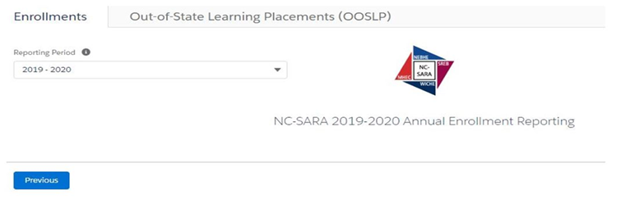

Please use the institution-specific link below to submit data for [Institution Name].

Click here to go to the Online Survey

Thank you!

NC-SARA Staff
National Council for State Authorization Reciprocity Agreements (NC-SARA)
3005 Center Green Drive, Suite 130
Boulder, CO 80301
data@nc-sara.org

OOSLP Confirmation Email

Date: AUTO FILL

Greetings [First Name] [Last Name]

NC-SARA is pleased to inform you that we have received the Out-of-State Learning Placement (OOSLP) data submission for [Institution Name].

Please note that there are two required submissions (see figure below), Out-of-State Learning Placements (OOSLP) and Distance Education Enrollment. If you have not already submitted and received a separate confirmation email for your Distance Education Enrollment data, complete the requirement before the reporting window closes on June 30, 2020.

An automated confirmation email will be sent by NC-SARA to all active institutional contacts upon each of the Enrollment and OOSLP data submission.

If you believe the data has been submitted in error or if you have another data related question, please email data@nc-sara.org.

Thank you!

NC-SARA Staff
National Council for State Authorization Reciprocity Agreements (NC-SARA)
3005 Center Green Drive, Suite 130
Boulder, CO 80301
data@nc-sara.org

Enrollment Confirmation Email

Date: AUTO FILL

Greetings [First Name] [Last Name]

NC-SARA is pleased to inform you that we have received the Distance Education Enrollment data submission for [Institution Name].

Please note that there are two required submissions (see figure below), Distance Education Enrollment and Out-of-State Learning Placements (OOSLP). If you have not already submitted and received a separate confirmation email for your OOSLP data, complete the requirement before the reporting window closes on June 30, 2020.

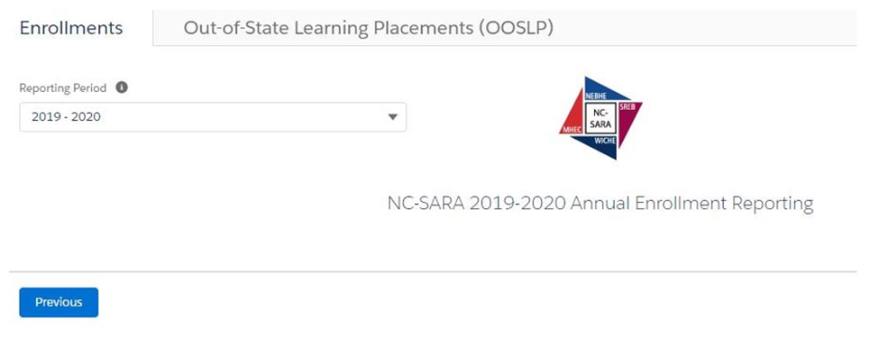

An automated confirmation email will be sent by NC-SARA to all active institutional contacts upon each of the Enrollment and OOSLP data submission.

If you believe the data has been submitted in error or if you have another data related question, please email data@nc-sara.org.

Thank you!

NC-SARA Staff
National Council for State Authorization Reciprocity Agreements (NC-SARA)
3005 Center Green Drive, Suite 130
Boulder, CO 80301
data@nc-sara.org

First & Second Reminder Email - OOSLP

Dear [First Name Last Name]

Greetings from NC-SARA! As you are aware, all SARA participating institutions report data annually (see Section 6 of the SARA Manual). Our records indicate that your institution has not yet submitted Out-of-State Learning Placement data for 2020. The deadline for data submission is June 30, 2020.

The 2020 NC-SARA Data Reporting Handbook contains details about reporting requirements and instructions for submitting your institution’s data. Please review the Data Reporting Handbook; if you have additional questions, contact NC-SARA at data@nc-sara.org.

There are two tabs at the top of the Online Survey (see figure below); one tab is for Enrollment and one tab is for Out-of-State Learning Placements (OOSLP) – both surveys must be completed. In addition, there is a Confirmation and Authorization screen for each of the two surveys to be completed.

Please use the institution-specific link below to submit data for [Institution Name].

Click here to go to the Online Survey

Thank you!

NC-SARA Staff
National Council for State Authorization Reciprocity Agreements (NC-SARA)
3005 Center Green Drive, Suite 130
Boulder, CO 80301
data@nc-sara.org

First & Second Reminder Email - ENROLL

Dear [First Name Last Name]

Greetings from NC-SARA! As you are aware, all SARA participating institutions report data annually (see Section 6 of the SARA Manual). Our records indicate that your institution has not yet submitted Enrollment Data for 2020. The deadline for data submission is June 30, 2020.

The 2020 NC-SARA Data Reporting Handbook contains details about reporting requirements and instructions for submitting your institution’s data. Please review the Data Reporting Handbook; if you have additional questions, contact NC-SARA at data@nc-sara.org.

There are two tabs at the top of the Online Survey (see figure below); one tab is for Enrollment and one tab is for Out-of-State Learning Placements (OOSLP) – both surveys must be completed. In addition, there is a Confirmation and Authorization screen for each of the two surveys to be completed.

Please use the institution-specific link below to submit data for [Institution Name].

Click here to go to the Online Survey

Thank you!

NC-SARA Staff
National Council for State Authorization Reciprocity Agreements (NC-SARA)
3005 Center Green Drive, Suite 130
Boulder, CO 80301
data@nc-sara.org

4 Days Left - Reminder Email - OOSLP

Dear [First Name Last Name]

As you are aware, all SARA participating institutions report data annually (see Section 6 of the SARA Manual).

Our records indicate that your institution has not yet submitted Out-of-State Learning Placement Data for 2020. To remain in compliance with SARA requirements, Out-of-State Learning Placement Data must be submitted by June 30, 2020.

The 2020 NC-SARA Data Reporting Handbook contains details about reporting requirements and instructions for submitting your institution’s data. Please review the Data Reporting Handbook; if you have additional questions, contact NC-SARA at data@nc-sara.org.

There are two tabs at the top of the Online Survey (see figure below); one tab is for Enrollment and one tab is for Out-of-State Learning Placements (OOSLP) – both surveys must be completed. In addition, there is a Confirmation and Authorization screen for each of the two surveys to be completed.

Please use the institution-specific link below to submit data for [Institution Name].

Click here to go to the Online Survey

Thank you!

NC-SARA Staff
National Council for State Authorization Reciprocity Agreements (NC-SARA)
3005 Center Green Drive, Suite 130
Boulder, CO 80301
data@nc-sara.org
4 Days Left - Reminder Email - ENROLL

Dear [First Name Last Name]

As you are aware, all SARA participating institutions report data annually (see Section 6 of the SARA Manual).

Our records indicate that your institution has not yet submitted Enrollment Data for 2020. To remain in compliance with SARA requirements, Enrollment Data must be submitted by June 30, 2020.

The 2020 NC-SARA Data Reporting Handbook contains details about reporting requirements and instructions for submitting your institution’s data. Please review the Data Reporting Handbook; if you have additional questions, contact NC-SARA at data@nc-sara.org.

There are two tabs at the top of the Online Survey (see figure below); one tab is for Enrollment and one tab is for Out-of-State Learning Placements (OOSLP) – both surveys must be completed. In addition, there is a Confirmation and Authorization screen for each of the two surveys to be completed.

Please use the institution-specific link below to submit data for [Institution Name].

Click here to go to the Online Survey

Thank you!

NC-SARA Staff
National Council for State Authorization Reciprocity Agreements (NC-SARA)
3005 Center Green Drive, Suite 130
Boulder, CO 80301
data@nc-sara.org

LAST DAY to Report - Reminder Email - OOSLP
Dear [First Name Last Name]

For the past several weeks, NC-SARA has sent out notifications informing SARA-participating institutions that the 2020 Annual Data Reporting Period is May 15-June 30. Today, June 30, 2020 is last day of the reporting window.

At this time, we have not received your Out-of-State Learning Placement Data. There will be no extension of the deadline unless specifically granted. If you wish to request an extension of 3 days, please email Marianne Boeke, Director for Policy Research and State Support at data@nc-sara.org with an explanation of why your institution cannot meet the published deadline. Please put ‘Extension Request’ in the subject line of your email to ensure prompt attention to your request.

The 2020 NC-SARA Data Reporting Handbook contains details about reporting requirements and instructions for submitting your institution’s data. Please review the Data Reporting Handbook; if you have additional questions, contact NC-SARA at data@nc-sara.org.

There are two tabs at the top of the Online Survey (see figure below); one tab is for Enrollment and one tab is for Out-of-State Learning Placements (OOSLP) – both surveys must be completed. In addition, there is a Confirmation and Authorization screen for each of the two surveys to be completed.

Please use the institution-specific link below to submit data for [Institution Name].

Click here to go to the Online Survey

Thank you!

NC-SARA Staff
National Council for State Authorization Reciprocity Agreements (NC-SARA)
3005 Center Green Drive, Suite 130
Boulder, CO 80301
data@nc-sara.org

LAST DAY to Report - Reminder Email - ENROLL
Dear [First Name Last Name]

For the past several weeks, NC-SARA has sent out notifications informing SARA-participating institutions the 2020 Annual Data Reporting period is May 15-June 30. Today, June 30, 2020 is the last day of the reporting window.

At this time, we have not received your Enrollment Data. There will be no extension of the deadline unless specifically granted. If you wish to request an extension of 3 days, please email Marianne Boeke, Director for Policy Research and State Support, at data@nc-sara.org with an explanation of why your institution cannot meet the published deadline. Please put ‘Extension Request’ in the subject line of your email to ensure prompt attention to your request.

The 2020 NC-SARA Data Reporting Handbook contains details about reporting requirements and instructions for submitting your institution’s data. Please review the Data Reporting Handbook; if you have additional questions, contact NC-SARA at data@nc-sara.org.

There are two tabs at the top of the Online Survey (see figure below); one tab is for Enrollment and one tab is for Out-of-State Learning Placements (OOSLP) – both surveys must be completed. In addition, there is a Confirmation and Authorization screen for each of the two surveys to be completed.

Please use the institution-specific link below to submit data for [Institution Name].

Click here to go to the Online Survey

Thank you!

NC-SARA Staff
National Council for State Authorization Reciprocity Agreements (NC-SARA)
3005 Center Green Drive, Suite 130
Boulder, CO 80301
data@nc-sara.org

