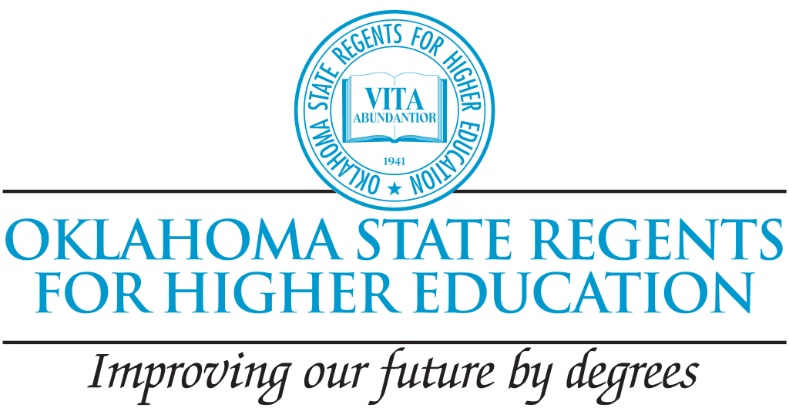

Call for Proposals
Full STEM Ahead Program Grants
Seize the opportunity to impact the future of Oklahoma students! Join the Full STEM Ahead initiative and lead the way in creating exciting and engaging STEM opportunities for students in grades 6-8.
Apply by February 6th for a grant of up to $6,400!
Who Can Apply?
- Public State System institutions with authorization to operate in the State of Oklahoma. Multiple proposals from the same institution will be considered, however the priority is to broaden opportunities across the state. Therefore, if total proposal requests exceed the overall budget for this program this priority will be considered in the grant proposal selection process.

Funding Available
- Up to $6,400 available per grant award
Application Deadline
- Proposal Deadline: February 6, 2026
Steps to Apply
- Review pages two and three of this document for Application Requirements, Program Requirements and Budget Information
- Complete the Full STEM Ahead Grant Application Form no later than February 6, 2026
Award Information
Award notifications will be sent after the April 2026 Regents Board Meeting with the following required of participants:
- Awardee Agreements - due May 15, 2026
- Project Report - due March 5, 2027
Questions
- Contact Annette Long at along@osrhe.edu

Overview of the Oklahoma State Regents for Higher Education (OSRHE)

The Oklahoma State Regents for Higher Education (OSRHE) serves as the coordinating board of control for all public institutions in the State System of Higher Education in Oklahoma. OSRHE has the statutory authority to prescribe academic standards of higher education, determine functions and courses of study at state colleges and universities, grant degrees, and approve public college and university budget allocations as well as tuition and fees within the limits set by the Oklahoma Legislature.

Blueprint 2030: Innovating and Elevating Oklahoma Higher Education for Tomorrow’s Workforce presents recommendations that increase Oklahoma’s educational attainment, align higher education with state workforce needs, and leverage system resources more effectively and efficiently. The plan looks toward Oklahoma’s bright future and reflects the State Regents’ commitment to leading a responsive, forward-thinking, and data-driven state system of higher education. The innovative strategies contained in the plan will guide the work of the State Regents, the 25 public colleges and universities that comprise our state system of higher education, and our agency staff. By supporting disciplines such as engineering, computer science and nursing, OSRHE hopes to address these issues and create additional opportunities for skills development in the STEM fields. The plan is anchored by four fundamental goals: 1) Produce workforce-ready graduates; 2) Grow the student pipeline; 3) Focus on student success; and 4) Improve system efficiency and effectiveness.

Background Full STEM Ahead
- The OSRHE 2030 Strategic Plan goal is to produce 100,000 degrees and other credentials in STEM and critical occupations by 2030
- Challenges:
  - In 2025, only 5% of ACT-tested public-school graduates met the STEM College Readiness Benchmarks, which is significantly lower than the national percentage.
  - In 2025, only 9% of ACT-tested public-school graduates met all four ACT College Readiness Benchmarks
- Opportunities to address challenges:
  - High quality STEM experiences that positively impact students’ attitudes toward STEM.
  - Exploration of careers in STEM and academic pathways to STEM.

Grant applications are due no later than February 6, 2026. Applicants will be asked to provide information regarding:
- Partnering school or agency and how the partner qualifies (See more on this in the Program Requirements section below).
- How the proposed project addresses the challenges and aligns with the opportunities outlined in the background section, citing research to support your STEM activities.
- Proposal Budget (template attached in email).
- The learning goals for your program.

Program Requirements
- Hold at minimum five (5) events September 2026 through February 2027, each event a minimum of three (3) hours
- Partner with one or more of the following:
  - a local school that is underperforming,
  - a local school that has a 75% or higher free or reduced-price lunch student population, or
  - a local nonprofit afterschool program that serves a similar population.
- Provide students with information about Oklahoma’s Promise.
- Partner with K-12 faculty with appropriate expertise.
- Serve students in grades 6-8, or any subset of these grades.
- Provide hands-on, minds-on learning opportunities for students through focused and motivating activities in STEM.
- Institutions are encouraged to allow students to explore multiple STEM fields.
- Participate in a follow-up meeting to discuss successes and areas for improvement to help this initiative grow in the future.
- Submit final reporting, to include written and budget reports.
- Institutions are encouraged to collaborate with industry partners.
- Ensure appropriate supervision of students.
- Priority consideration will be given to proposals that include sustainability details.

This grant is intended to fund new STEM focused programs or programs previously funded by Full STEM Ahead, not programs in existence prior to participation in Full STEM Ahead. Institutions that received funding for Full STEM Ahead Spring 2024 and/or Spring 2025 are eligible to submit a proposal.

Funding
An institution may request up to $6,400 per proposal to be used for student activities, refreshments, transportation (if needed to transport students), mileage for staff and personnel costs. Due to limited funding, no incentives or indirect costs will be allowable. Funding is subject to availability. Should funding or a reduction in or elimination of any source of funding occur, the award will not be granted.

Proposal Selection Process
This pilot program has a limited budget. As the budget allows, reasonable proposals meeting requirements will be funded.

Support Offered to Full STEM Ahead Participating Institutions
- State Regents staff will provide technical assistance through the duration of this program.
- State Regents staff will provide resources for determining appropriate partnerships.

