**Directions to OSUIT Library**

Approaching from the South – Turn right at Hwy 62, and left onto Loop 56.

Approaching from the North – Turn left onto Loop 56

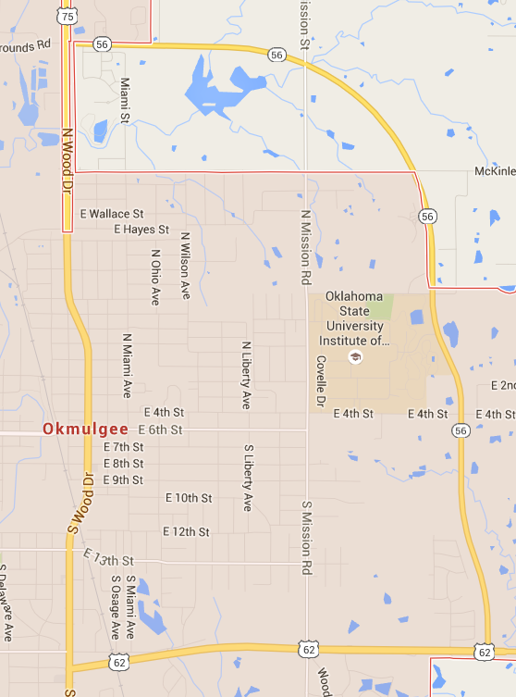

Turn by Turn:

Turn in at the main OSUIT entrance

Drive the curvy entrance, and at the first stop sign, take a right.

At the next stop sign, take another right.

Follow the road past a long, skinny parking lot and keep on it as it curves to the left.

Follow this road until you see a parking lot entrance on your left

Enter the parking lot and park on the far south end.

The State Room is on the Southwest side of the parking lot. The Library is the Learning Resource Center on the Southeast end of the parking lot.

**Turn by Turn Directions with Pictures**

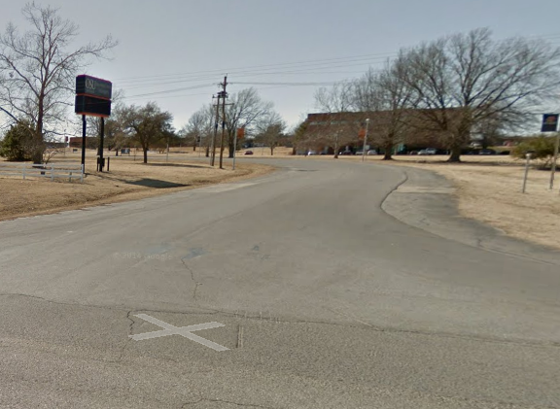Turn in at the main OSUIT entrance:

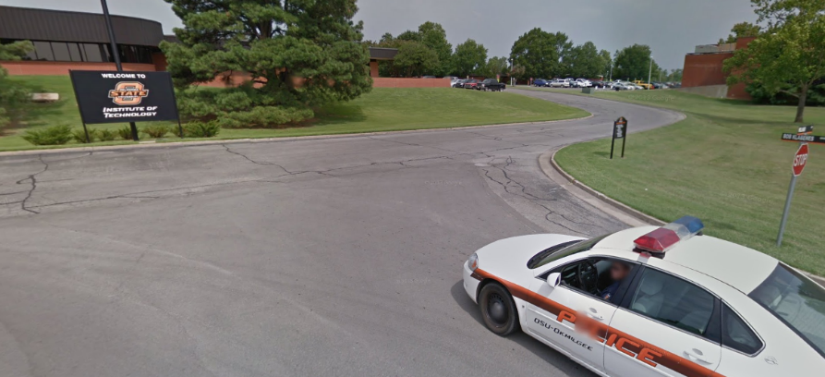Drive the curvy entrance, and at the first stop sign, take a right.

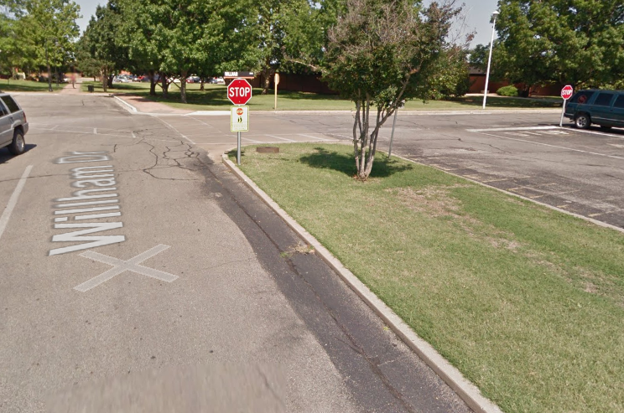

At the next stop sign, take another right.

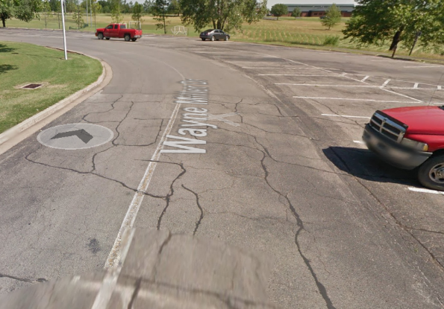Follow the road past a long, skinny parking lot and keep on it as it curves to the left.

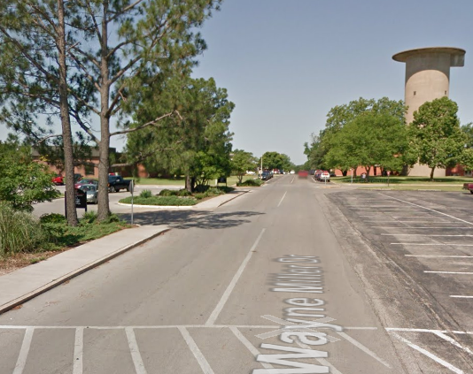Follow this road until you see a parking lot entrance on your left

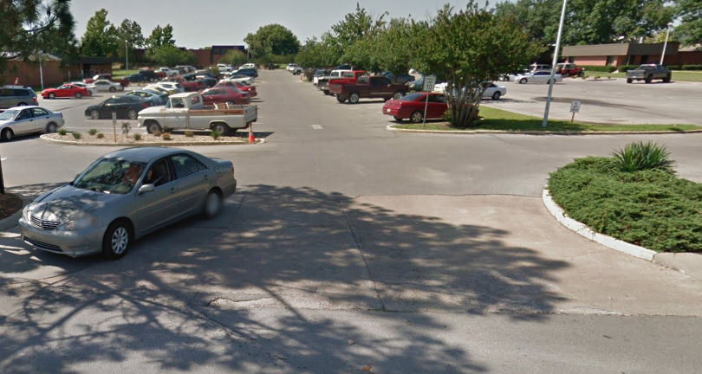Enter the parking lot and park on the far south end.

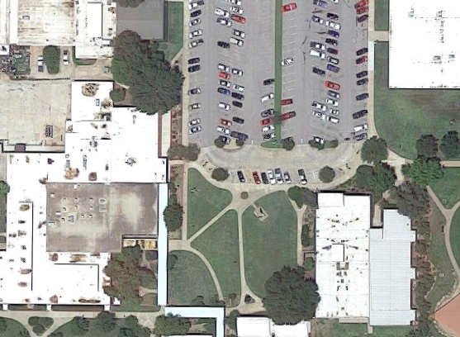

State Room Entrance

Park here

Library entrance