▲ Designated Parking

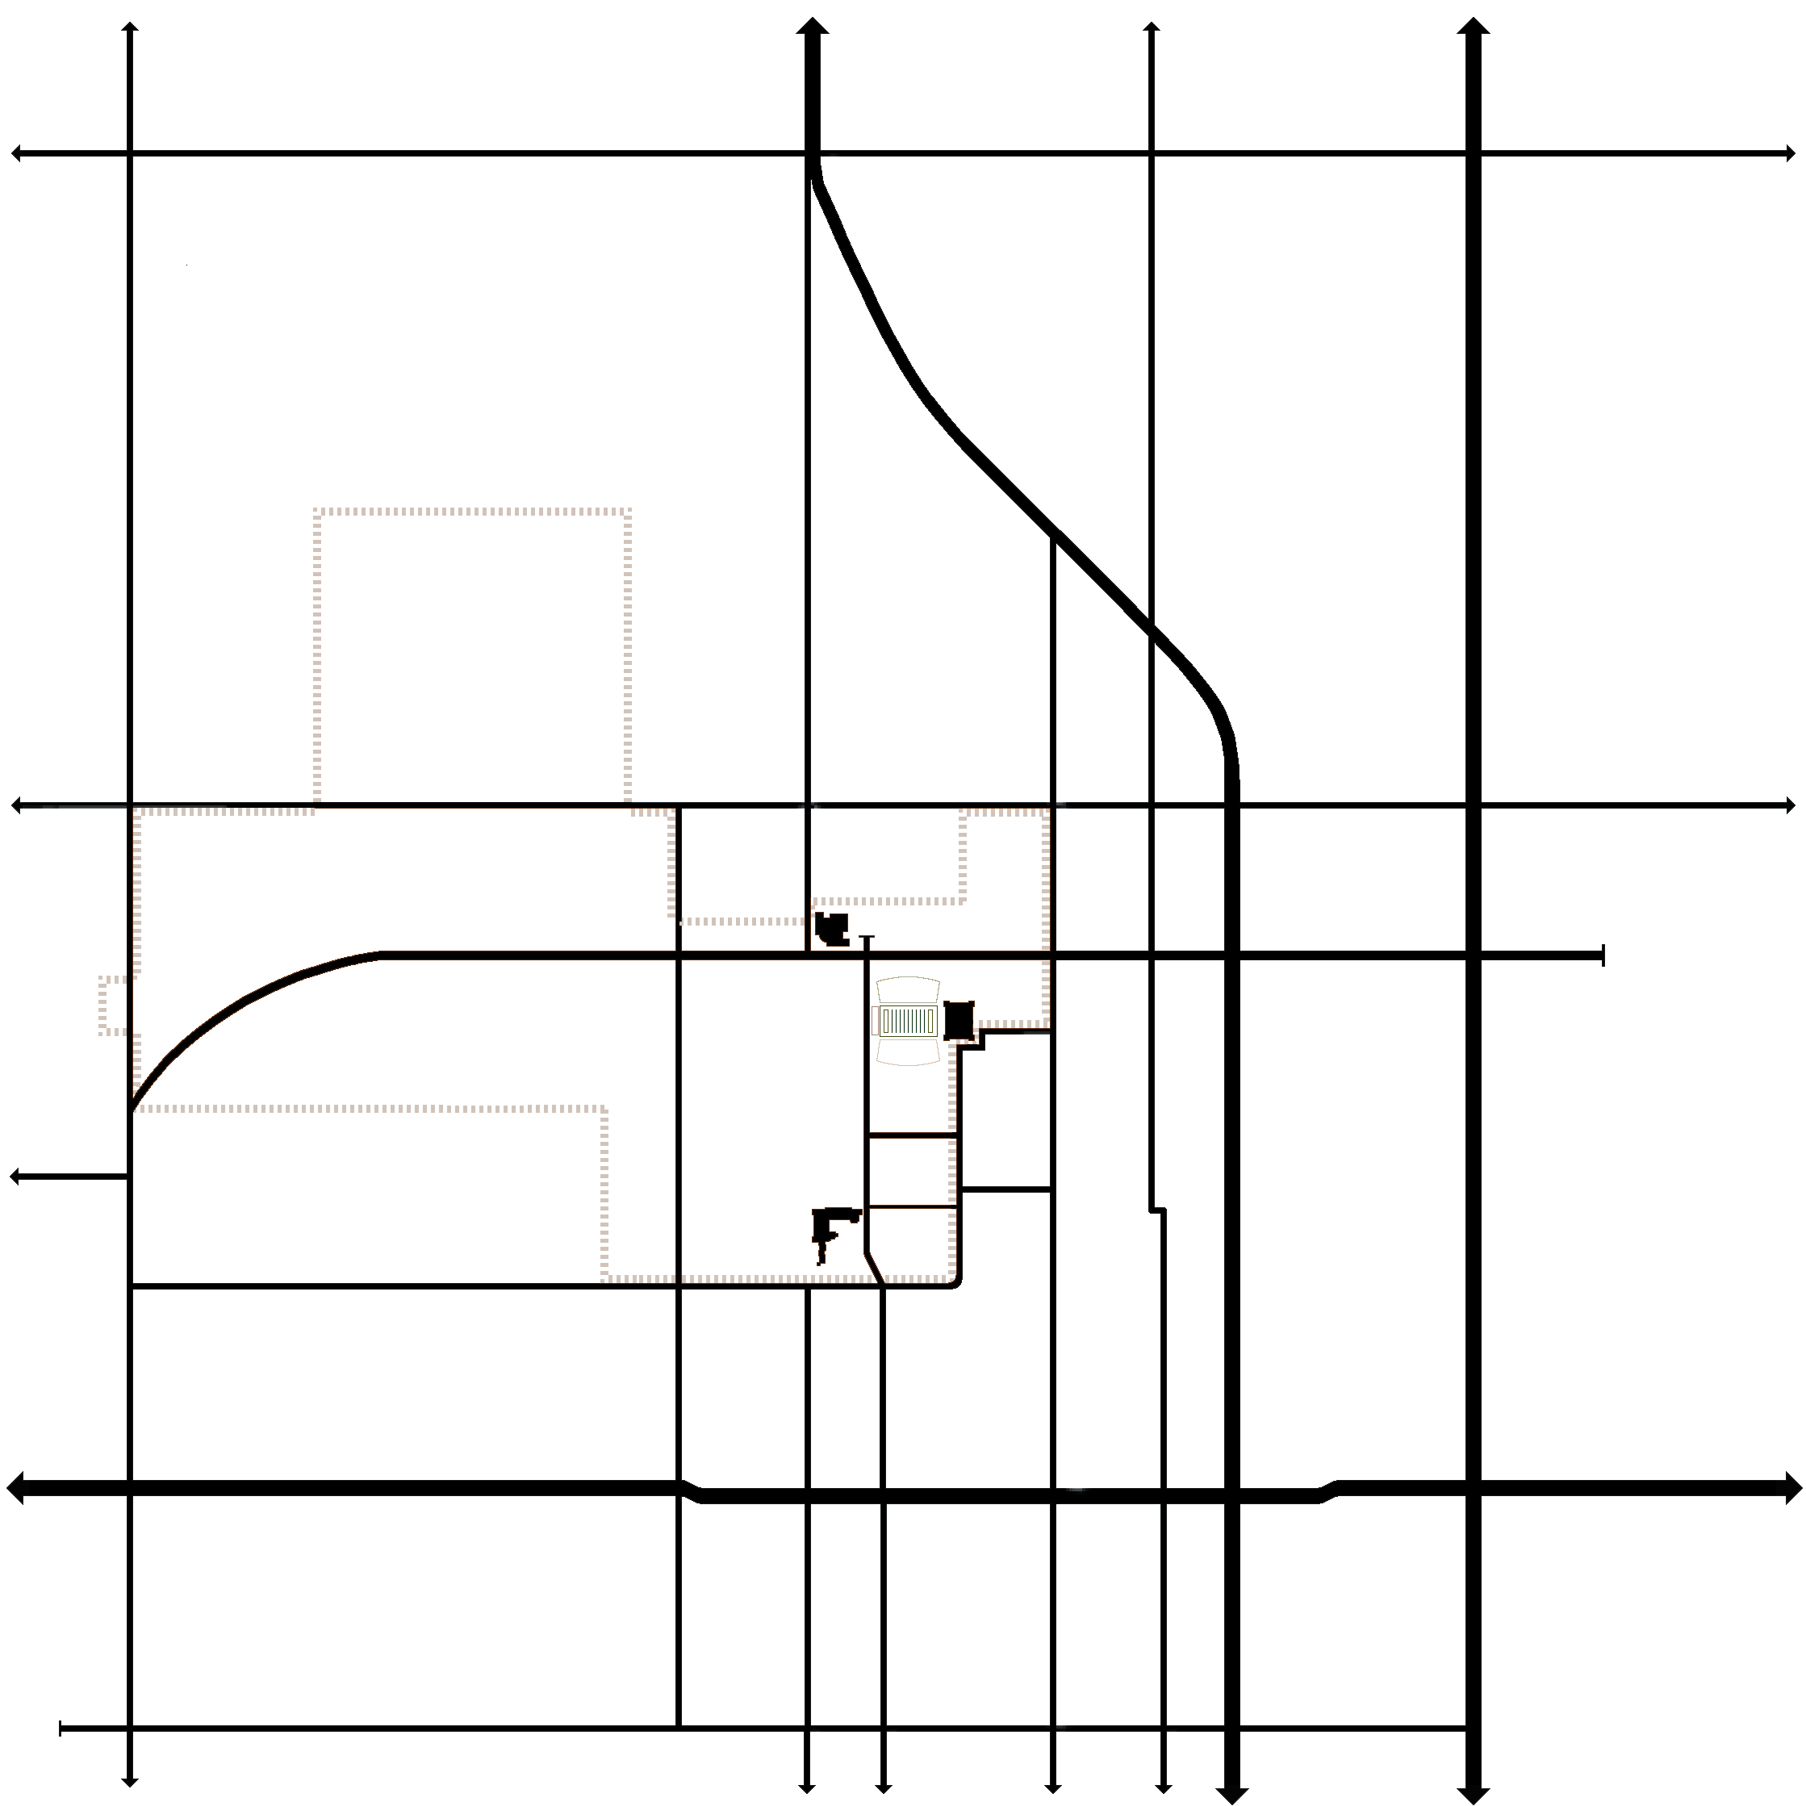
Monroe
Western
Washington
Hester
Duck
Husband
Main
Perkins Rd
Washington
Husband
Perkins Rd
o

m

B

o

e

r

51
177
177
Lot 10A
Lot 1
Main
Knoblock
Hall of Fame Closed between
Knoblock & Hester

Hester
Lot 9A
Monroe
The
Watkins
Center
Lots 109/109a/110
Lakeview
McElroy
University
Hall of Fame
6th
9th
Elm
OSU Campus
Stadium
Student Union
Scott

Lot 9a Parking lots immediately surrounding the Watkins Center and
west of Hester Street. 61 Spaces
Lot 10a Southeast corner of Washington & Hall of Fame, accessible only from Washington. This lot is directly south of Cordell Hall. There is a lot on the east side of Cordell (Lot10) that runs to Hall of Fame, but it is for students only. 82 Spaces

Lots 109/109a/110 Southeast corner of Monroe & Scott (just west of
the Farmhouse fraternity).
Overflow parking. 472 Spaces

Lot 1 Southeast corner of Knoblock & McElroy (just west of the softball
field). Overflow parking if listed on your permit. 122 Spaces

