Eating Establishments Around Tom Steed Center
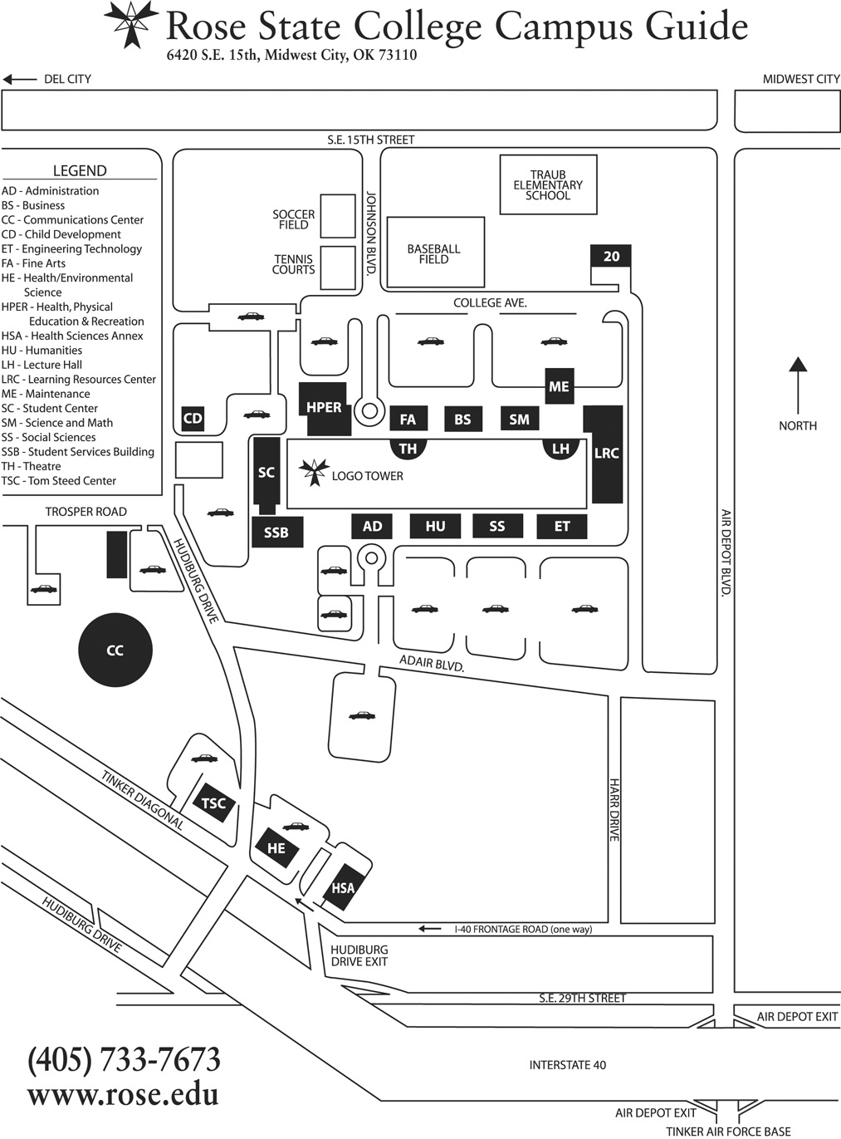

Eating Establishments Around Tom Steed Center

East on Adair Blvd from the Tom Steed Center and turn right (south) on Air Depot and then left (east) on 29th Street:

Chili’s | 7141 S.E. 29th
Santa Fe Steakhouse | 7101 S.E. 29th
Steak n’ Shake | 7181 S.E. 29th

East on Adair and turn left (north) on Air Depot, between Adair & Reno:

Applebee’s | 608 S. Air Depot
Arby’s | 1700 S. Air Depot
Fazoli’s | 408 S. Air Depot
Golden Corral | 617 S. Air Depot
KFC | 1420 S. Air Depot
Los Vaqueros Mexican | 1114 S. Air Depot
Mr. Sprigg’s BBQ | 1017 S Air Depot
Mazzio’s | 1425 Gateway Plaza - corner of Air Depot and S.E. 15th
Quizno’s | 1701 S. Air Depot
Ron’s Hamburgers | 351 N. Air Depot-located just north of Reno
Sonic | 221 S. Air Depot
Subway | 1215 S. Air Depot
Taco Bell | 300 S. Air Depot
Taco Bueno | 7010 S.E. 15th – corner of Air Depot and S.E. 15th

Others in the area:

Chelino’s Mexican | 115 S. Sooner Road (between S.E. 15 and Reno)
CiCi’s Pizza | 2321 S. Air Depot (between Adair and S.E. 29th on Air Depot)
City Bites | 6811 S.E. 15th (between Sooner and Air Depot)
McDonald’s | 7025 S.E. 15th (between Air Depot and Midwest Blvd)
Primo’s Italian | 5661 Tinker Diagonal (just south of Reed Convention Center)

