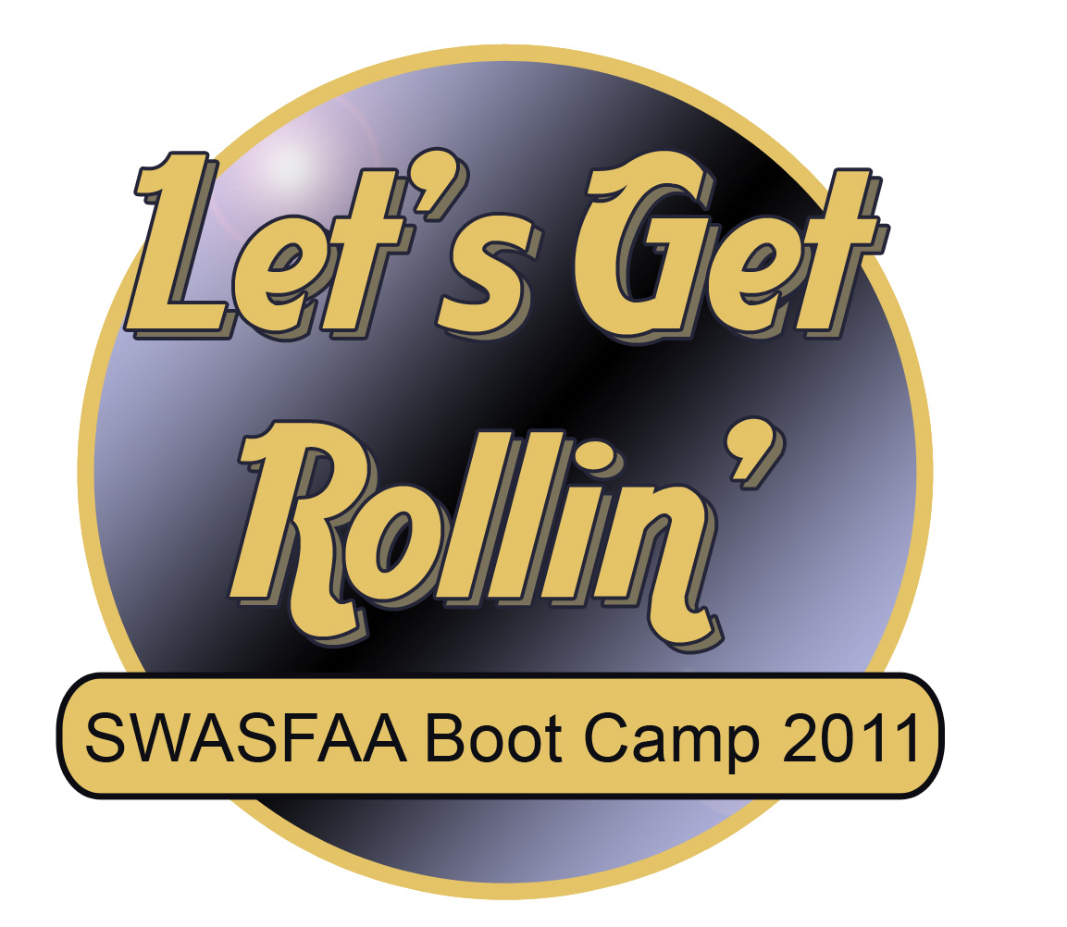
“The presenters were excellent and the topics well organized. This is the first time I have enjoyed a conference and not felt drained by all of the information. Thank you for being so organized and concise but flexible! I loved the interaction between the trainers and the conference attendees.” – anonymous attendee

SWASFAA Boot Camp 2011 offered novice financial aid officers a chance to “Get Rollin’” into the world of administering financial aid. The knowledgeable presenters provided attendees with a comprehensive introduction to Campus Based Programs, Federal Methodology, Application and Student Eligibility, Pell Grant, Direct Loans, Verification, R2T4, customer service, and Professional Judgment as well as a list of electronic tools and resources that can be referred to once back in the office. Many thanks go out to our guest presenters Trevor Summers, USDE Trainer and Pam Cole, Financial Aid Coordinator, Oklahoma Career Tech. We also appreciate Lacy Myers, Oklahoma College Assistance Program, for her assistance on our graphic designs.

The Conference and Local Arrangement chairs Andrew Hammontree and Kelli Kelnar worked very closely with the Boot Camp committee to ensure we had a successful workshop and to them we extend our sincere gratitude.

But most importantly, we thank our 88 boot camp attendees. Without your involvement and participation, our boot camp would not have been so successful. So, HAVE YOU SUBMITTED YOUR VOLUNTEER FORM YET??? Volunteer form link: http://www.swasfaa.org/docs/forms/memVolunteer.html

Sincerely,
Your SWASFAA Boot Camp 2011 Committee
John Jefferson, AR
Mary Sue Rix, LA
Brent Small, NM
Linda Good, OK
Denise Welch, TX (Co-chair and 2012 Chair)
Shannon Guillory, 2011 Chair

