

O-SAFE

Instruction Manual

External User

EXTERNAL USER

LOGIN

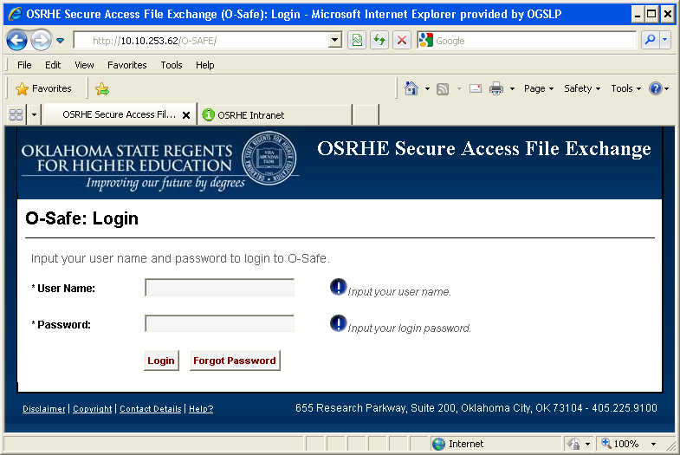
Once you have successfully logged into O-Safe you will be able to access your program(s) and organization(s). If your program(s) and/or organization(s) are not listed or are incorrect, please contact your Program Administrator.

If you forget your O-Safe password, click on Forgot Password button to have the password emailed to you. After successfully entering your email a message window will display stating that, “Your password has been emailed.” Just click OK.

FILE EXCHANGE

Notice that when a program name is expanded and no organization is selected the permissions are set to “Has Access”. Once an organization name is selected the permissions displayed are either set to upload & download, download only or upload only.

UPLOAD

When uploading a file, notice that the UPLOAD FILE button is grayed out. Browse to desired location by selecting the program name, then click on the organization name and notice that the UPLOAD FILE button goes from grayed out to red.

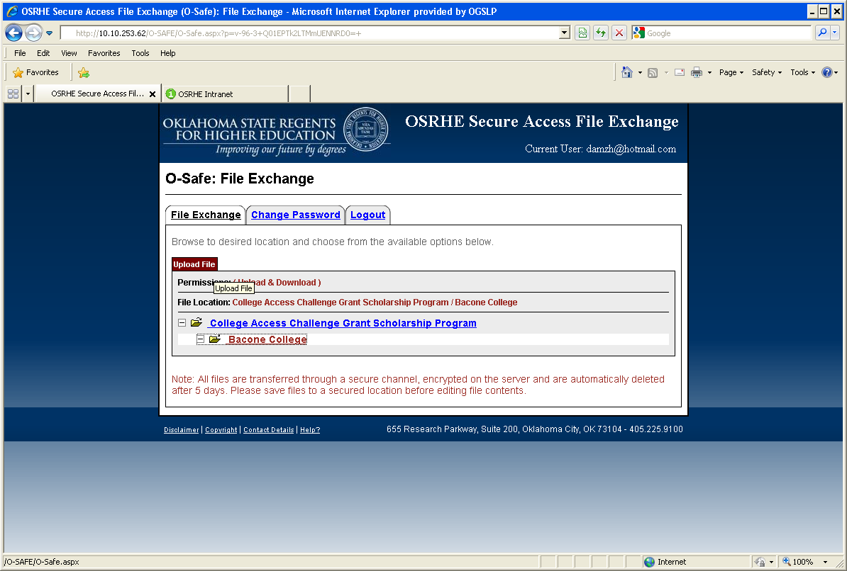

When the color is red, click the UPLOAD FILE button to display the file upload options window. Then click the Browse button and select a file from the File Upload dialog box. When the file is selected click the Open button followed by the Upload button. A confirmation message will display stating that the file has been uploaded successfully or will display an error message if failed.

To view the most recent activity of the file, click on the question mark next to the file (example below).
TEST.txt (New)

Whenever a file has just been uploaded thru O-Safe a (New) message will be displayed besides the file name. This identifies the file as being new and will only be displayed until the file is downloaded.

Also notice that when an organization name is collapsed or not selected, a check mark () next to the organization name is displayed, meaning that the folder contains a file.

Delete File

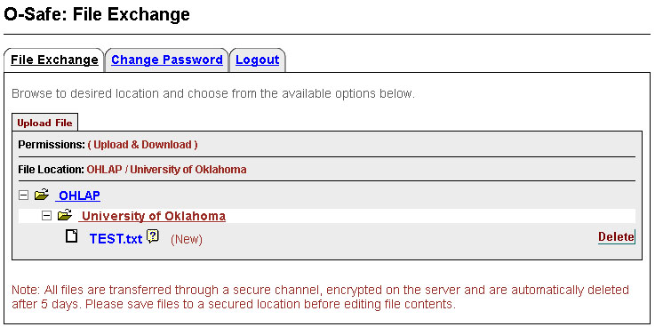

The Delete button to the right of the file name can be used to delete a file. Once clicked a confirmation window appears to make sure you want to delete the file. Once the file is deleted the only way to have the file restored is to upload the file again.

Download

If you have download permissions, download the file by clicking the file name. Once clicked the save file dialog box is displayed. Always select the option Save File to save the file to a secure location, followed by selecting OK.

CHANGE PASSWORD
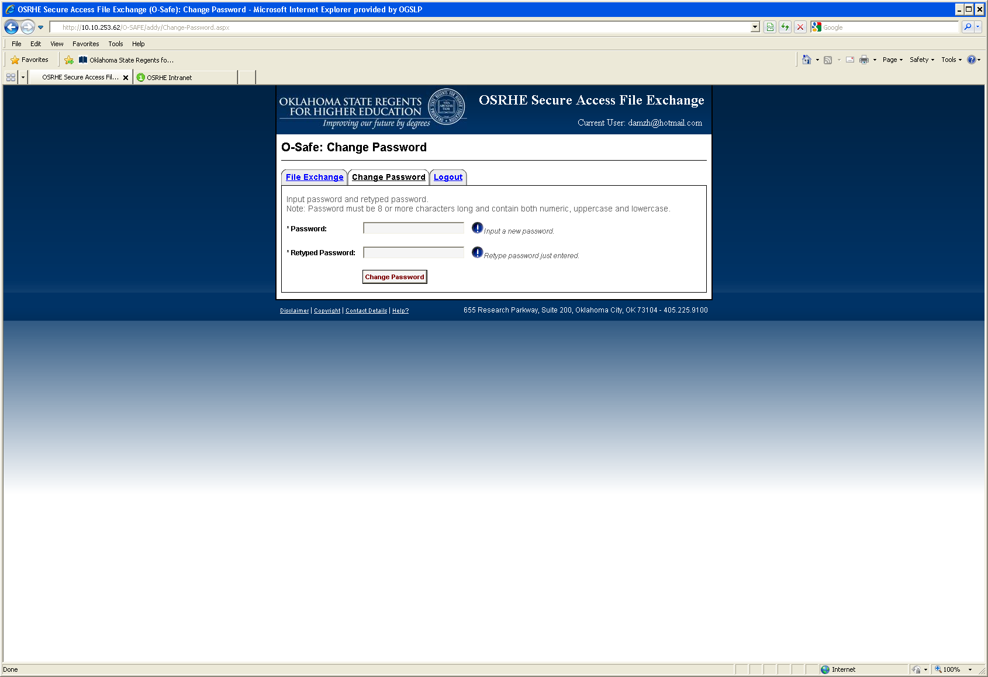

After clicking the Change Password tab or when the system requires a password change the above is displayed. Once a new password and retyped password have been entered, click the Change Password button and a message window is displayed stating that “Your Password has been changed successfully”. Just click OK.

LOGOUT

The Message below is displayed after clicking the Logout tab. Either close the browser window or choose the OK button. If the OK button is clicked, the system will automatically show the Login page.

