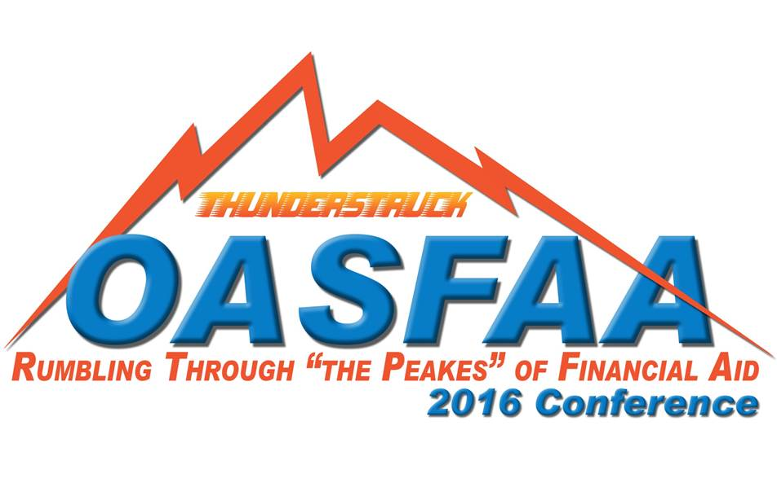
OASFAA 2016 Conference Draft Agenda
April 13-15 at the Embassy Suites in Oklahoma City

Wednesday, April 13th
11:00-1:00 Registration desk open
Exhibit Hall Open

1:00-2:00 Opening Session – Thunder Up!
Keynote Speaker – Pete Winemiller, Sr. Vice President of Guest Relations for the Thunder

2:00-3:00 Federal Update – Score big with new regs!
Kevin Campbell, Training Officer, United States Department of Education - Federal Update (Perkins info, 2016-17 Verification and much more!)

2:00-3:00 Registration desk open

2:30-4:15 Exhibit Hall Open

3:00-3:15 Snack Break – Time to rehydrate and get some carbs!

3:15-4:15 Breakout Sessions:
SESSION 1 –Repayment Plan/Strategies and Insights to Help Borrowers Succeed
Attend this session to learn strategies and insights to help your burrowers navigate the repayment process, including details of the newest option-REPAYE
Presenter: Carol Swenson, Senior Marketing Associate, Great Lakes
Moderator:

SESSION 2 – Unaccompanied Homeless Youth – How to assist these students!
Unaccompanied homeless youth face the challenges of higher education on their own, without basic needs such as food and housing. Many also struggle with histories of abuse or neglect and poverty. This session will explore the unique needs of this population and offer ways to implement financial aid policies and practices on their behalf.
Presenters: Lisa Blazer, University of Texas-San Antonio, NASFAA
Moderator:

SESSION 3 – What is the Right Type of Loan? – Help your students fast break to the best loan for them!
This session focuses on how you can help families look at all aspects of choices in financing an education and how the variety of choices impacts the total cost of education. Hear how some schools communicate the choices, what trends they noted and the impact on the financial aid office.
Presenter: Julie Rehder, ELM Resources
Denise Sullivan, Relationship Manager, Discover Student Loans
Moderator:

4:15-4:30 Break

4:30-5:00 Sector Meetings
4 Year
Facilitator: Jonna Raney, Director of Financial Aid, Oklahoma Baptist University

2 Year
Facilitator: Karen Jeffers, Director of Financial Aid, Tulsa Community College

State public career technology centers
Facilitator: Pam Cole

Proprietary schools
Facilitator:

Dinner on your own

Thursday, April 14th
8:00-11:45 Registration desk open

9:00-9:30 Exhibit Hall open

8:00-9:15 Breakfast – Breakfast Buffet!

9:30-10:30 General Session – NASFAA Update
Presenter: Lisa Blazer, University of Texas-San Antonio, NASFAA
Moderator:

10:30-10:45 Break – Time to Rehydrate!

10:30-12:00 Exhibit Hall open

10:45-11:45 Breakout Sessions
SESSION 4 – Modules & Academic Year – Rumblin’, Bumblin’, Stumblin’ through Modules?
Any course in a program that does not span the entire length of a payment period or a period of enrollment is considered to be a module. This session will explain how to administer Title IV aid when your standard term academic calendar contains modules. Modules may be included exclusively or in conjunction with full-term courses, year-round, or only during a summer term.
Presenter: Kevin Campbell, Training Officer, United States Department of Education
Moderator:

SESSION 5 – 5 Must-Haves for Modern Financial Aid
Learn how your institution can move away from manual financial aid processes to modern, mobile financial aid that puts the student first. It’s easier than you think and brings faster financial aid processing, higher completion rates, and quicker financial aid awards – not to mention the extra time you get to counsel students.
Presenter: Niki Harris, Regional Director, CampusLogic
Moderator:

SESSION 6 – C - Flag Resolution – In our court, there are no objections, only Rejections!
This session will teach you how to properly resolve those pesky C Codes. What documentation is needed? We will look at all of them!
Presenter: Karli Greenfield, Training Specialist, OCAP
Moderator:

12:00-2:00 Lunch – All American Buffet

Awards and Recognitions

2:00-2:15 Break

2:00-3:45 Exhibit Hall open
2:15-3:15 Breakout Sessions
SESSION 7 – Gainful Employment – You can’t win if you don’t know the rules.
This session will provide an overview of the Gainful Employment regulations.
Presenters: Kevin Campbell, Training Officer, United States Department of Education
Moderator:

SESSION 8 – Financial Literacy 2.0: Translating Financial Education into Applied Behaviors
Delivering financial education is the first step to improved financial literacy. Step two presents the real challenge: having students make the leap from knowledge gain to behavior modification. Attendees will come away from this session with ideas for financial education application at their campus and suggestions on how to create a campus-wide approach for teachable moments.
Presenter: Craig Poleman, Strategic Business Director, Inceptia
Moderator:

SESSION 9 –Prior, Prior Year is a game changer!
PPY will affect every institution. What does this regulation mean for your school? Come learn how to prepare your faculty, staff and students for the move to PPY.
Presenter: Lisa Blazer, University of Texas-San Antonio, NASFAA
Moderator:

3:15-3:45 Break

3:45-4:45 Breakout Sessions
SESSION 10 – Active Shooter/Workplace Violence Training
Learn what to do to keep you and your staff as safe as possible if tragedy strikes your campus.
Presenter: Sgt. Jason Knight, Oklahoma City Police Department
Moderator:

SESSION 11 – Panel on Program Reviews
The panel members will share information and tips from their personal experiences with Program Reviews. There will also be time for questions from attendees.
Presenter: Karen Jeffers, Lori Coffey and others
Moderator:

5:30-7:00 Dinner and Basket drawings – THUNDER special guests will join us!
Italian Buffet

Friday, April 15th
8:00-9:00 Breakfast – Buffet Breakfast

9:00-9:30 OASFAA Business Meeting

9:30-9:45 Break

9:45-10:00 SWASFAA Update
Presenter: Janell Valdez, 2016 SWASFAA President

10:00-11:00 OTAG and Oklahoma’s Promise Updates
Presenters:
Irala Magee, Director Oklahoma Tuition Aid Grant Program, Oklahoma State Regents for Higher Education
Bryce Fair, Associate Vice Chancellor for Scholarships and Grants, Oklahoma State Regents for Higher Education

Conference adjourns

